Pick and Mix Homework Menu Topic – Seaside Author Study – Nathan Bryon & Dapo Adeola
Summer is here (sort of) and with the start of the Summer term at school, we will begin with a seaside topic. We hope to explore beautiful creatures, environments and do a little good in the word. Please return your Learning Log back to school on a Thursday for it to be marked and sent home on Friday. Ready, steady, go!

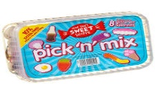
Spicy!!!
Medium
Mild

Communication and Language | Retell one of your favourite seaside stories. It can be one you have read in class or at home.  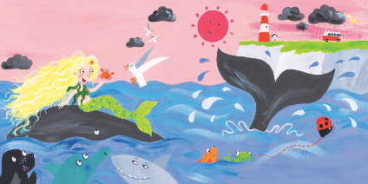 | Tricky word speed wall. Create your own tricky word speed wall. Keep it over the summer term!  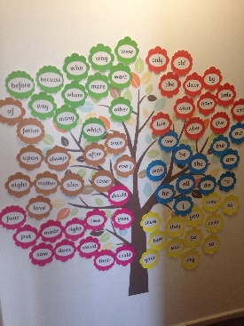 | Sound hunt. Hide your sounds around the house and hunt them down. Once you have found the sound write as many words as possible that link to that sound. | Choose your own! What can you think of together?

Personal, Social and emotional Development. | Think of something you are scared or nervous to do and persevere. This could be riding a bike, swimming or doing something you have failed at. | Worry box. The transition into year 1 can be worrisome. This Summer term make your own worry box and hand it to Mr McGill. A worry shared is a worry halved.  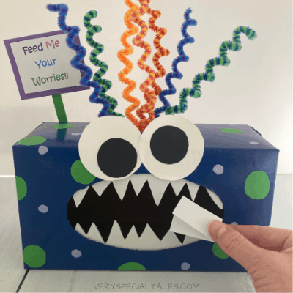 | Write about the time you and your family had a celebration together. This could be a birthday, wedding or a family meal. When did you come together as a family and celebrate. | Choose your own! What can you think of together?

Physical Development  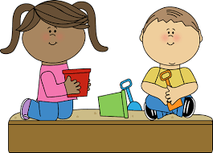 | Select a range of your favourite seaside animals and move just like them.  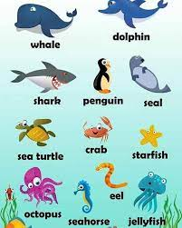 | Create your own mini family sports task, ready for Sports Week. What challenges will you work on? | Navigate a jungle gym like monkey, or creep through the corals like a shark. Get out and explore the amazing world around us.  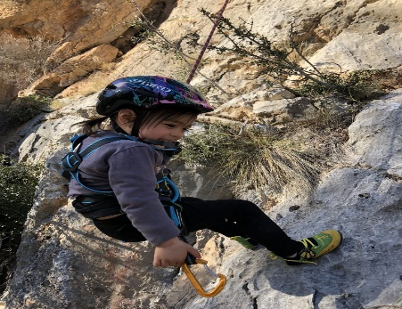 | Choose your own! What can you think of together?

Literacy | Create your own sound wall to keep working on those sounds. Keep working on them over the Summer Term  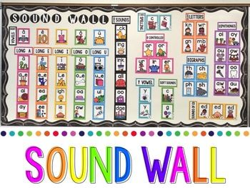 | Research our authors and pick a book you love to write about.  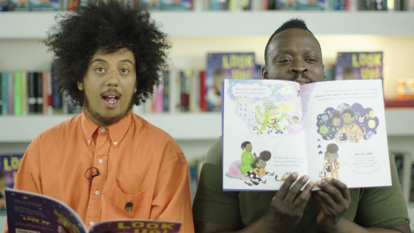 | Change the narrative of one of your favourite stories. It can be from this current topic or one you love. Make it fun and unique, just like you! | Choose your own! What can you think of together?

Mathematics  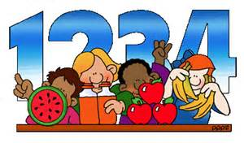 | Number formation wall. Work on your numbers 0-20 in the bath, shower, pool, kitchen or a big old book! Can you make them neater? | Create your own numberbond rainbow up to 10.  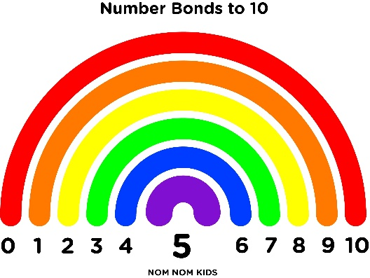 | Create your own numbers! How many ways can you make numbers up to 10? To make it bright and beautiful use bingo pens, fingers paints or crayons.  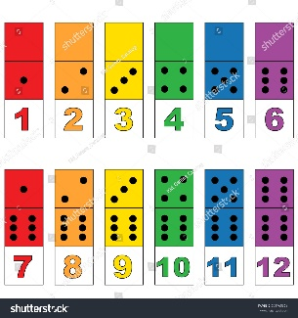 | Choose your own! What can you think of together?

Expressive arts and design | Create your own seaside artwork. Try using recycled materials to held reduce, reuse and recycle.  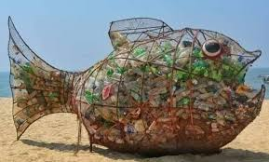 | Create your own seaside creature. | Make your own mini seaside sculputre. Perhaps use real sand and shells for an incredible maserpiece.  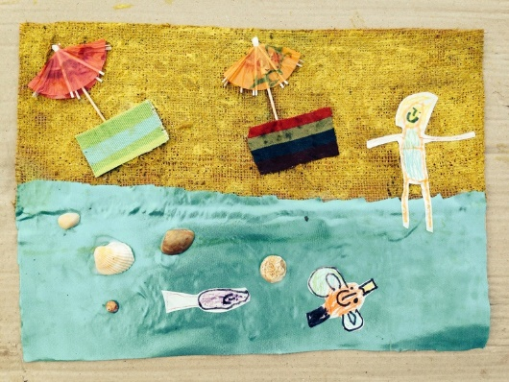 | Choose your own! What can you think of together?

Understanding of the world | Create your own treasure map! Remember – X marks the spot!  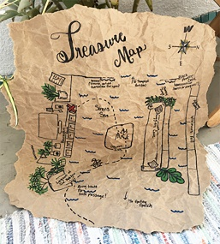 | Litter pickers assemble! Can you help your local beach or even your area by picking up rubbish you find along the way.  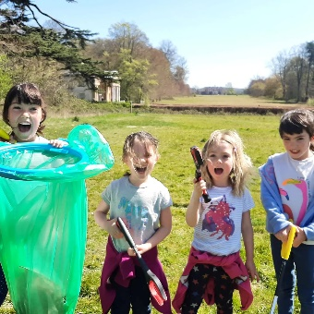 | Create your own fact file about a seaside creature that you think is incredible. | Choose your own! What can you think of together?

