Pick and Mix Homework Menu Topic – Seaside Author Study – Valarie Thomas & Paul Korky
Our last topic in Reception, how has that happened! The kick start this wonderful topic we have are children’s favourite story with Valarie Thomas and Paul Korky (Winne the Witch) as the weeks go by we have an incredible range of stories for the children and will taper our learning to these incredible and unique tales. You cannot have a topic about the seaside without a visit to the seaside and we are hard to work to make that happen.

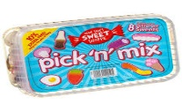
Spicy!!!
Medium
Mild

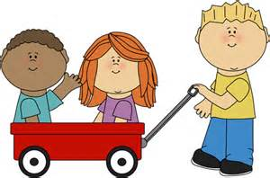  Communication and Language | Retell one of your favourite Thomas and Kory story. It can be one you have read in class or at home.  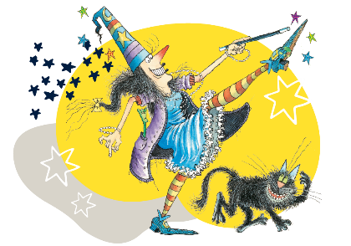 | Tricky word speed wall. Create your own tricky word speed wall. Keep it over the summer holidays too!  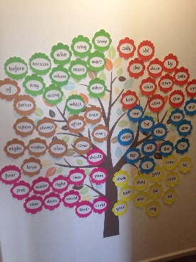 | Sound hunt. Hide your sounds around the house and hunt them down. Once you have found the sound write as many words as possible that link to that sound. | Choose your own! What can you think of together?

Personal, Social and emotional Development. | Just like the Wilbur in the story. Think of something you are scared or nervous to do and persevere. | Worry box. Moving into year 1 can be a little scary. Make your own worry box and hand it to Mr McGill. A worry shared is a worry halved.  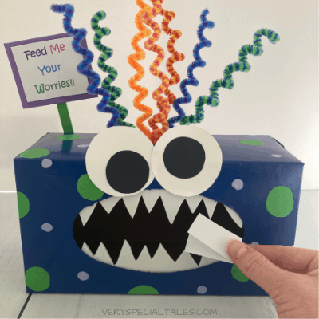 | Write about the time you and your family had a celebration together. This could be a birthday, wedding or a family meal. When did you come together as a family and celebrate. | Choose your own! What can you think of together?

Physical Development  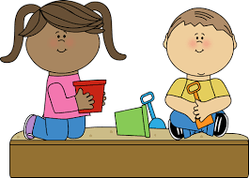 | Select a range of your favourite seaside animals and move just like them.  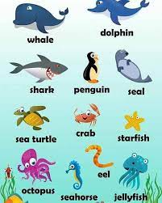 | Create your own mini family sports day in preparation for the school sports day. What challenges will you work on? | Navigate a jungle gym like monkey, or creep through the corals like a shark. Get out and explore the amazing world around us.  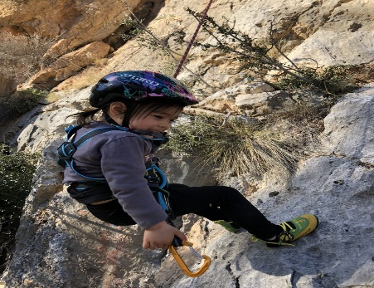 | Choose your own! What can you think of together?

Literacy | Create your own sound wall to keep working on those sounds. Keep working on them over the Summer Holidays.  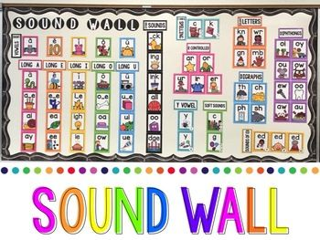 | Research our authors and pick a book you love to write about.  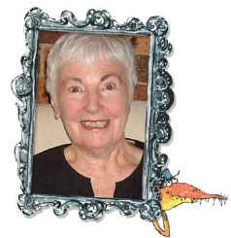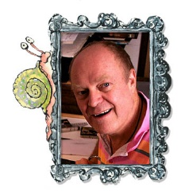 | Change the narrative of one of your favourite stories. It can be from this current topic or one you love. Make it fun and unique, just like you! | Choose your own! What can you think of together?

Mathematics  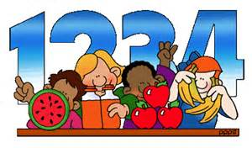 | Play double snap with a friend. If you put down a number 4 your friend has to double it! Take turn swapping roles. | Create your own numberbond rainbow up to 10.  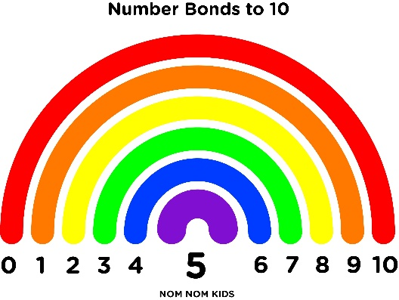 | Create your own numbers! How many ways can you make numbers up to 10? To make it bright and beautiful use bingo pens, fingers paints or crayons.  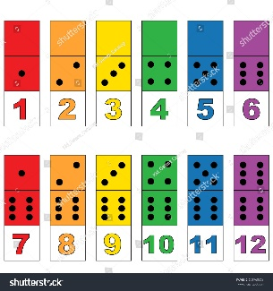 | Choose your own! What can you think of together?

Expressive arts and design  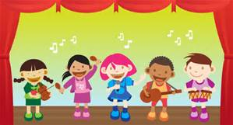 | Create your own seaside artwork. Try using recycled materials to held reduce, reuse and recycle.  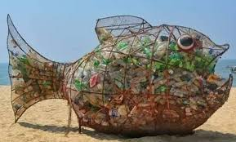 | Create your own seaside creature. | Make your own mini seaside sculputre. Perhaps use real sand and shells for an incredible maserpiece.  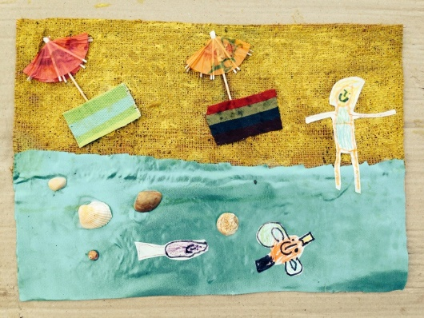 | Choose your own! What can you think of together?

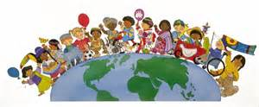  Understanding of the world | Create your own treasure map! Remember – X marks the spot!  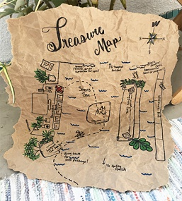 | Litter pickers assemble! Can you help your local beach or even your area by picking up rubbish you find along the way.  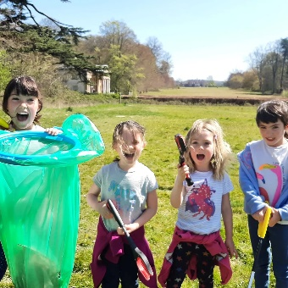 | Create your own fact file about a seaside creature that you think is incredible. | Choose your own! What can you think of together?

