Pick and Mix Homework Menu Topic – Traditional Tales Author Study – Matty Long
We are diving into the wonderful world of Traditional Tales, a truly magical time. Accompanying us on our journey into Traditional Tales is the wonderful author Matty Long who takes great inspiration from Tolkien and stories that greatly influences books/ movies we enjoy to this day.

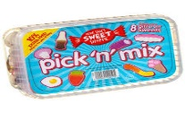
Spicy!!!
Medium
Mild

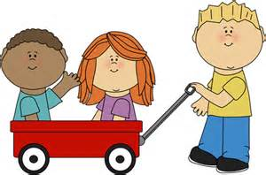  Communication and Language | Create picture cards and sequence your favourite traditional tale story.  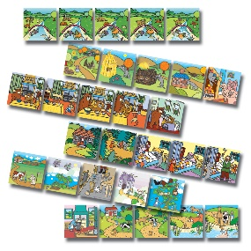 | List, draw and describe your favourite characters.  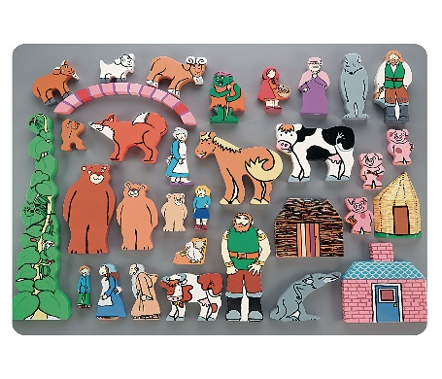 | Create your own traditional tale story with a twist. | Choose your own! What can you think of together?

Personal, Social and emotional Development. | Create your own beanstalk. Use it to measure your height over this summer term and set yourself some goals along the way. Keep growing your body and mind. | Share your achievements on your beanstalk to see what you could not do and what you can now do. You will be astounded by how much you know.  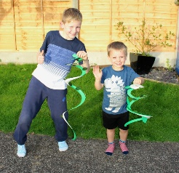 | Explore characters in the stories and how did they act. Was Goldilocks a kind person?  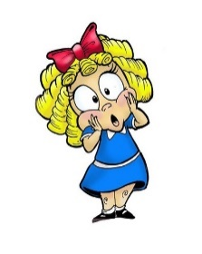 | Choose your own! What can you think of together?

Physical Development  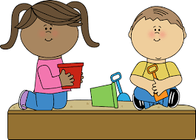 | Work on your penmanship and practise your letter and number formation! | Play Gingerbread tag with your family or friends. | Fe Fi Fo Fum you need to put something in my tum! Quick, create the giant a healthy, tasty plate.  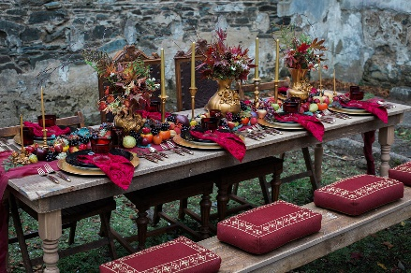 | Choose your own! What can you think of together?

Literacy  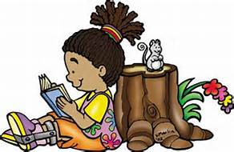 | Create your own role play masks and say your characters lines. | Using your own tricky word list and your character list. How many silly sentences using tricky words can you write about the characters? | Magic hard phonics. Play a hard (or favourite music) and see how many words you can write on your sound mat. For instance s = sit ai = train igh night. How many can you get? | Choose your own! What can you think of together?

Mathematics  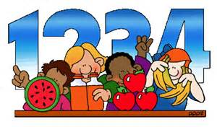 | Complete a jigsaw experimenting with size and shape. Draw your own picture, chop it up and make your own. | Using Jack’s magic beans, create your own addition and subtraction sums. Really show off by recording them.  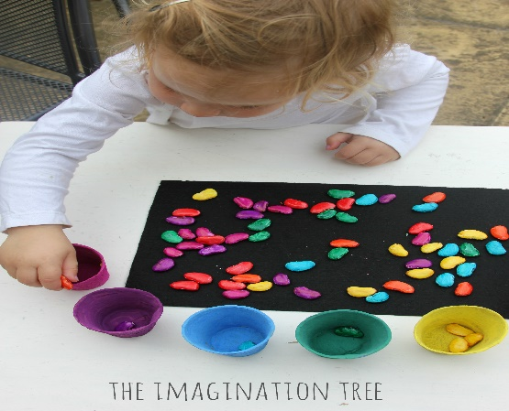 | Shape art. Create your own shape stamper and create a picture with them. If not a picture, why not make a 3 part + stamping pattern!  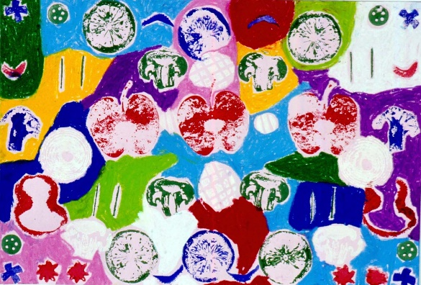 | Choose your own! What can you think of together?

Expressive arts and design  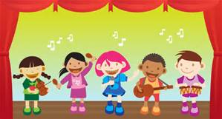 | Build, draw or paint for favourite Traditional Tales Character.  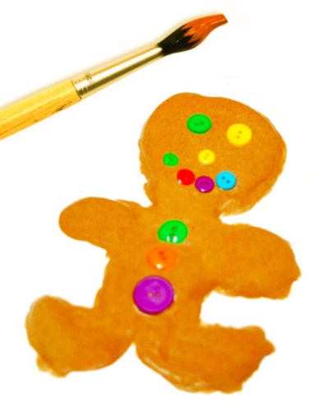 | Get your story telling hats on. Retell your favourite story. | Create your own junk model castle in the sky!  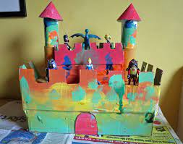 | Choose your own! What can you think of together?

Understanding of the world | Create your own cinnamon Gingerbread man playdough. Mums and Dads, take a back seat and read the instructions. What do you see? Smell? Feel?  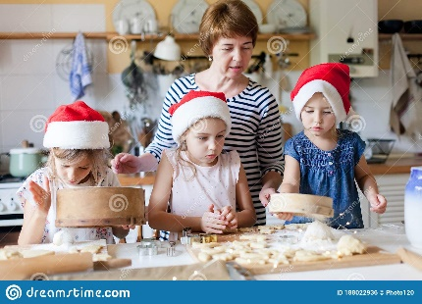 | Research your favourite castle and create your own mini fact file on it. | Grow your own beanstalk (plant of your choosing) and record its journey as a little seed, to plant. If it goes wrong and dies, log it, what went wrong. | Choose your own! What can you think of together?

