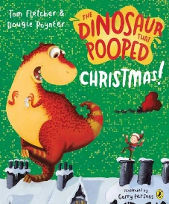
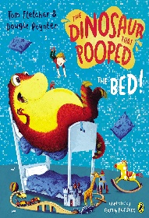
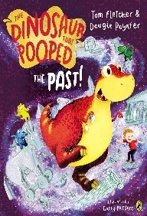
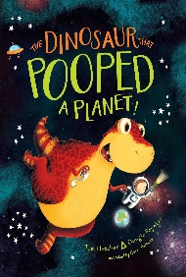
Pick and Mix Homework Menu
Topic – Dinosaurs
Author Study – Tom Fletcher and Dougie Poynter

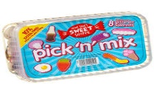
Spicy!!!
Medium
Mild

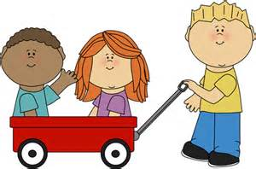  Communication and Language | Test your speedy reflexes with sound and tricky word snap.  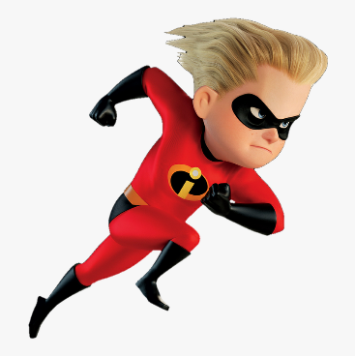 | Pick your favourite dinosaur and describe it to family or record it for your friends in class. | Rhyming card snap! Write out your own words with rhyming pairs and play a game of snap, how quick can you be? | Choose your own! What can you think of together?

Personal, Social and emotional Development. | Reflection on Christmas time with family. | Think of one thing we would like to improve upon this new year. How will we improve it? | During these dark January mornings tell your loved ones what you love about them most. It might be an uncle you haven’t seen in a while or a Grandma who may live far away. Let them know you are thinking about them. | Choose your own! What can you think of together?

Physical Development  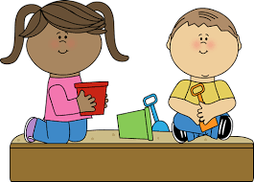 | Dinosaur boogie. Can you move like a dinosaur? Record yourself and your dinosaur movements.  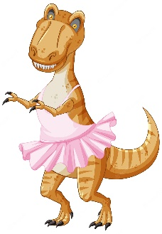 | Create your own dinosaur target and practise your overarm and underarm throw. | Dino egg baking/ cooking. Help in the kitchen by chopping ingredients, mixing and cracking those eggs. Show me your creations.  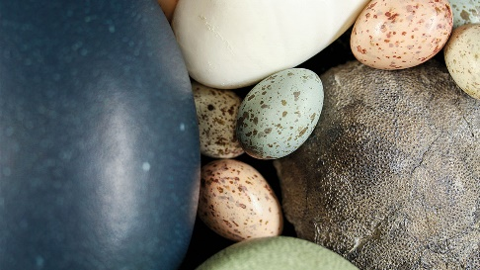 | Choose your own! What can you think of together?

Literacy | Pick a tricky word and put it into a sentence.  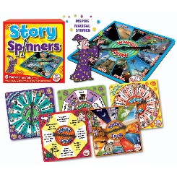 | Dino descriptions. Pick your favourite dinosaur and describe it.  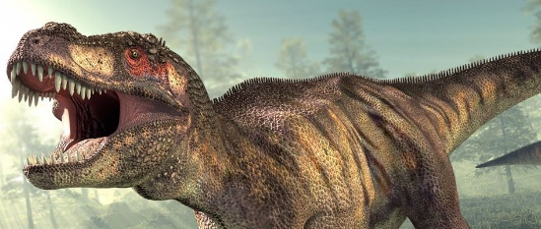 | Pick your favourite story from Tom Fletcher / Dougie Poynter and retell the story. | Choose your own! What can you think of together?

Mathematics  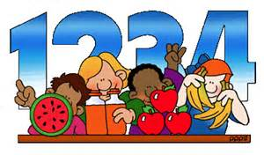 | Create your own dinosaur number line. | Work through your own number bonds list.  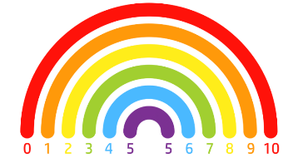 | Using your dinosaur egg hide a number inside. You can work on number writing or counting. Either hide the number in the egg and tell someone or get the number out the egg and go hunting!  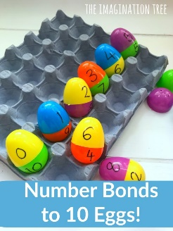 | Choose your own! What can you think of together?

Expressive arts and design | Create your own dinosaur egg.  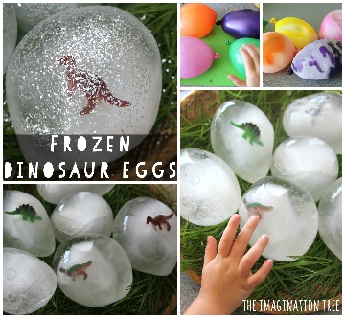 | Draw your own dinosaur picture. Feel free to be creative with your materials. | Junk model your very own Dinosaur!  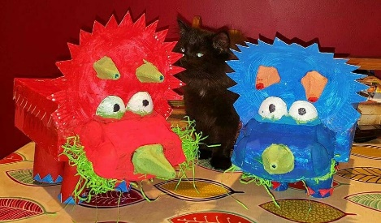 | Choose your own! What can you think of together?

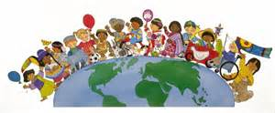  Understanding of the world | Go on a winter walk and collage the colours that you find – enjoy! | Create your own dinosaur fact file.  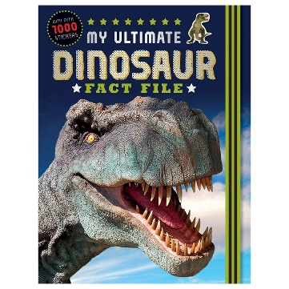 | Group up herbivores, omnivores and carnivores. | Choose your own! What can you think of together?

