Pick and Mix Homework Menu
Topic – Space Author Study – Oliver Jeffers
Before we all go Christmas crazy! We will be exploring the wonderful world of space. The possibilities are endless! Our author will be the incredible Oliver Jeffers and his incredible stories and illustration. Before you know it we will be hearing jingle bells and the clip clop of hooves above.

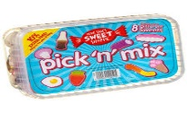
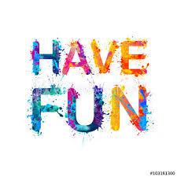
Spicy!
Medium
Mild

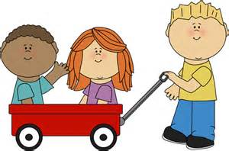  Communication and Language | Collect your coins on you Bug Club adventure. | Create your own astronaut silly sentences using your tricky words. How many tricky words can you use?  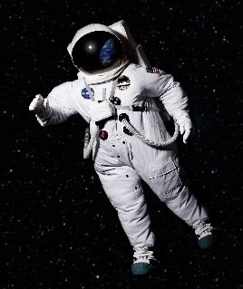 | Record yourself landing on an alien planet. How what you say? What do you see!  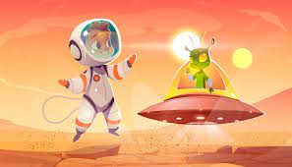 | Choose your own! What can you think of together?

Personal, Social, and emotional Development.  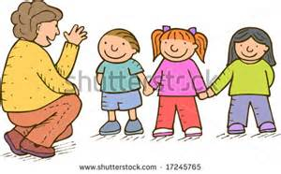 | Join a new afterschool club to find a new passion, trying something new and make even more friends.  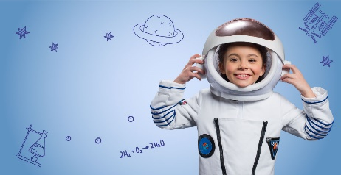 | Record yourself retelling the story of Christmas.  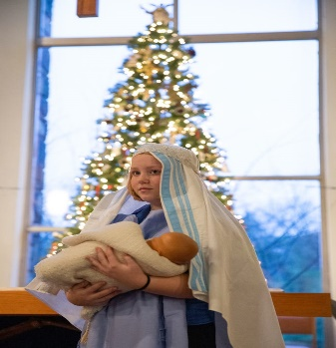 | Make a light of the world book and reflect on all the kind things you have done. | Choose your own! What can you think of together?

Physical Development  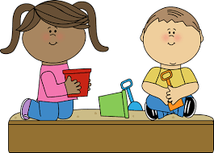 | Create your own Play-Doh and using your funky fingers make your own space scene. | It may be cold but let’s have a meteor fight (water balloon fight) use your agile movements and great overarm throwing.  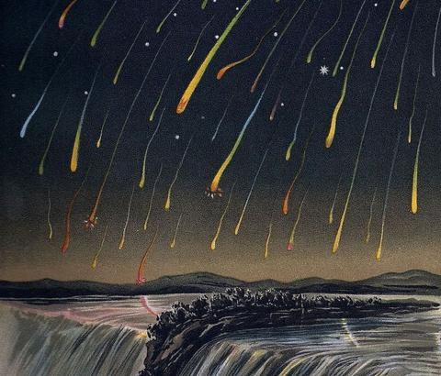 | Astronaut training! Sprint 110 yards, walk 110 yards. Time and track your results.  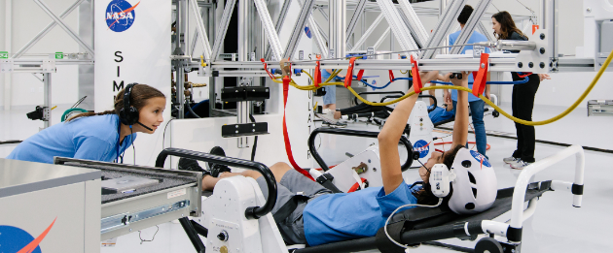 | Choose your own! What can you think of together?

Literacy | Digraph and trigraph sound hunt. Create your own or have someone hide them for you!  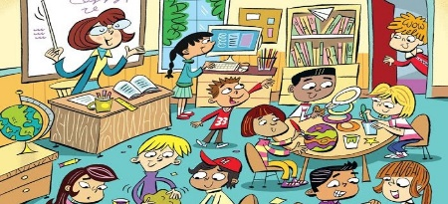 | Write about your favourite character from the Oliver Jeffers book. | Become a star gazer or an entomologists. Make notes of what you observe.  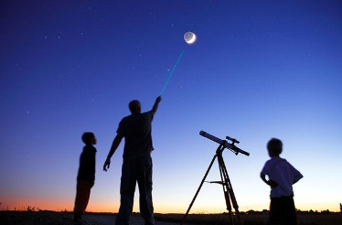 | Choose your own! What can you think of together?

Mathematics  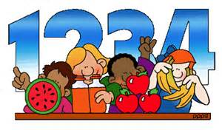 | Star jump counting – how high can you go! | Create your own 2d shape rocket!  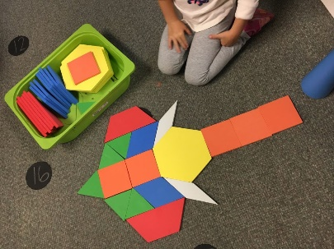 | Bake your own space themed biscuits. A great way to work on volume, capacity and counting. | Choose your own! What can you think of together?

Expressive arts and design  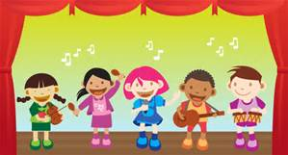 | Rehearse your Nativity songs! | Papier-mâché your own Earth or Moon! | Create your own space artwork of the solar system.  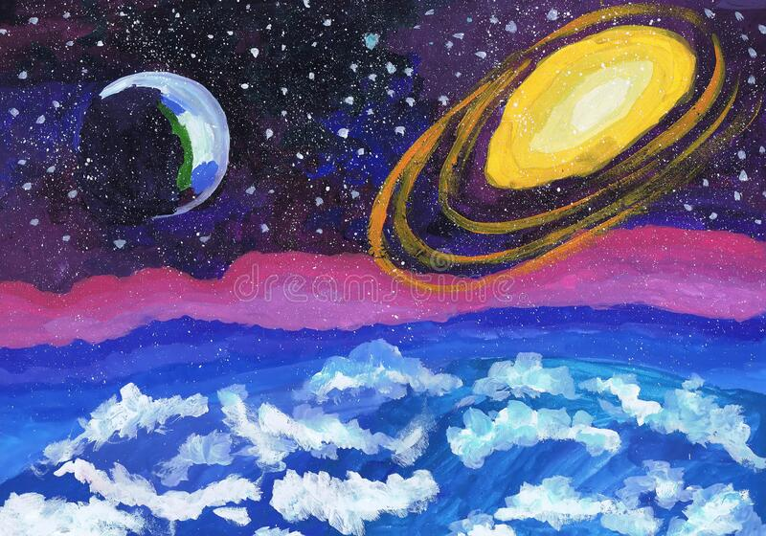 | Choose your own! What can you think of together?

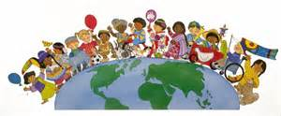  Understanding of the world | Launch your very own bottle rocket, how high can you go?  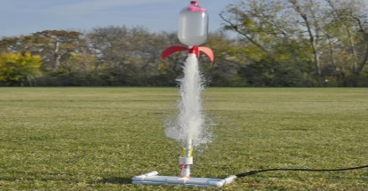 | Become a star gazer and see what constellations you can see or even draw!  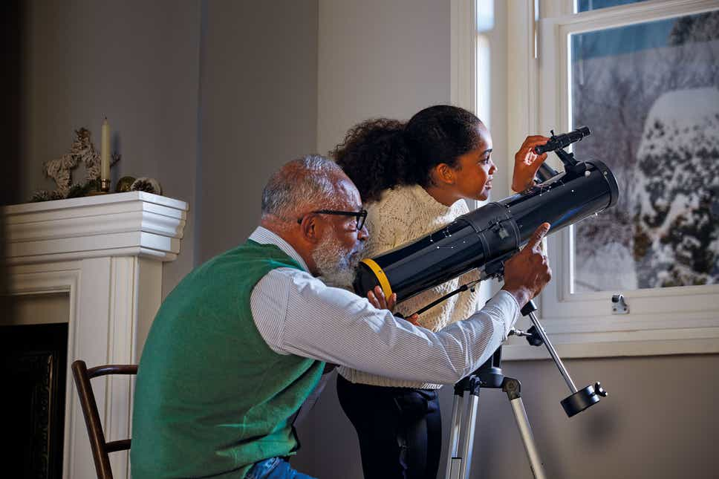 | Compare earth to other planets. Which are the similarities and what are the differences? | Choose your own! What can you think of together?

