Read every day. Try to read a variety of book genres eg. science fiction, adventure stories, legends, biographies, poetry and information texts. | Music Compose a song or rap using electronic sounds. For inspiration, use the following link to find out more about Delia Darbyshire who created the Doctor Who theme tune. https://www.bbc.co.uk/teach/ten-pieces/classical-music-ks2-delia-derbyshire-doctor-who-theme/zbfvt39 | Science Design an electrical safety poster.  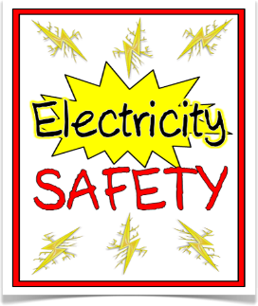 | Computing Make a poster or Powerpoint presentation with information about how to stay safe online.
Art Create your own atmospheric ‘Electrical Storm’ picture.  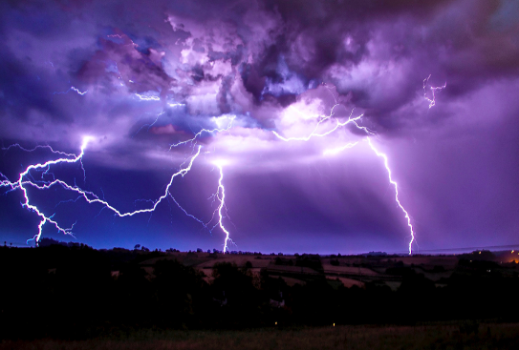 | Maths Learn the times tables you are not confident with. Make posters to help you remember them. Ask someone at home to test you with quick-fire questions. Practise on: https://play.ttrockstars.com  Have fun practising and applying your other maths skills on: Prodigy:https://play.prodigygame.com | English Write an explanation of how something works or is made.  Remember to include:-  - Complex sentences using if, so,  because, when.  - Connectives – time and causal.  - Appropriate technical  vocabulary.  - Sequenced steps. | RE Create a St. Francis fact file. It is St. Francis’ Feast Day on 4th October.  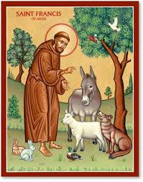
Fairsnape Class Pick And Mix Homework Menu
Topic – Sparks Might Fly!
In the table, there are lots of different homework activities to choose from. You MUST complete the activities that are coloured green every week. Try and do as many of the others as you can and be creative! We will celebrate and share learning logs every Friday.

