Pick and Mix Homework Menu Topic – Jungles Author Study – Giles Andreae
Where has the time gone! For our end of year topic Pendle Class decided to delve into the wonderful world of jungles. Fantastic habitats, creatures of all shapes and sizes, beautiful locations around the world and incredible cultures to learn from. The possibilities are endless. I cannot wait to see what we find out.

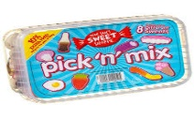
Spicy!!!
Medium
Mild

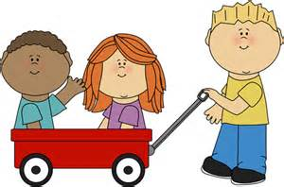  Communication and Language | Retell one of your favourite Giles Andreae stories. It can be one you have read in class or at home.  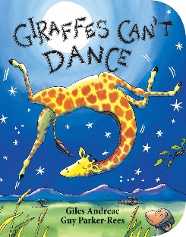 | Tricky word speed wall. Create your own tricky word speed wall. Keep it over the summer holidays too!  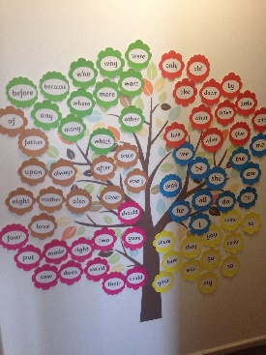 | Sound hunt. Hide your sounds around the house and hunt them down. Once you have found the sound write as many words as possible that link to that sound. | Choose your own! What can you think of together?

Personal, Social and emotional Development. | Just like the giraffe in the story. Think of something you were scared or nervous to do and persevere. | Worry box. Moving into year 1 can be a little scary. Make your own worry box and hand it to Mr McGill. A worry shared is a worry halved.  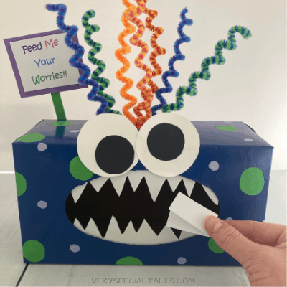 | Write about the time you and your family had a celebration together. This could be a birthday, wedding or a family meal. When did you come together as a family and celebrate. | Choose your own! What can you think of together?

Physical Development  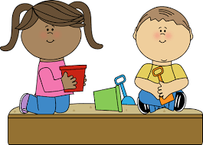 | Select a range of your favourite animals and move just like them.  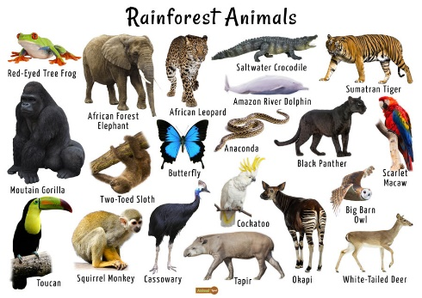 | Create your own mini family sports day in preparation for the school sports day. What challenges will you work on? | Navigate a jungle gym, or creep through the woods like a panther. Get out and explore the amazing world around us.  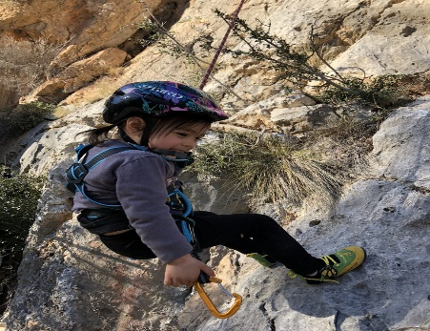 | Choose your own! What can you think of together?

Literacy | Create your own sound wall to keep working on those sounds. Keep working on them over the Summer Holidays.  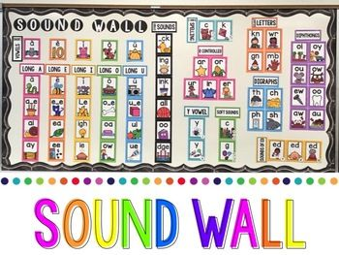 | Research Giles Andreae and pick a book you love to write about.  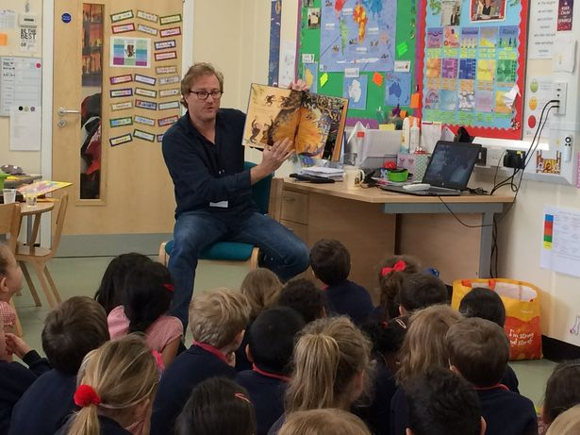 | Change the narrative of one of your favourite stories. It can be from this current topic or one you love. Make it fun and unique, just like you! | Choose your own! What can you think of together?

Mathematics  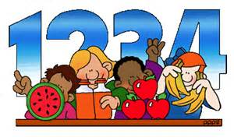 | Play double snap with a friend. If you put down a number 4 your friend has to double it! Take turn swapping roles. | Create your own numberbond rainbow up to 10.  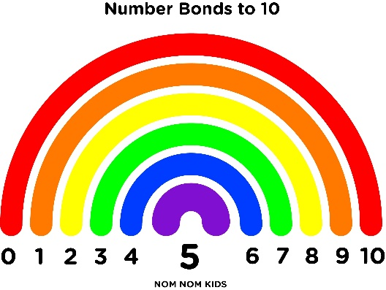 | Create your own numbers! How many ways can you make numbers up to 10? To make it bright and beautiful use bingo pens, fingers paints or crayons.  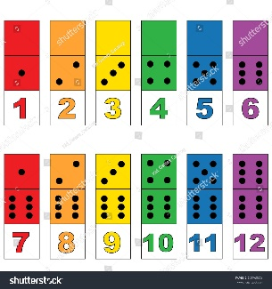 | Choose your own! What can you think of together?

Expressive arts and design | Record yourself singing your favourite jungle boogie. Let’s get down in the jungle. | Create your own beautiful bird of paradise.  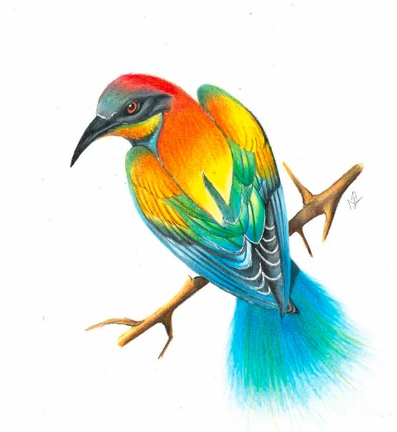 | Create your own Jungle themed painting. Take your time and don’t forget to use a pencil first to fit in all those details.  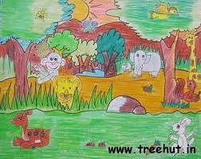 | Choose your own! What can you think of together?

Understanding of the world | Get out there and get bird/nature spotting. I know lots of you love nature so you can record the amazing creatures you see or  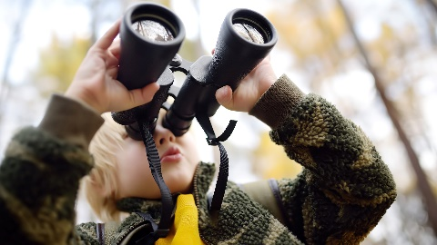 | Look at the world map and locate the rainforests on it. | Create your own fact file about a jungle or creature that you think is incredible.  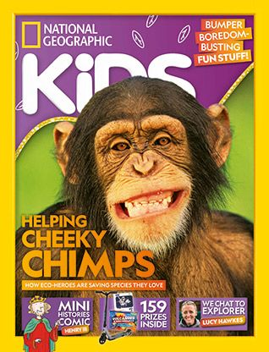 | Choose your own! What can you think of together?

