Pick and Mix Homework Menu Topic – Farming Author Study – Martin Waddle
The final term – time truly flashes by! Pendle Class decided that our next topic is going to be all about farming. They all voiced something they would like to learn about during this topic. Keep up the hard work and we will truly reach the stars and our potential. Thank you as always Pendle Class!

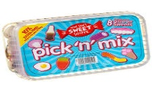
Spicy!!!
Medium
Mild

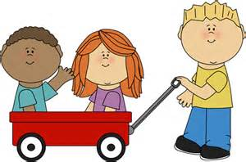  Communication and Language | Retell one of your favourite farming stories. It can be one you have read in class or at home.  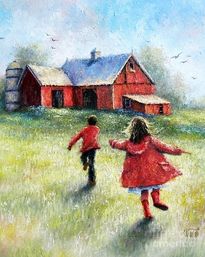 | We have heard of needle in a haystack, have you heard of tricky word in a haystack? Place tricky words in a haybale (or some straw) and rummage around for tricky words. | Visit your local farm and take pictures of your trip. After you have visited create your very own mini presentation about your exciting trip on the farm. What animals did you see? Did you feed them? What did they look like? Share your knowledge. 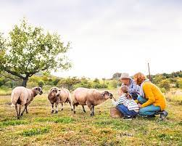 | Choose your own! What can you think of together?

Personal, Social and emotional Development.  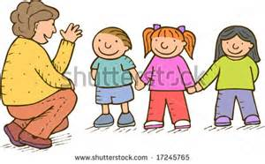 | Create your own mini booklet on how to care for a baby farm animal.  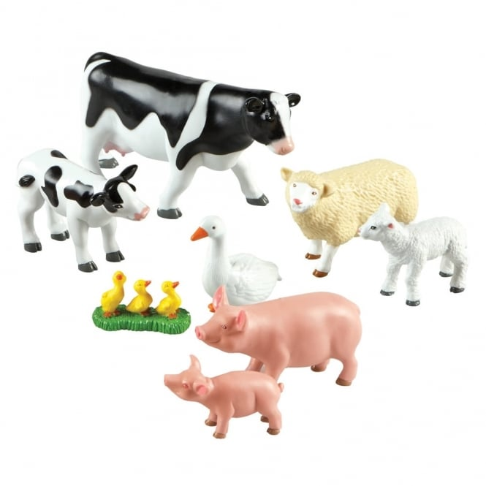 | Retell a grandparent a religious story you remember. It can be one you have learned/ are learning about at school or one at home.  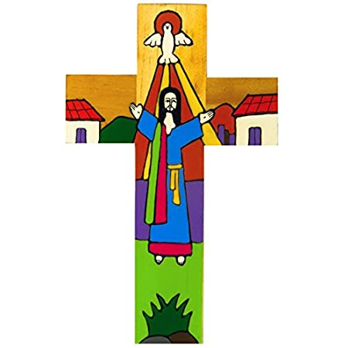 |  | Choose your own! What can you think of together?

Physical Development  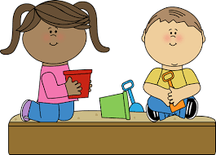 | Put your green fingered hands to the test. Every farmer needs to know how to look after living things. Help out in your own garden. If you do not have a garden then purchase some plants and tend them. 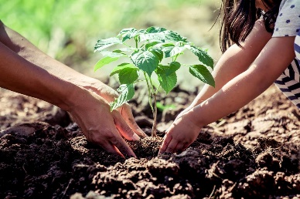 | Get out on your peddle tractors and bikes and get those feet working. Unbuckle your trailers and move those heavy loads. If you do not have a tractor, use your bike.  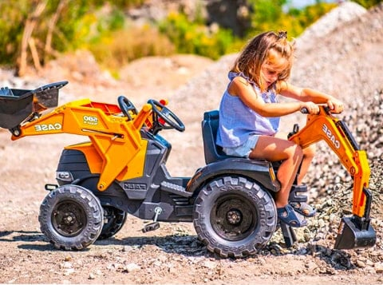 | Create or visit a farmyard obstacle race. Get climbing under those tractors, jumping over the wheels and running across those fields to get in those cheeky sheep.  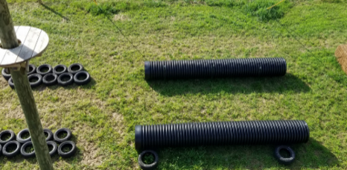 | Choose your own! What can you think of together?

Literacy  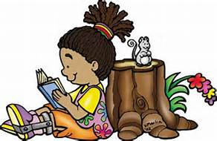 | Farmyard snap! Let your children write little farm flashcards (duck, cow, farm, soil etc.) have 2 sets and off you go. You can always tweak the game as you go. | Rewrite your own farming story. It can be a tale in the classroom or one of your favourites at home.  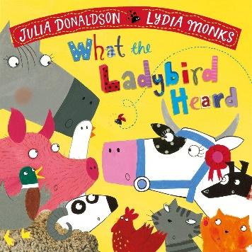 | This school has wonderful times to our community and the local farms and farmers. If you are related to any farmers ask them about a day in their lives, what does a farmer do? If you are not lucky enough to have a relative that is a farmer, research it.  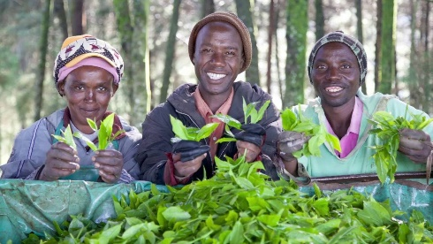 | Choose your own! What can you think of together?

Mathematics  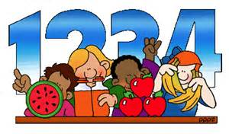 | Creating your own doubling ladybird for What the Ladybird Heard.  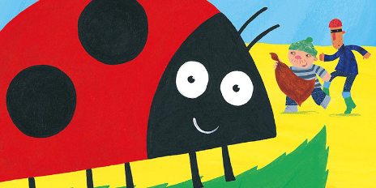 | Share your topping ingredients evenly by baking. You could make a Play-Doh cupcake, pizza or biscuits. Make sure each delicious item has the same amount of toppings. | Allow your children to hold the money in shops to familiarise themselves with money. If you are buying a carton of milk that costs £1.50 let them hold the 50p and work as a team to pay at the checkout. Money will mean much more to them that way.  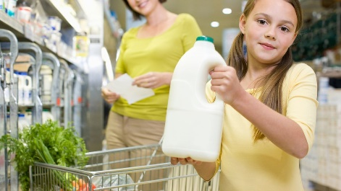 | Choose your own! What can you think of together?

Expressive arts and design  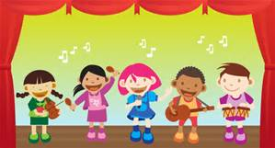 | Experiment with different materials to create animal covers (skins). 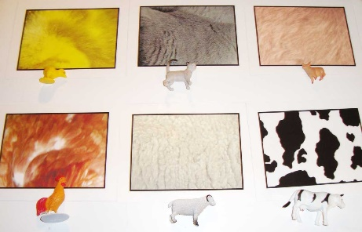 | For Mrs Davies Poetry challenge, record yourself preforming a poem of your choosing. | Create your own story spoons for a farm tale you love.  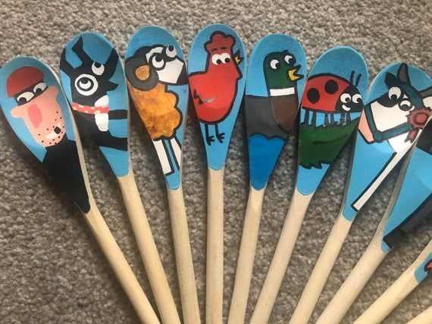 | Choose your own! What can you think of together?

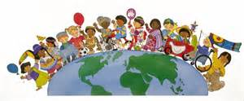  Understanding of the world | Create your own cress seed sheep. It will be great fun watching your fluffy friend grow and an opportunity to watch the plant grow.  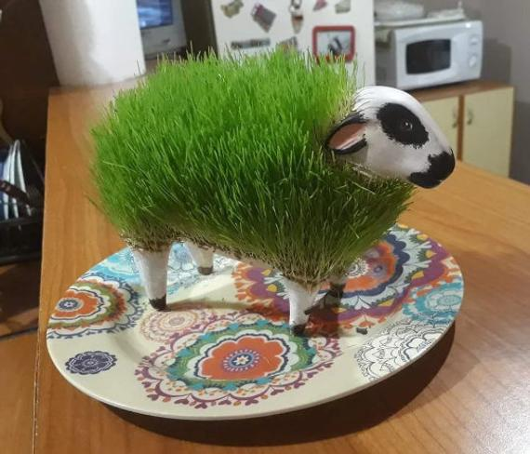 | Create your own baby farm animals fact file. Pick your favourite baby farm animals and describe how they change and what stays the same as they grow. | Make your own nature collection box with an egg box. Reduce, reuse, recycle and rethink! What will you discover in your garden or local area?  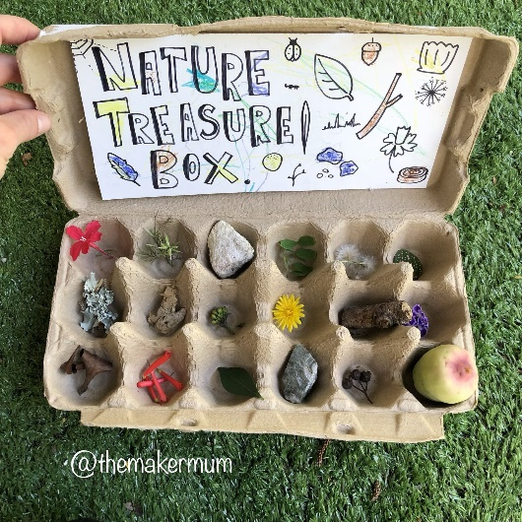 | Choose your own! What can you think of together?

