Pick and Mix Homework Menu
Topic – Space Author Study – Valarie Thomas and Korky Paul
At the unbelievable halfway point for the year – unbelievable! We are going to on a magical and scientific adventure with Winnie the Witch and space. I hope we all have a brilliant final half of our spring term and continue aiming for the stars. If you need any support, please contact me.

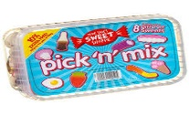
Spicy!
Medium
Mild

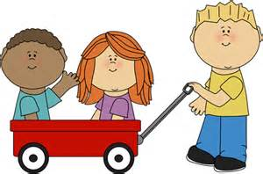  Communication and Language | Collect your coins on you Bug Club adventure. | Create your own Winnie silly sentences using your tricky words. How many tricky words can you use?  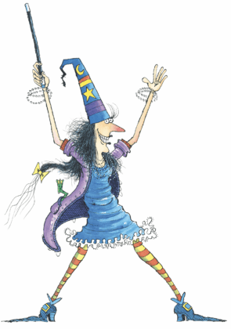 | For a story you have read at home answer questions on your favourite tale and then create your own! | Choose your own! What can you think of together?

Personal, Social, and emotional Development. | Join a new afterschool club to find a new passion, trying something new and make even more friends.  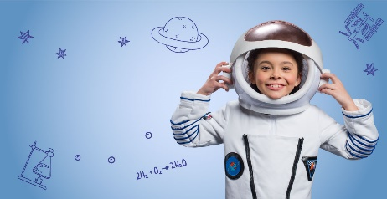 | Just like Winnie cares for Wilbur, create a log book for how you can care for God’s creatures or God’s world.  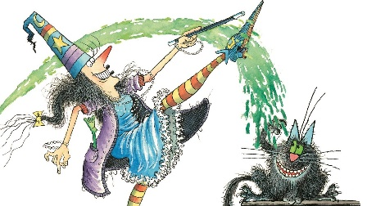 | Share the story of Jesus resurrection with you family. | Choose your own! What can you think of together?

Physical Development  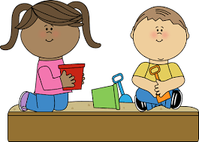 | Create your own Play-Doh and using your funky fingers make your own space scene. | It may be cold but let’s have a meteor fight (water balloon fight) use your agile movements and great overarm throwing.  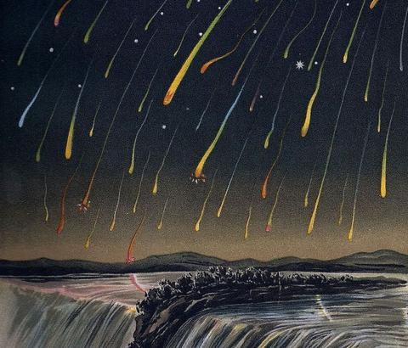 | Astronaut training! Sprint 110 yards, walk 110 yards. Time and track your results.  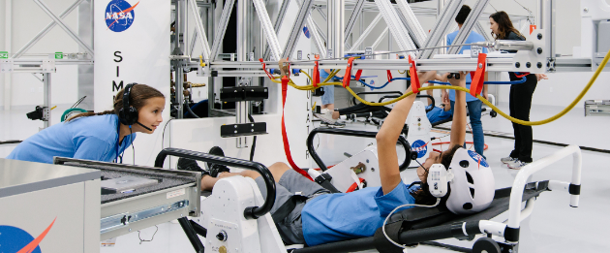 | Choose your own! What can you think of together?

Literacy | Digraph and trigraph sound hunt. Create your own or have someone hide them for you!  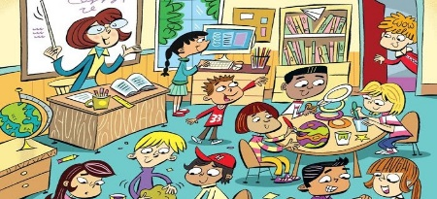 | From World Book Day, write your own story from your World Book Day character. | Become a star gazer or an entomologists. Make notes of what you observe.  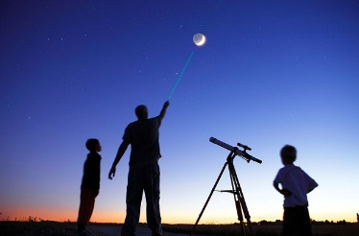 | Choose your own! What can you think of together?

Mathematics  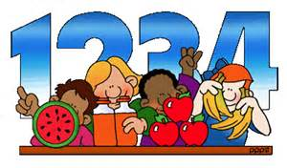 | Star jump counting – how high can you go! | Create your own 2d shape rocket!  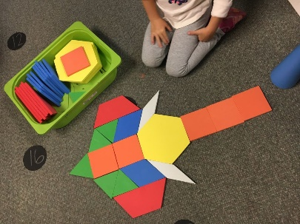 | Bake your own space themed biscuits. A great way to work on volume, capacity and counting. | Choose your own! What can you think of together?

Expressive arts and design  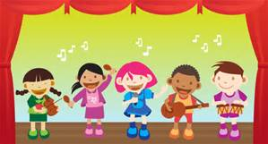 | Create your own bottle rocket. | Papier-mâché your own Earth or Moon! | Create your own space artwork of the solar system.  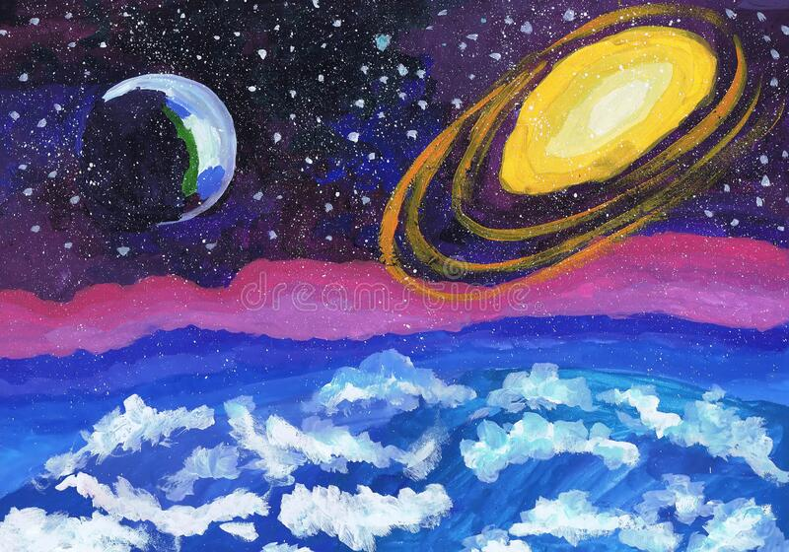 | Choose your own! What can you think of together?

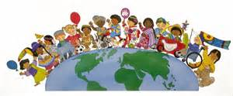  Understanding of the world | Launch your very own bottle rocket, how high can you go?  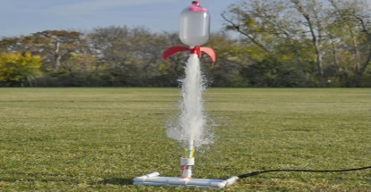 | Create your own crazy cress head for Winnie and watch her grow over this half term. 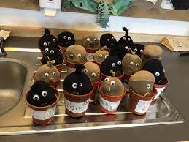 | Compare earth to other planets. Which are the similarities and what are the differences? | Choose your own! What can you think of together?

