Pick and Mix Homework Menu
Topic – Traditional Tales Author Study – Matty Long
To begin 2022 we shall be delving into Traditional Tales. Pendle class will be looking at classical stories to help fuel our learning. Running parallel to this topic will be Matty Long as his books are a real wonderland for children to fuel children’s imagination. Happy New Year everyone!

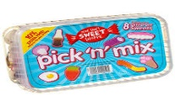
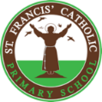
Spicy!!!
Medium
Mild

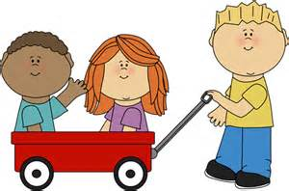  Communication and Language | Hide your phase 2/3 tricky words around the house and go on a word hunt. | Create a picture of your favourite character and describe them to your mummy or daddy. See if they can guess it.  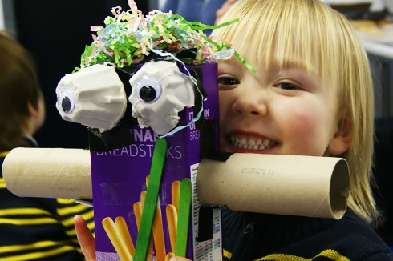 | Record yourself retelling your favourite Traditional Tale story. You can even use the face masks you made! | Choose your own! What can you think of together?

Personal, Social, and emotional Development.  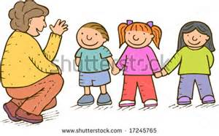 | Create a picture where you brought Jesus’ light into the world. What kind/caring things have you done?  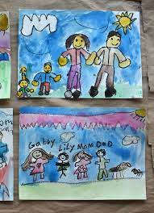 | Pretend you are the big bad wolf. Send an apology letter to the 3 little pigs for breaking 2 of their houses. | Tell your family about one of Jesus’ miracles.  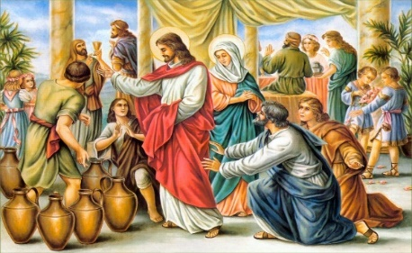 | Choose your own! What can you think of together?

Physical Development  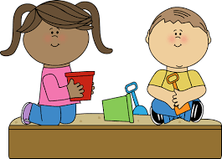 | Create your own target throw in your house. Show your best underarm throw.  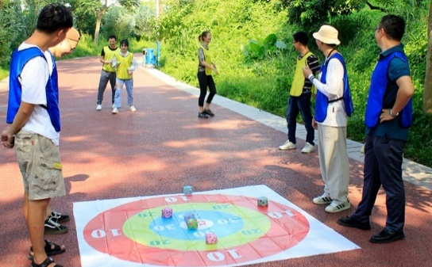 | Create your own hammer art of plants that are around your home. Explore the range of colours you can find.  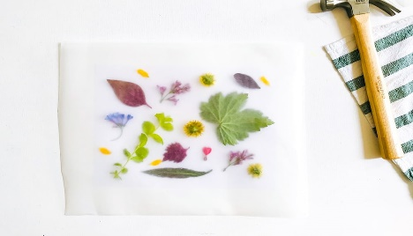 | Create your own giants treasure hoard. Place your favourite toys by a sleeping mummy or daddy, then tackle your obstacle course. Have something you can creep under and have something you can climb over then tiptoe to the finish. Don’t wake them up! | Choose your own! What can you think of together?

Literacy  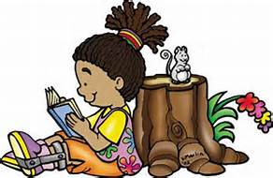 | Log onto Bug Club and collect 10 golden coins. Try the games or books. | Paint the baddie from a traditional tale and label it. You might label the big bad wolf’s sharp teeth or the giant’s enormous boots.  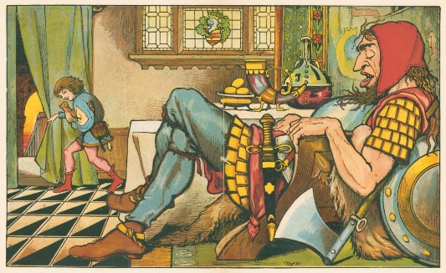 | Can you write your own favourite traditional tale? Do not forget your sound mat!  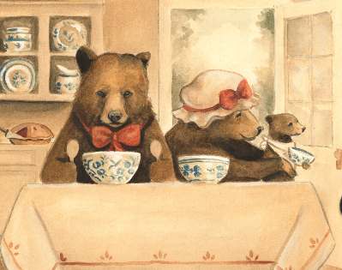 | Choose your own! What can you think of together?

Mathematics  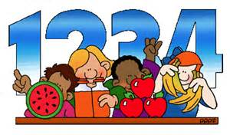 | Create your own number board poster. This will help you become a neat number writing master. | Create your own number bond rainbow to 10. Learn the relations number have with each other.  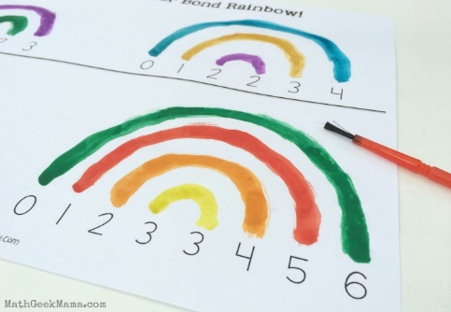 | Race against the clock and double. Using number cards be shown a number and quickly double it. You can collect your favourite toys, Jack’s magic beans or Grannie’s button box.  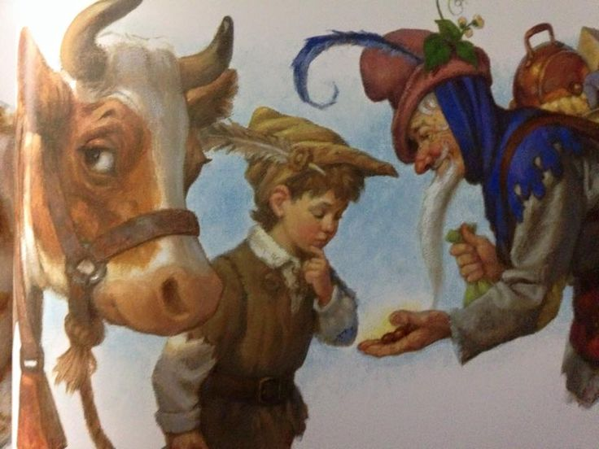 | Choose your own! What can you think of together?

Expressive arts and design  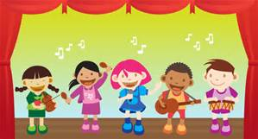 | Create face masks for your favourite traditional tales story.  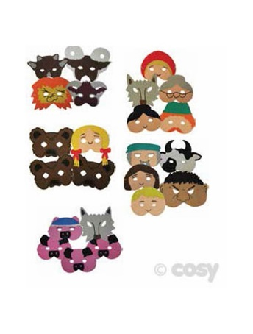 | Create your very own junk model castle in the sky! | Build your own 3 little pig’s house. Think what would be the best material to use to keep a big bad wolf out. | Choose your own! What can you think of together?

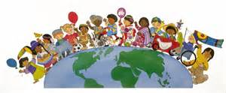  Understanding of the world | Go on a nature walk and create your very own nature box of the things you find. An egg box is great for this. | Become a weather reporter and observe the changing weather. If you really want to show off, get dressed up and record it! | Go out and visit a castle in your local area. I have provided you a list in your Curriculum Booklet.  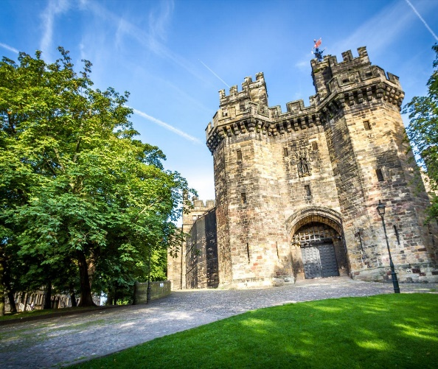 | Choose your own! What can you think of together?

