Pick and Mix Homework Menu
Topic – Winter Wonderland Author Study – Nick Butterworth
The final stretch to our very first term. The class have decided our topic will be Winter Wonderland to enchant and excite. We cannot wait to get started with this topic and will be drawing from a larger range of authors and use some Christmas magic to truly amaze. FANTASTIC!

Spicy!!!
Medium
Mild

Communication and Language | Discuss what you see in your environment around Christmas time. | Water pistols to ‘blast’ letter sounds Phase 2/3.Fastest blaster wins the round-keep a score board and tally your results.  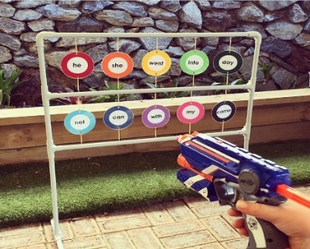 | Create your own sound speed wall and work on those sounds. You can use paints, pens, foam, mud or snow. Get saying those sounds loud and proud.  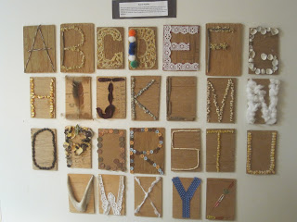 | Choose your own! What can you think of together?

Personal, Social, and emotional Development. | Discuss what is the meaning of Christmas? | Discuss the kind actions of Percy or another protagonist that you love reading about. 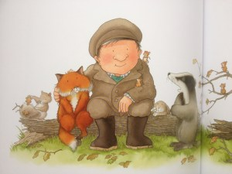 | Create your very own present filled shoebox for the Christmas appeal. | Choose your own! What can you think of together?

Physical Development | Percy cares for the world around him. Let’s do the same. Can you help something grow in the garden or create a fat ball to help birds in the winter? | Build your own snowman! If the snow does not come, use mash potatoes – IT WILL BE S-MASHING!  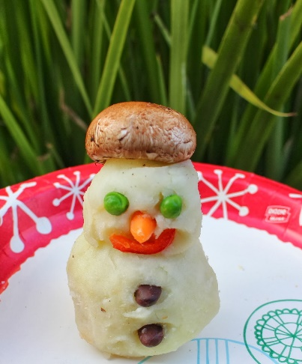 | Target throwing. Create your very own targets to kick or throw balls into to practise your keep eye. 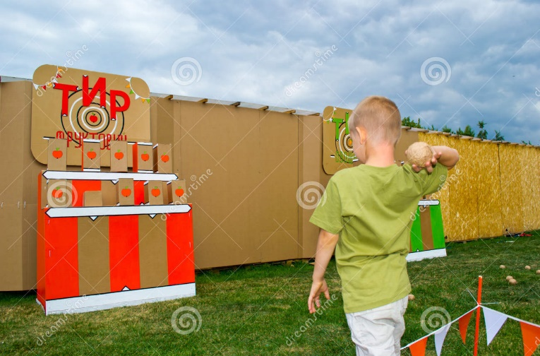 | Choose your own! What can you think of together?

Literacy | Get your funky fingers working and chop up or write out a Christmas list for Santa. | Create your own tricky word hunt for your friend and family to find. Remember to double check your spelling. | Show off you phonics knowledge by picking a tricky word and putting it in a silly sentence! | Choose your own! What can you think of together?

Mathematics  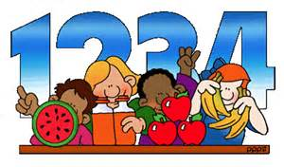 | Create your own festive pattern. 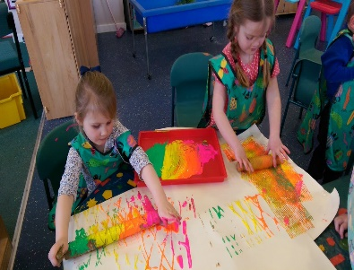 | Go on a number hunt and see what numbers you can find. | Count the different decorations on your Christmas tree and write down the total. | Choose your own! What can you think of together?

Expressive arts and design | Build or draw a picture of the nativity.  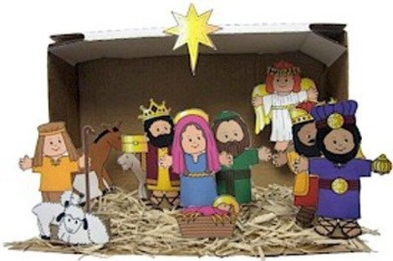 | Rehearse your Nativity songs! | Record yourself practising your favourite Christmas Carol, with or without your family. | Choose your own! What can you think of together?

Understanding of the world | Discuss the different significant characters in the nativity. | Make a minifact file of your favourite animals or the ones Percy encounters. 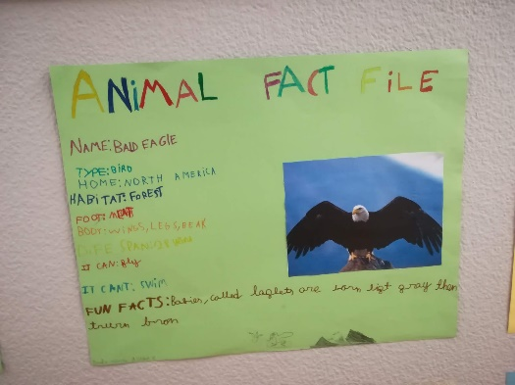 | Show off your green fingers for Percy and plant and care for your very own plant.  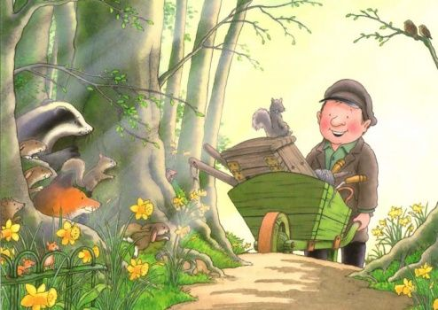 | Choose your own! What can you think of together?

