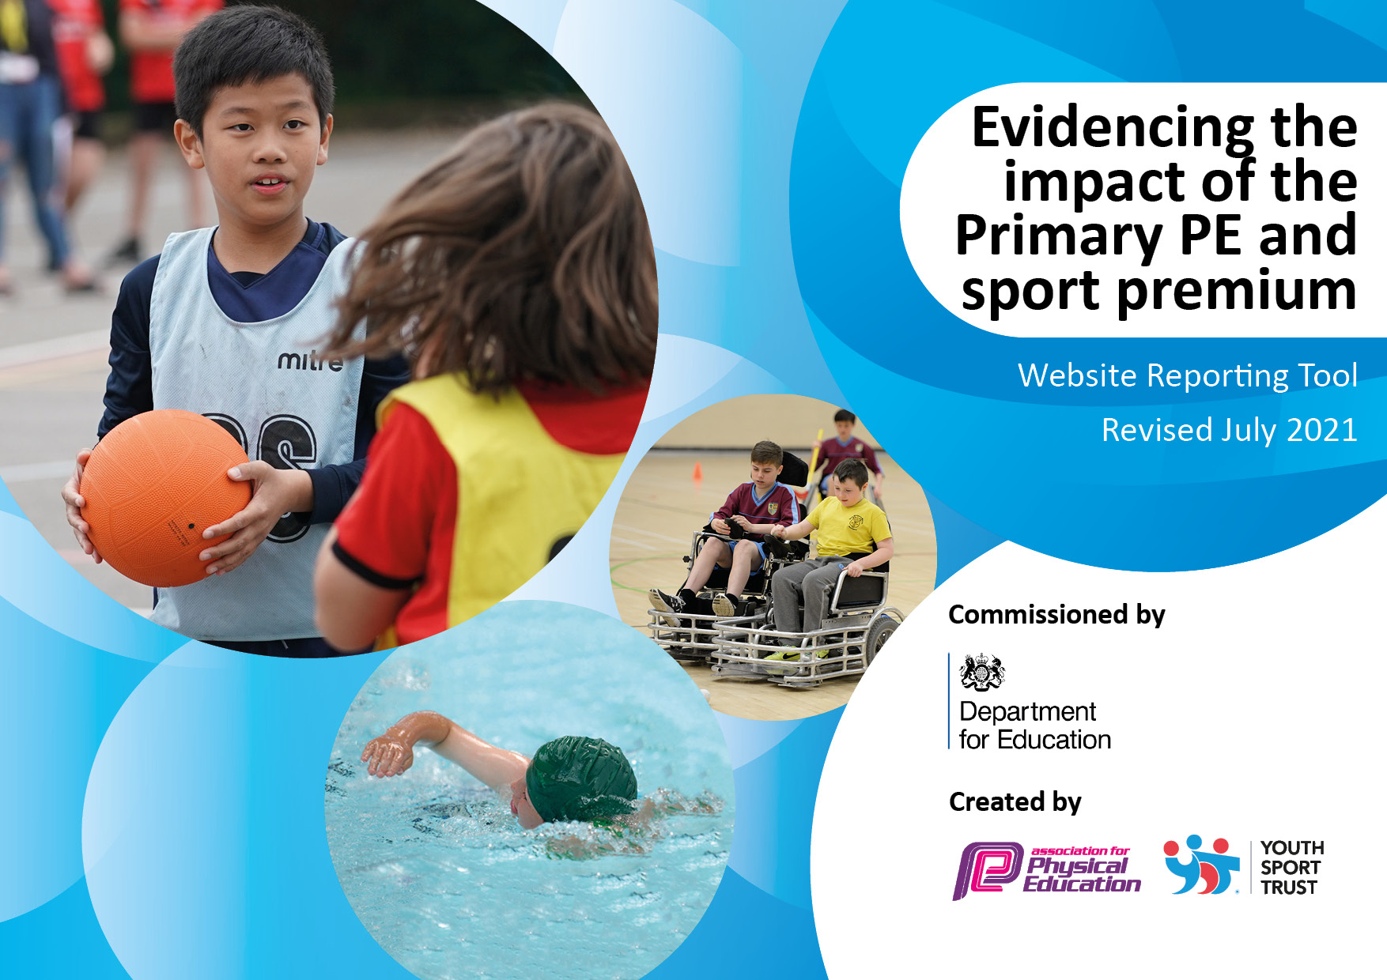
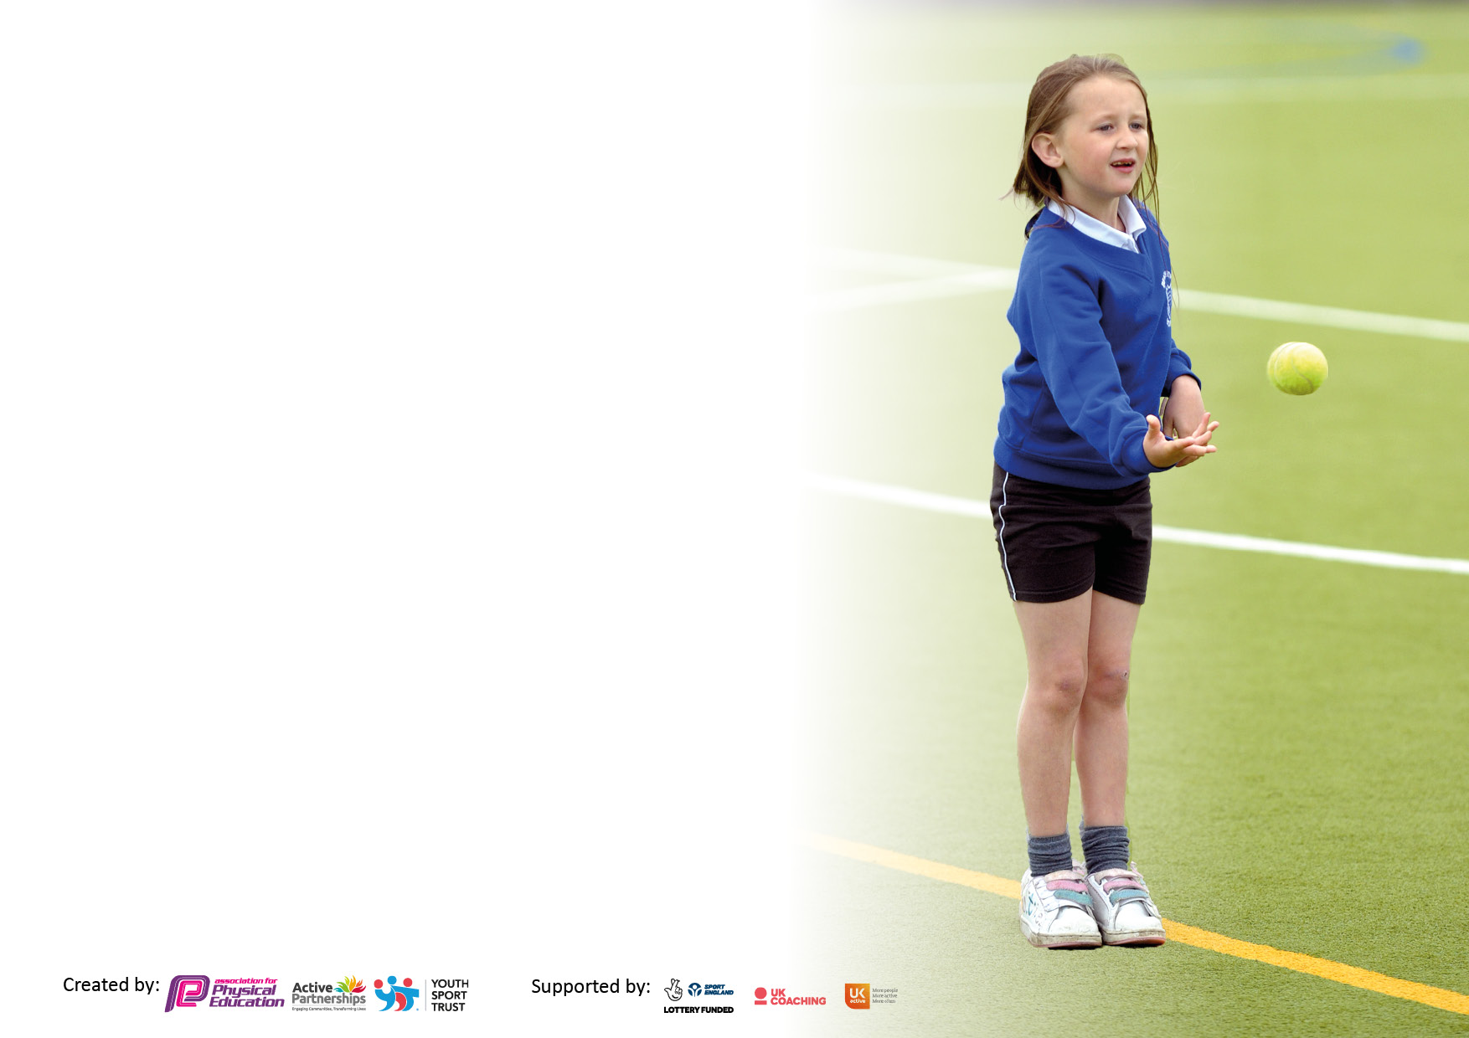

It is important that your grant is used effectively and based on school need. The Education Inspection Framework makes clear there will be a focus on ‘whether leaders and those responsible for governors all understand their respective roles and perform these in a way that enhances the effectiveness of the school’.

Under the Quality of Education Ofsted inspectors consider:
Intent - Curriculum design, coverage and appropriateness
Implementation - Curriculum delivery, Teaching (pedagogy) and Assessment
Impact - Attainment and progress

To assist schools with common transferable language this template has been developed to utilise the same three headings which should make your plans easily transferable between working documents.

Schools must use the funding to make additional and sustainable improvements to the quality of Physical Education, School Sport and Physical Activity (PESSPA) they offer. This means that you should use the Primary PE and sport premium to:

- Develop or add to the PESSPA activities that your school already offer
- Build capacity and capability within the school to ensure that improvements made now will benefit pupils joining the school in future years
- The Primary PE and sport premium should not be used to fund capital spend projects; the school’s budget should fund these.

Pleasevisitgov.ukfortherevisedDfEguidanceincludingthe5keyindicatorsacrosswhichschoolsshoulddemonstrate animprovement.Thisdocumentwillhelpyoutoreviewyourprovisionandtoreportyourspend.DfEencouragesschools to use this template as an effective way of meeting the reporting requirements of the Primary PE and sport premium.

We recommend you start by reflecting on the impact of current provision and reviewing the previous spend.

Schools are required to publish details of how they spend this funding, including any under-spend from 2019/2020, as well as on the impact it has on pupils’ PE and sport participation and attainment. All funding must be spent by 31st July 2022.

We recommend regularly updating the table and publishing it on your website throughout the year. This evidences your ongoing self-evaluation of how you are using the funding to secure maximum, sustainable impact. Final copy must be posted on your website by the end of the academic year and no later than the 31st July 2021. To see an example of how to complete the table please click HERE.

Details with regard to funding
Please complete the table below.

Total amount carried over from 2019/20 | £5000
Total amount allocated for 2020/21 | £16640
How much (if any) do you intend to carry over from this total fund into 2021/22? | £11500
Total amount allocated for 2020/21 | £5100
Total amount of funding for 2021/22 To be spent and reported on by 31st July 2022. | £31,620 next academic year and previous years amount
Swimming Data
Please report on your Swimming Data below.

Meeting national curriculum requirements for swimming and water safety.

N.B. Complete this section to your best ability. For example you might have practised safe self-rescue techniques on dry land which you can then transfer to the pool when school swimming restarts.
Due to exceptional circumstances priority should be given to ensuring that pupils can perform safe self rescue even if they do not fully meet the first two requirements of the NC programme of study
What percentage of your current Year 6 cohort swim competently, confidently and proficiently over a distance of at least 25 metres?  N.B. Even though your pupils may swim in another year please report on their attainment on leaving primary school at the end of the summer term 2020.  Please see note above | 100%
What percentage of your current Year 6 cohort use a range of strokes effectively [for example, front crawl, backstroke and breaststroke]?  Please see note above | 100%
What percentage of your current Year 6 cohort perform safe self-rescue in different water-based situations? | 100%
Schools can choose to use the Primary PE and sport premium to provide additional provision for swimming but this must be for activity over and above the national curriculum requirements. Have you used it in this way? | Yes – £1000 for additional lessons

Action Plan and Budget Tracking
Capture your intended annual spend against the 5 key indicators. Clarify the success criteria and evidence of impact that you intend to measure to evaluate for pupils today and for the future.

Academic Year: 2020/21 | Total fund allocated:16,660 | Date Updated: July 2021
Key indicator 1: The engagement of all pupils in regular physical activity – Chief Medical Officers guidelines recommend that primary school pupils undertake at least 30 minutes of physical activity a day in school |  |  |  | Percentage of total allocation:
 |  |  |  | 2%
Intent | Implementation |  | Impact
Your school focus should be clear what you want the pupils to know and be able to do and about  what they need to learn and to  consolidate through practice: | Make sure your actions to achieve are linked to your intentions: | Funding allocated:£550 | Evidence of impact: what do pupils now know and what can they now do? What has changed?: | Sustainability and suggested next steps:
Allow all children to access sports activities at lunch times and break times | Put a sports coach in to run clubs at lunch time and break time/after school club | £550 | Children were trained to run their own groups as well as taking part in a range of sports | Covid interrupted the process, hopefully the children can continue to run sports activities next year
Key indicator 2: The profile of PESSPA being raised across the school as a tool for whole school improvement |  |  |  | Percentage of total allocation:
 |  |  |  | 0%
Intent | Implementation |  | Impact
Your school focus should be clear what you want the pupils to know and be able to do and about  what they need to learn and to  consolidate through practice: | Make sure your actions to achieve are linked to your intentions: | Funding allocated: | Evidence of impact: what do pupils now know and what can they now do? What has changed?: | Sustainability and suggested next steps:
All sporting achievements reported to the parents via the weekly school newsletter which is also available on the school website.  Successes shared via social media.  Celebrate children’s successes and achievements of PE and sport both within school and within external clubs and competitions.  Photographs to be displayed on school noticeboards and on the website.  Parents are engaged in their children being fit and healthy and actively encourage it. | Sporting excellence is shared across the school to promote sporting activities and keeping fit and healthy. | £0 | Children continue to take part in sports events inside of school and outside of school | Sport is continued to be promoted across the school website and social media

Key indicator 3: Increased confidence, knowledge and skills of all staff in teaching PE and sport |  |  |  | Percentage of total allocation:
 |  |  |  | 0.5%
Intent | Implementation |  | Impact
Your school focus should be clear | Make sure your actions to | Funding | Evidence of impact: what do | Sustainability and suggested
what you want the pupils to know | achieve are linked to your | allocated: £300 | pupils now know and what | next steps:
and be able to do and about | intentions: |  | can they now do? What has
what they need to learn and to |  |  | changed?:
consolidate through practice:
Continuing the hold staff meeting regarding the PE app to promote confidence and skills in teaching PE following previous year’s coaching from Preston North End Community Sports programme  Develop Mr. McGill as a new subject PE leader | Regular meeting regarding using the app – supported by SLT  Potential observations – covid affected.  Mr. McGill to lead PE curriculum and Sports activities across school | £300  £0 | Staff are more confident delivering PE, with the supportive planning and supportive videos.  Mr. McGill to attend training course and PE subject leader courses | The standard of PE teaching is consistent across school  Having more PE leaders within school to promote the PE curriculum and sports acitivites
Key indicator 4: Broader experience of a range of sports and activities offered to all pupils |  |  |  | Percentage of total allocation:
 |  |  |  | 24%
Intent | Implementation |  | Impact
Your school focus should be clear | Make sure your actions to | Funding | Evidence of impact: what do | Sustainability and suggested
what you want the pupils to know | achieve are linked to your | allocated:  £4000 | pupils now know and what | next steps:
and be able to do and about | intentions: |  | can they now do? What has
what they need to learn and to |  |  | changed?:
consolidate through practice
To bring in a range of sports, through Judo education. Through Covid this is not possible.  Use the anomaly screen for children to experience dance, outdoor activities and activities to keep fit. To be used a playtimes, children supported by a member of staff.  Take an inventory of the current set of sporting equipment we have on offer and improve teaching resources for all sports – to be used for the curriculum, playtimes and after school activities | Bring Judo Education in after covid  Staff to support and facilitate the use of the anomaly screen.  Up-to-date equipment for use across all key stages | £2000  £2000 | Children take part in a range of sporting activities that are on offer at playtimes.  Children take part in a range of sporting activities that are on offer at playtimes.  New equipment allows for staff to teach all areas of PE. Children have the opportunity to take part | Look into Judo education next year  Train further staff and pupils up to use the screen.  A future inventory to ensure we have all required equipment

Key indicator 5: Increased participation in competitive sport |  |  |  | Percentage of total allocation:
 |  |  |  | 0.5%
Intent | Implementation |  | Impact
Your school focus should be clear | Make sure your actions to | Funding | Evidence of impact: what do | Sustainability and suggested
what you want the pupils to know | achieve are linked to your | allocated: £200 | pupils now know and what | next steps:
and be able to do and about | intentions: |  | can they now do? What has
what they need to learn and to |  |  | changed?:
consolidate through practice:
Children to actively take part in sporting competitions | With the limitations due to covid, we will compete virtually with the sports organiser coming into school | £250 | The children enjoy competing. We ensure all children across the school are able taking part in a sports competition | After Covid, keeping up the sports events – hopefully competing against other schools.

Signed off by
Head Teacher: | Sarah Deakin
Date: | 07/21
Subject Leader: | James Gilmour/Josh McGill
Date: | 07/21
Governor: | Michael Blair
Date: | 07/21

