Read every day. Try to read a variety of book genres eg. science fiction, adventure stories, legends, biographies, poetry and information texts.  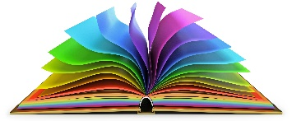 | Computing Design an online safety poster that can be displayed in the classroom.  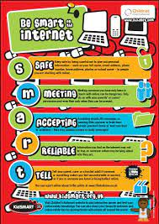 | Science The theme of World Space Week 2021 is 'Women in Space'. Create your own space themed fact file with fascinating facts about inspirational ‘Women in Space’. What can you find out about Katharine Coleman Goble Johnson?  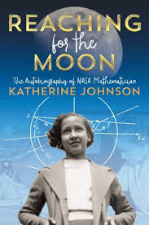 | DT Get creative…design a healthy picnic for your family. Can you identify the food groups that your delicious delights belong to?In  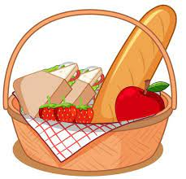
Art Sketch, paint or make 3-D models of food items.  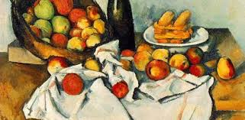 | Maths Learn the times tables you are not confident with. Make posters to help you remember them. Ask someone at home to test you with quick-fire questions. Practise on: https://play.ttrockstars.com  Have fun practising and applying your other maths skills on: Prodigy:https://play.prodigygame.com | English Create your own poetry collection. You could use food as your inspiration; Just enjoy being a poet!  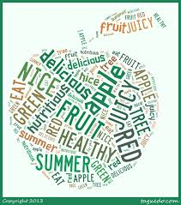 | RE In preparation for the feast of St.Francis, carry out some research and design a fact file for our patron Saint.  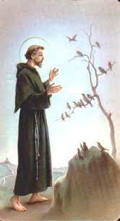
Fairsnape Class Pick And Mix Homework Menu
Topic – Healthy Humans
In the table, there are lots of different homework activities to choose from. You MUST complete the activities that are coloured green every week. Try and do as many of the others as you can and be creative!

