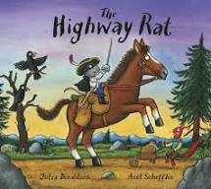
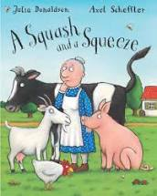
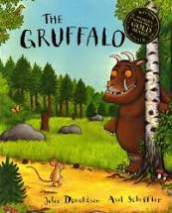
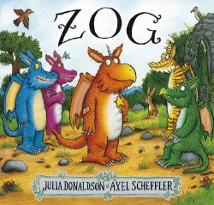
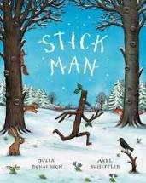
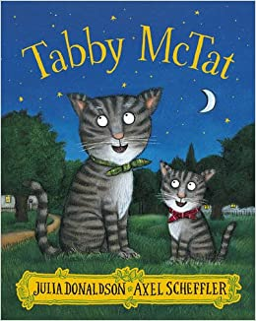
Pick and Mix Homework Menu
Topic – All About Me
Author Study – Julia Donaldson

.

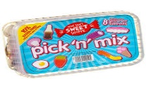
Spicy!!!
Medium
Mild

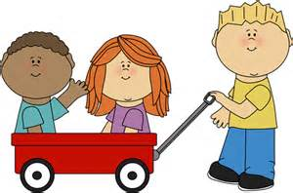  Communication and Language | Go on a sound hunt in the house, garden or just out and about. Put those amazing phonics skills to the test.  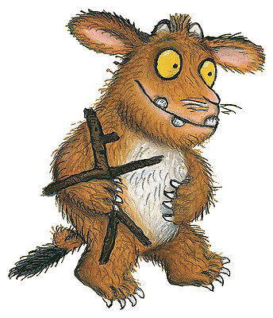 | Head Bands! Allow your child to design their own headband cards. You will then place the card on your head and guess what it is using the description provided by the other person. Remember - no peaking! | Tricky word hopscotch – in your garden or street write out these tricky words – I, go, no, to, the, into. Jump from spot to spot saying the words as you go along.  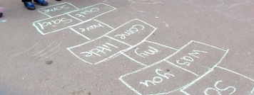 | Choose your own! What can you think of together?

Personal, Social and emotional Development. | Create your own Mini-Me and place him/her into a story. What are you great at? What do you like to do?  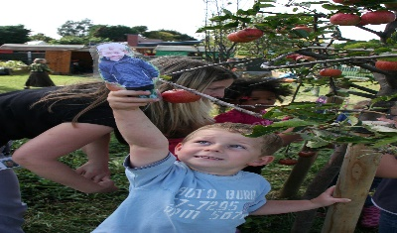 | Discuss how we can show kindness to an upset friend. You can write, act out or draw a picture of your idea.  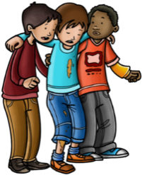 | Make a ‘Carebook’ in which you can show how you care and look after your pets by loving, feeding, bathing and general care. You may have a cat or a horse it does not matter, they all need our love. If you don’t have a pet, show your love and caring nature to a family member. | Choose your own! What can you think of together?

Physical Development  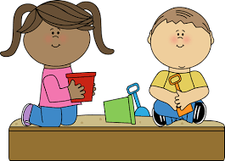 | Can you help out in the Garden in anyway you can? This may be digging up weeds, dead heading plants or sweeping up. Get out there and get active! | Make your own healthy food plate, showing a healthy balanced diet. Cakes may be delicious but are certainly not the only thing we should eat.  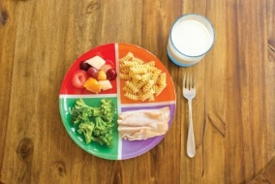 | Make your own obstacle course with your family in the garden and give it a go. Test out your jumping, hopping and running skills.  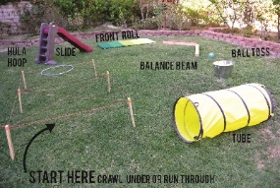 | Choose your own! What can you think of together?

Literacy | Work on the letters that make up your name, at the end you will hopefully be able to write your name! You can write it as many times you want in paint, pencils, glitter, sand etc. Just try your best.  . | Have a go writing our tricky words, you can write them in the bath, on a window, with a paintbrush or in your book. You can even hide them after and go on a hunt for them. | Create your own story stones and discuss one of Julia Donaldson’s stories together. | Choose your own! What can you think of together?

Mathematics  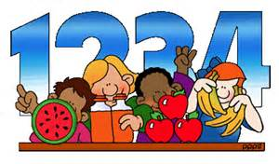 | Create a number line to 10. You can use whatever materials you like, just try your best to count carefully to 10. It will help you keep track with your counting in the future. | You are the Highway Rat and you need to count up todays taking. Can you gather up the best (or perhaps most delicious) things you can find. You count up all the cakes, coins and other treasures you have pinched?  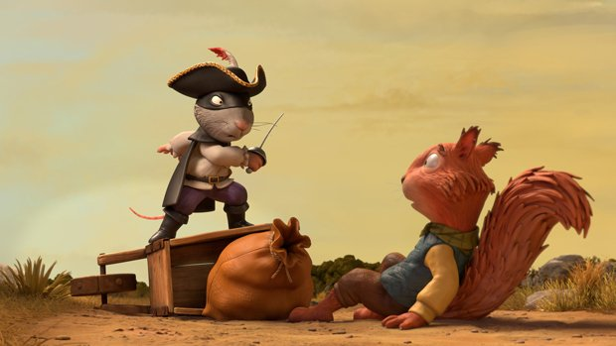 | Can you combine items and add them together? It could be 2 hats and 3 shoes (2+3=5) You can carry out as many calculations you want, make sure you keep switching the numbers and items around to make it fun!  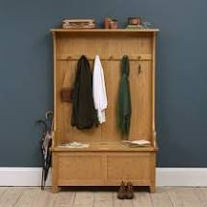 | Choose your own! What can you think of together?

Expressive arts and design | Get outdoors and using the materials you collect and find create your own outdoor collage.  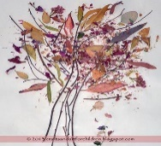 | Practice and preform your very own nursery rhyme song. | Junk model your own Gruffalo! Remember, he has terrible tusks and terrible claws and terrible teeth in his terrible jaws, he is the Gruffalo!  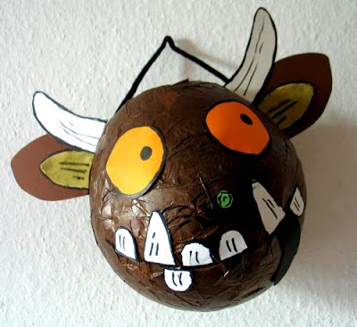 | Choose your own! What can you think of together?

Understanding of the world | Log into your Minimash account and save a piece of work you’ve done in your tray.  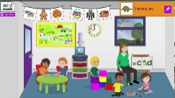 | Use a computer, tablet or draw your family tree. You can go as far back as you wish.  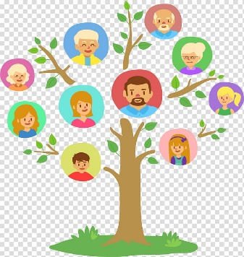 | Be a weather reporter over the weekend and discuss the changing weather. You can write it, draw it, take pictures or act it out on camera. | Choose your own! What can you think of together?

