Summer Term 2 Topic – Farming
Just like that we have reached our final half term. It is always unbelievable looking back and seeing how fast time goes and how much we have all grown. Our final topic chosen by the class will be farming. We will explore a range of great farm themed stories and use that inspiration to fuel our love or learning. Thank you all for your support with your home learning – keep it up!

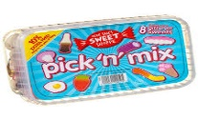
Spicy!!!
Medium
Mild

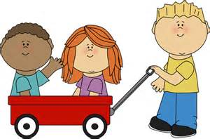  Communication and Language | Retell one of your favourite farming stories. It can be one we have read in class or at home.  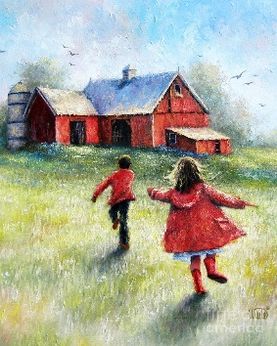 | We have heard of needle in a haystack, have you heard of tricky word in a haystack? Place tricky words in a haybale (or some straw) and rummage around for tricky words. | Visit your local farm and take pictures of your trip. After you have visited create your very own mini presentation about your exciting trip on the farm. What animals did you see? Did you feed them? What did they look like? Share your knowledge. 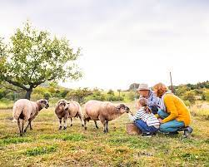 | Choose your own! What can you think of together?

Personal, Social and emotional Development.  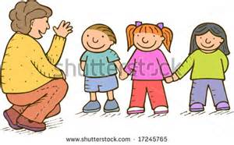 | Create your own mini booklet on how to care for baby farm animals.  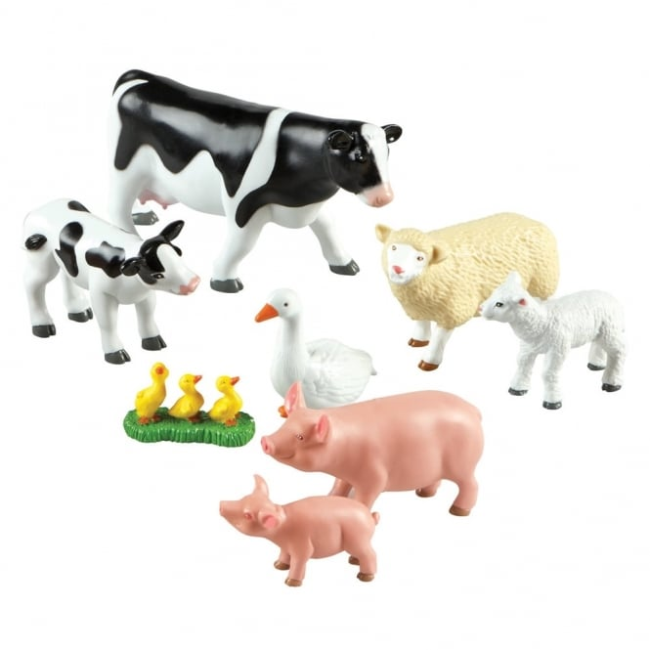 | Retell a grandparent a religious story you remember. It can be one you have learned/ are learning about at school or one at home.  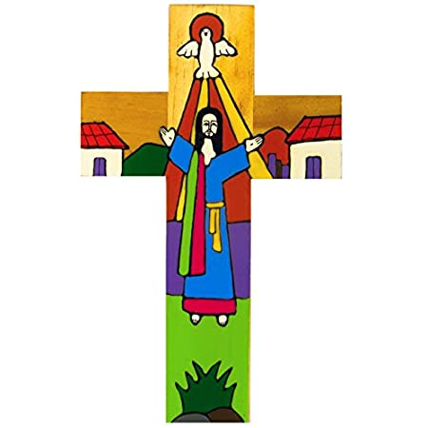 | Write what you are most excited about entering year 1. | Choose your own! What can you think of together?

Physical Development  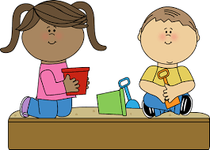 | Put your green fingered hands to the test. Every farmer needs to know how to look after living things. Help out in your own garden. If you do not have a garden then purchase some plants and tend them. 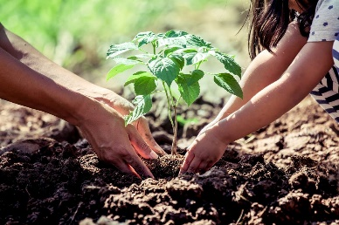 | Get out on your peddle tractors and bikes and get those feet working. Unbuckle your trailers and move those heavy loads. If you do not have a tractor, use your bike. 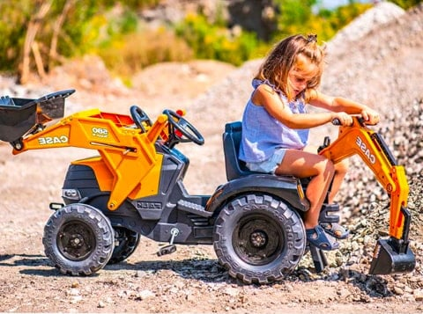 | In preparation for sports day. Work on running races, obstacle courses, ball dribbling and relay running. Ready! Steady! Go! | Choose your own! What can you think of together?

Literacy  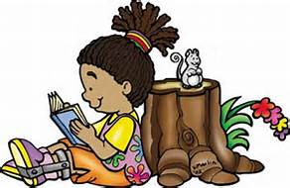 | Farmyard snap! Let your children write little farm flashcards (duck, cow, farm, soil etc.) have 2 sets and off you go. You can always tweak the game as you go. | Rewrite your own farming story. It can be a tale in the classroom or one of your favourites at home.  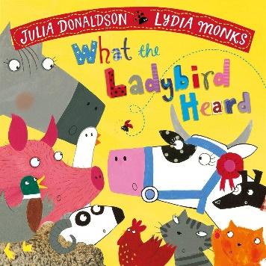 | This school has wonderful times to our community and the local farms and farmers. If you are related to any farmers ask them about a day in their lives, what does a farmer do? If you are not lucky enough to have a relative that is a farmer, research it.  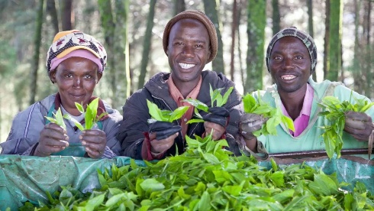 | Choose your own! What can you think of together?

Mathematics  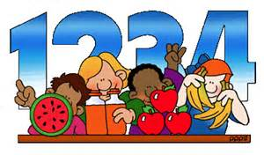 | Create your own 2d or 3d junk model farm.  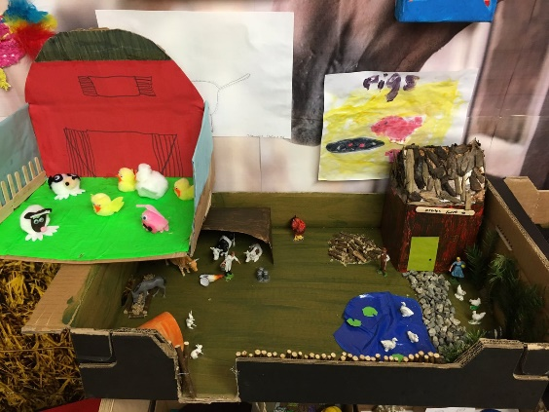 | Make your very own farmshop and swap roles of customer and shopkeeper. Don’t forget the change. | Allow you children to hold the money in shops to familiarise themselves with money. If you are buying a carton of milk that cost £1.50 let them hold the 50p and work as a team to pay at the checkout. Money will mean much more to them that way.  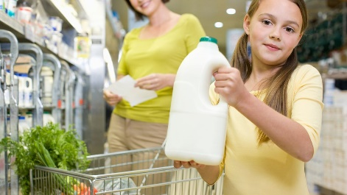 | Choose your own! What can you think of together?

Expressive arts and design  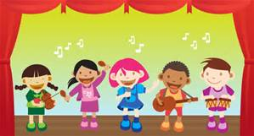 | Experiment with different materials to create animal covers (skins). 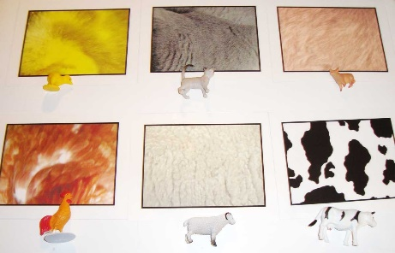 | Use Chrome Music Lab to create your very own musical rendition of Ba Ba Black Sheep.  https://musiclab.chromeexperiments.com/ | Create your own story spoons for a farm tale you love.  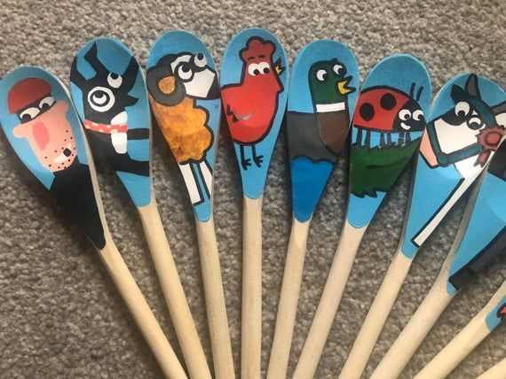 | Choose your own! What can you think of together?

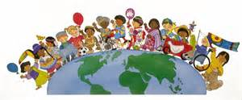  Understanding of the world | Create your own cress seed sheep. It will be great fun watching your fluffy friend grow and observe the plant grow.  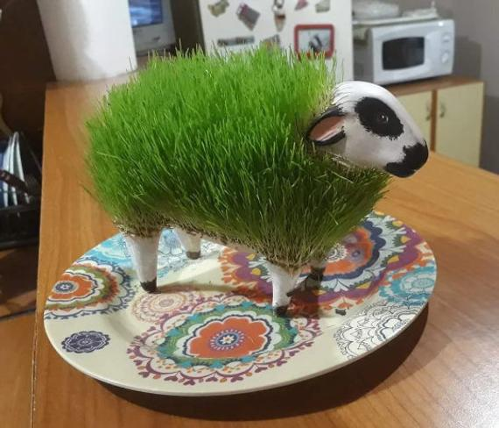 | Before you have your poached egg with soldiers. Compare the difference between a boiled egg, soft boiled and raw egg. It will broaden the vocabulary to make these kind of observations. (Be careful!)  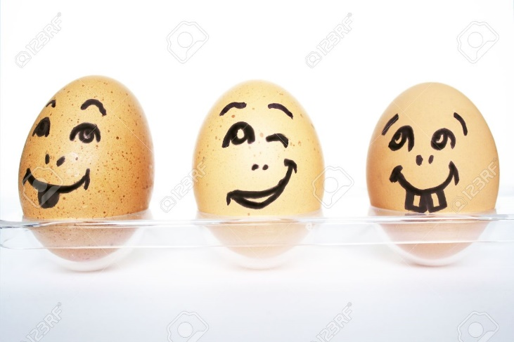 | Make your own nature collection box with an egg box. Reduce, reuse, recycle and rethink! What will you discover in your garden, local area?  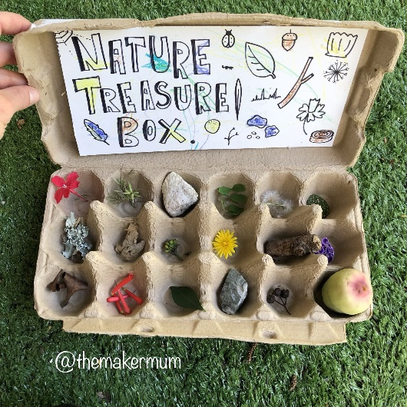 | Choose your own! What can you think of together?

