Summer Term Topic – Dinosaurs
We have moved into the glorious summer term and we are ready for a glorious finish! In the first half of the term we are going to be learning about Dinosaurs and following the wonderful author Ian Whybrow. As we explore this topic we will be going back in time and looking at the world and the marvellous places dinosaur fossils have been found. This is going to be a fantastic term team – hooray!

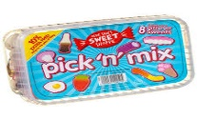
Spicy!
Medium
Mild

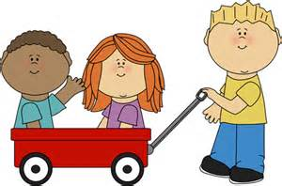  Communication and Language | 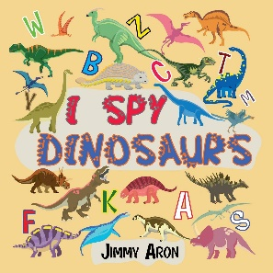  Play dinosaur I Spy. See if you can give any special clues linking to what you see. Just do not give it away! | 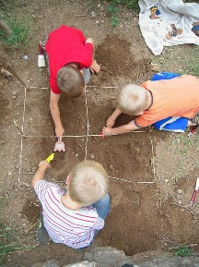  Burry some tricky words on pieces of rock, wood or plastic and go on a archaeologist hunt looking for them. | One glorious thing we had together during lockdown was stories! Can you record yourself reading a story you love from your library or one of your stories with a twist. | Choose your own! What can you think of together?

Personal, Social and emotional Development. | 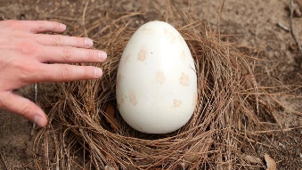  Discuss where the dinosaur egg came from. How could you look after it? | Play your favourite board game with your family. It is not about winning or losing, it is about enjoying time together. 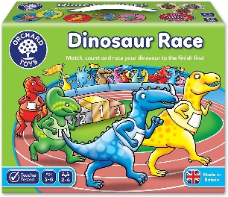 | Work as a team and create your own enormous dinosaur. Remember to listen that is helping you. Decorate, design and name it together!  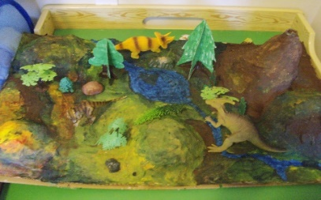 | Choose your own! What can you think of together?

Physical Development | Make your own dinosaur fossils using clay or playdoh and pressing shells, twigs pebbles.  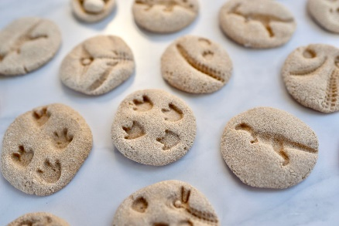 | Record yourself singing and preforming actions to the ‘Things for Fingers’ song. You are very welcome to show a song that has funky action too.  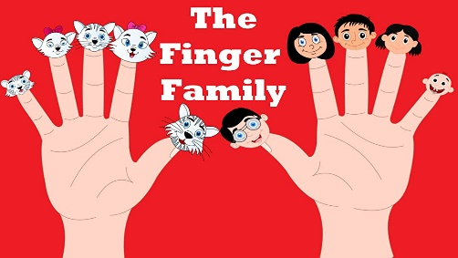 | Create your very own active journal. When you accomplish something amazing put it in your journal. You might have walked Pendle Hill (or gone for a big walk) learned to ride your bike, tried swimming for the first time. You decide what goes on your list. At the end you will have a list of marvellous accomplishments and memories. | Choose your own! What can you think of together?

Literacy  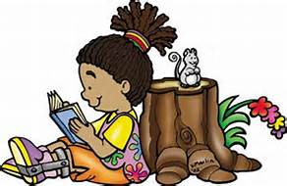 | Go on a tricky word hunt around the house. You may wish to only pick words you find particularly tricky. | Paint your own dinosaur picture and label it where you can. You can really show off by putting your words into a sentence.  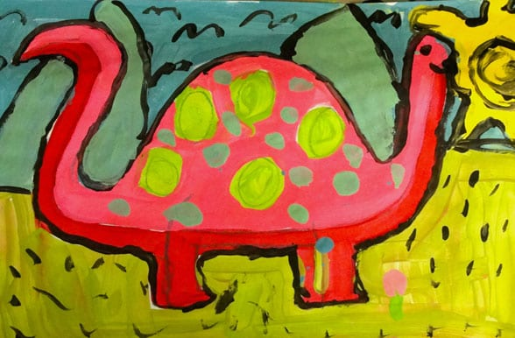 | Create your own dinosaur storybook. You can use other stories to influence you. | Choose your own! What can you think of together?

Mathematics  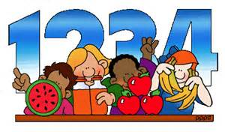 | Organise and sort money into the right section. I would recommend to use 1p, 2p, 5p, 10p and 20p coins. You are very welcome to go higher.  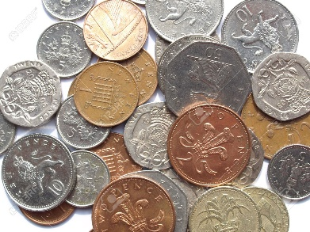 | Estimate how many dinosaurs you can see. You will have to make reasonable judgements on whether you are close. 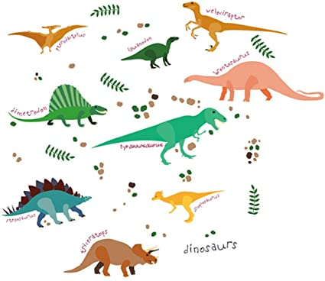 | Create your own shop and sell items to your family and friends. Make sure they pay you correctly!  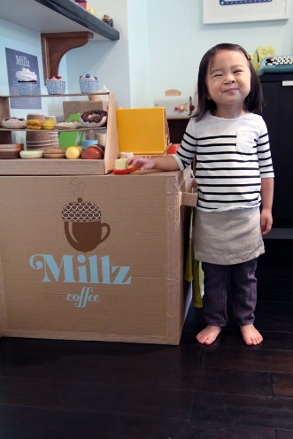 | Choose your own! What can you think of together?

Expressive arts and design | Create a picture or collage of your very own dinosaur. She/he can be based on a real dinosaur or you can design your own! Experiment with colour and texture.  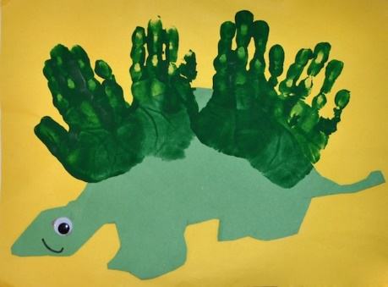 | Using some background music can you move like your favourite dinosaur? Would you have to duck under trees? Can fly across the sky? Are you a fast swimmer? Once you know the answer see if you can move around the room like your dinosaur. 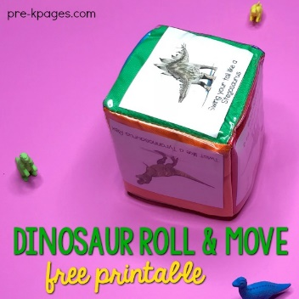 | Using large boxes or smaller construction kits such as Lego. Have a go at making a vehicle to escape from the dinosaurs.  Take photos of your vehicle!  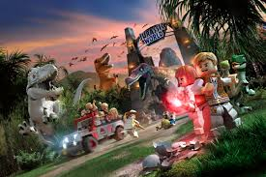 | Choose your own! What can you think of together?

Understanding of the world | If you are mesmerised by dinosaurs, then the Natural History museum is where to go. Please click the link and enjoy!  https://www.nhm.ac.uk/discover/dinosaurs.html | Build your own baking soda volcano. Can you find out what happens to the lava when it cools? | Write your own fact file about dinosaurs, it can be as big and funky as you want! Fill it with all the facts you are interested about!  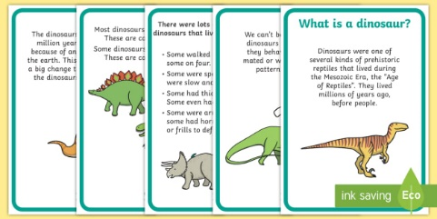 | Choose your own! What can you think of together?

