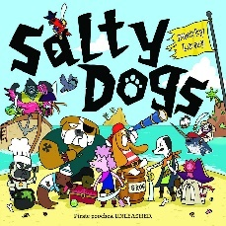
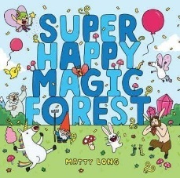
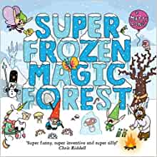
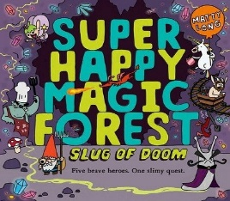
Pick and Mix Homework Menu
Topic – Castles, Princesses and Mythical Creatures
Author Study – Matty Long

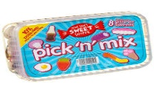
Spicy!!!
Medium
Mild

Communication and Language | Draw and describe the heroes you find in the Super Happy Magic Forest or your story of choice. I bet you can think of great ideas. | Water pistols to ‘blast’ letter sounds Phase 2/3 when catch a sound. Fastest blaster wins the round-keep a score board and tally your results.  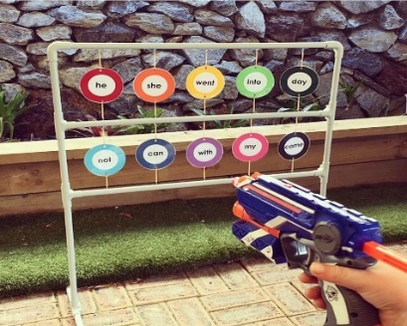 | Rhyming card snap! Write out your own words with rhyming pairs and play a game of snap, how quick can you be? | Choose your own! What can you think of together?

Personal, Social and emotional Development. | Heroic traits! Talk with your family about what makes a superhero super!  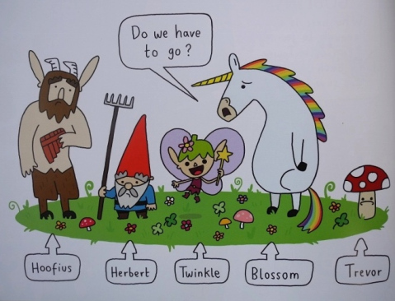 | Create your own pots of feelings. You might want to colour code the pots or wool ball for a distinct emotion. Talk about what makes you feel that emotion and how you help fix the more negative emotions. 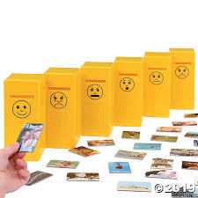 | Discuss all the things that you are super at and what you would like to get better at. You can do anything if you put your mind to it!  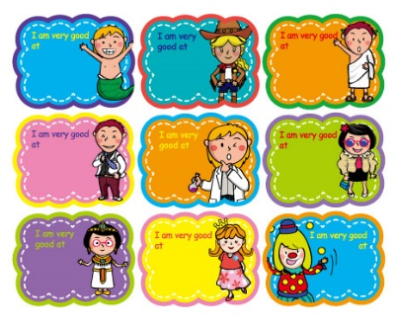 | Choose your own! What can you think of together?

Physical Development | Backyard balance tightrope. If you can tie 2 ropes from one end of the garden to another. If you cannot use ropes, walk on a chalk line, just don’t fall! 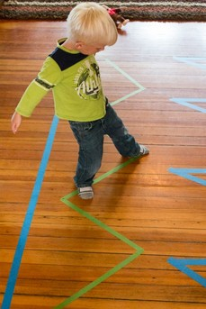 | Poppy threading or finger painting. Create your own Poppy for Remembrance Day that you have knitted with an adult or made yourself. 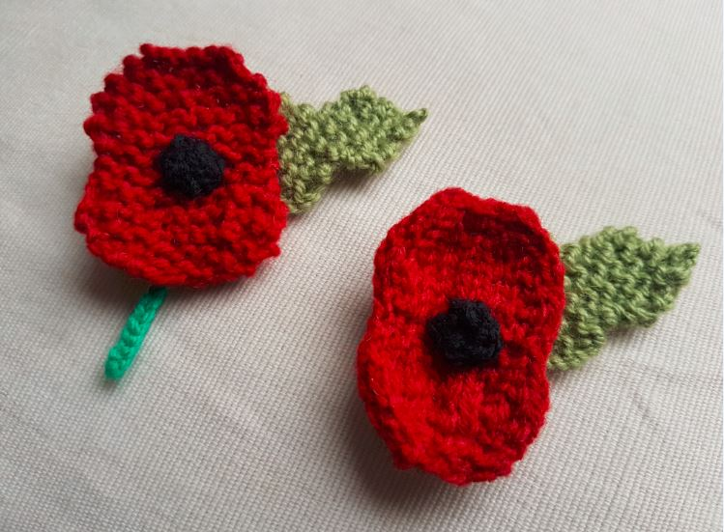 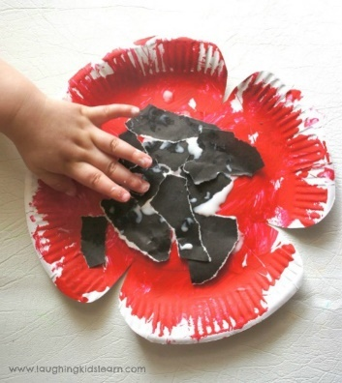 | Super scooter dash. You can show off your skills on a scooter, bike, skateboard, or anything else. Like any superhero you need to get to places quickly. Show off your speedy ways. | Choose your own! What can you think of together?

Literacy | Snail Slime writing tray, to keep writing fun and hands on. Fill a tub with slime and use it to write your tricky words – enjoy!  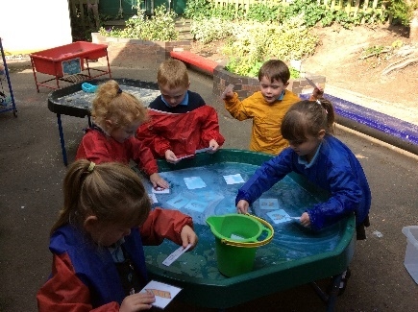 | Sound button matching. Write your phase 3 sounds on words and then see if you can match the sound to the word you can find. You will need to take your time and read carefully.  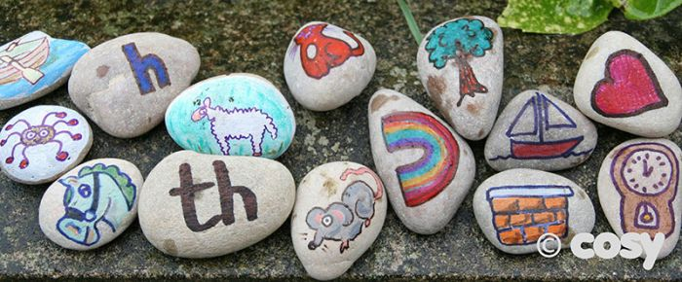 | Create your own story bag for a story you love. You will need to include your own version of the story, pictures of the characters, something they like to eat and a model of the setting.  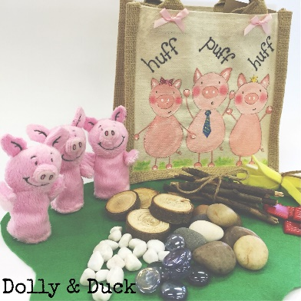 | Choose your own! What can you think of together?

Mathematics  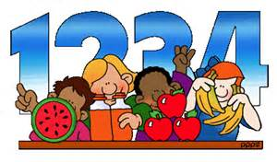 | Number dig and scavenge. Dig up buried numbers and then quickly scavenged the correct amount of that number. You are on the clock! | Playdough addition. Use number cards or a dice to generate your own sums. To keep it fun use play dough to break down those sums. | Log into your Mini Mash account and explore the maths games - and everything else! Go to the store and create your own addition and subtraction questions. 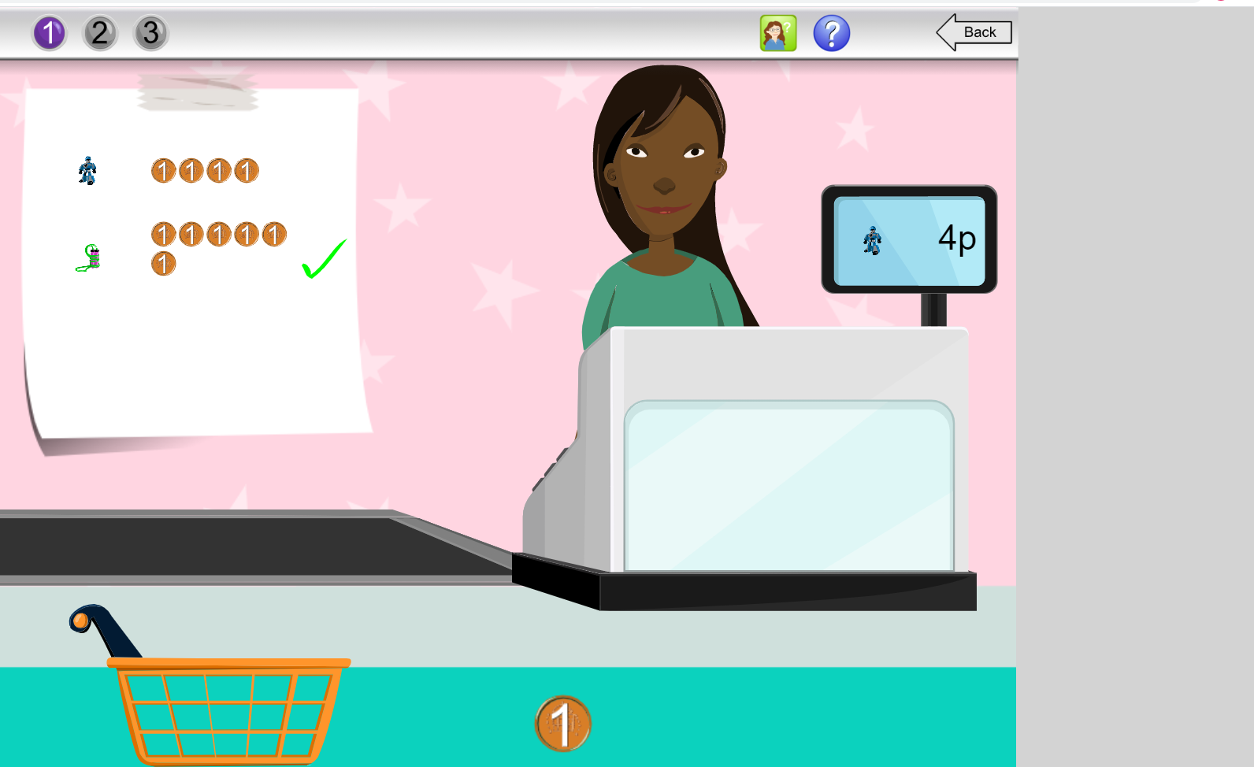 | Choose your own! What can you think of together?

Expressive arts and design | Record yourself singing Christmas Carols on your own or with your family. | Create your very own mythical creature. | Build your own junk model castle. | Choose your own! What can you think of together?

Understanding of the world | We live with so many superheroes, can you think of anyone who helps or has helped you? | Research your very own princess or prince. You may even want to get dressed up like him or her. 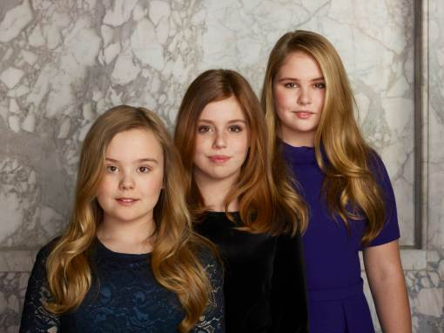 | Have a think about what would you like to be when you are older? Let me know why you would like to do that.  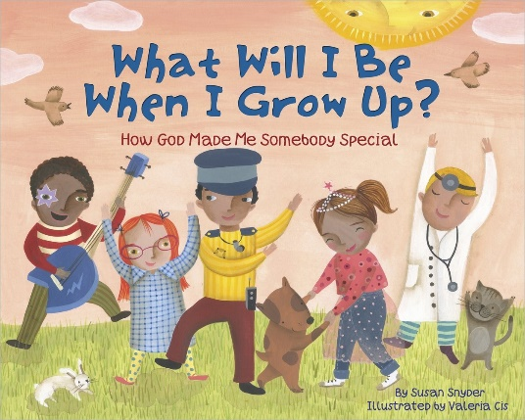 | Choose your own! What can you think of together?

