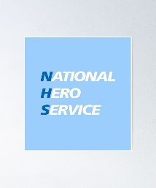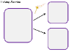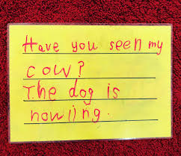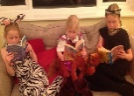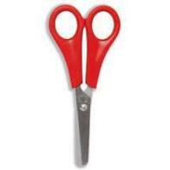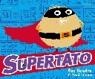

Summer Term 2 Topic: Superheroes

Mr McGill Pendle Class 2020 Author Study – Sue Hendra

We are into the final stretch now! All I can say is keep up the hard work and I hope and pray we get to see each other before the year ends. Well done everybody, I am so proud of all of you.

**R.E**

We will explore special places and people in Religion. Do you now where your local religious places are and why is it special / important. Think of the important people in your life and important religious figures.

**Mathematics** We will be supporting children’s understanding of halving and doubling which will allow many opportunities to work with numbers. Children will need to understand doubling and halving and demonstrate this using physical resources. To make this engaging and enjoyable for the children, using links to the story will make it relevant and enjoyable. Perhaps share cabbage leaves for Norman the slug or have a superhero tea party and equally share out the cakes and biscuits. Little ideas like this really showcase the key mathematics concepts to children.

**Personal, Social and Emotional Development**

Linked to our R.E subject discuss important people in your lives. Why are they important? Discuss what you would like to improve and in preparation for year 1, what are you looking forward to next year. Discuss your own classroom rules for home learning and back to school to see what rules you think will be important in how you and others behaviour and how you treat each other.

**Communication and Language**

A new topic will allow children to formulate and expand upon their ideas. You will find that stories captivate and interest your children in different ways, and this will provide several opportunities for children to express themselves. It can be from a child reading or retelling a Sue Hendra (Superhero) story or their own, acting out a certain scene or role playing it with you or a sibling. The use of unique vocabulary will help with their writing and overall vocabulary.

**Physical Development**

To be a qualified ‘Superhero’ you ned to be active and healthy. This topic will provide your children to work at a multitude of obstacle courses involving key gross motor skills such as running, jumping etc. Fine motor skills need to be continually practiced as skills such as handwriting and cutting need to be practiced too. Entering year 1 you will need to be able to dress yourself, take yourself to the toilet and wash your hands properly.

**Literacy**

Following from the new topic and Author study it will allow children to apply their phonetic phase 3 knowledge and beyond in engaging and meaningful contexts. Sue Hendra has a wide range of books and this will allow children to remain engaged while writing about their own superhero adventures. The fundamentals will be handwriting, phonetic knowledge and implementation of tricky words and finger spaces.

**Expressive Art and Design**

Explore and enjoy dancing and singing songs, you can use songs that are popular in your household or use the website Go Noodle. It provides a multitude of chances to sing and dance. Allow children to illustrate their books to help them build upon those ideas and demonstrate to others where the story is going. Continue to experiment with a wide range of resources such as baking, den building and paints.

**Understanding of the World**

Linking to the topic ‘Superheroes’ it would be greatly beneficial for children to look at the world and understand the people who help us in our lives. Looking at the various careers in the world and get them excited for the future. Utilise the booklets sent which allowed you to explore nature and be outdoors looking at habitats, lifecycles, weather and animals.