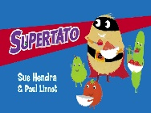
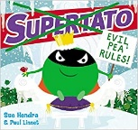
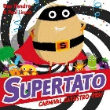
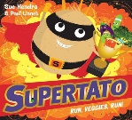
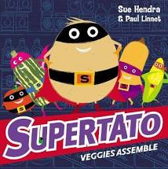
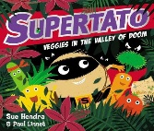
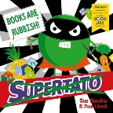
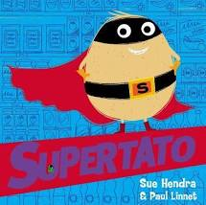
Pick and Mix Homework Menu
Topic – Superheroes
Author Study – Sue Hendra

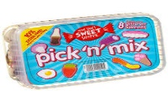
Spicy!!!
Medium
Mild

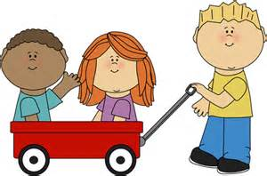  Communication and Language | Design and make your own superhero puppets or masks and role play your own story. You might even want to make yourself into one!  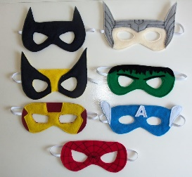 | Water pistols to ‘blast’ letter sounds Phase 3 when catch a sound. Fastest blaster wins the round-keep a score board and 1 child tally results.  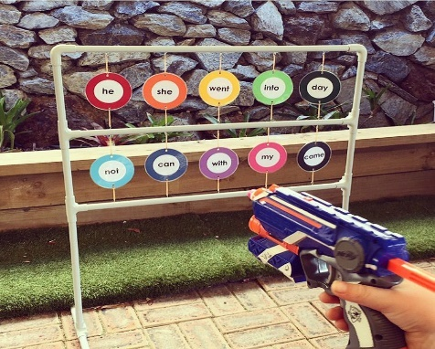 | Rhyming card snap! Write out your own words with rhyming pairs and play a game of snap, how quick can you be? | Choose your own! What can you think of together?

Personal, Social and emotional Development. | Heroic traits! Talk with your family about what makes a superhero super! | Create your own pots of feelings. You might want to colour code the pots or wool ball for a distinct emotion. Talk about what makes you feel that emotion and how you help fix the more negative emotions. 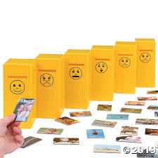 | Discuss all the things that you are super at and what you would like to get better at. You can do anything if you put your mind to it!  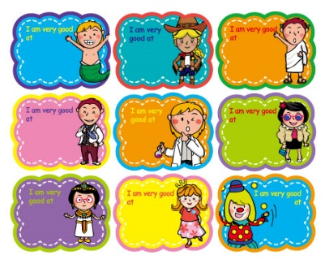 | Choose your own! What can you think of together?

Physical Development  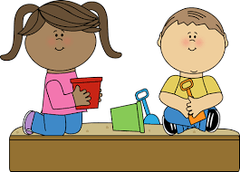 | Super scooter dash. You can show off your skills on a scooter, bike, skateboard, or anything else. Like any superhero you need to get to places quickly. Show off your speedy ways.  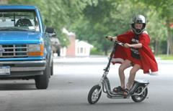 | Backyard balance tightrope. If you can tie 2 ropes from one end of the garden to another. If you cannot use ropes, walk on a chalk line, just don’t fall! | Learn a new dance on GO Noodle. I am sure there will be on perfect for you. Maximo is always good fun.  https://www.gonoodle.com/  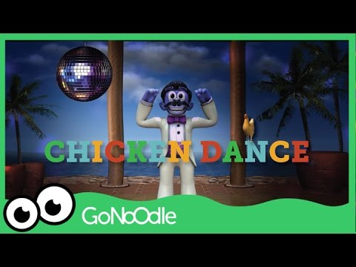 | Choose your own! What can you think of together?

Literacy | Snail Slime writing tray, to keep writing fun and hands on. Fill a tub with slime and use it to write your tricky and high frequency words – enjoy!  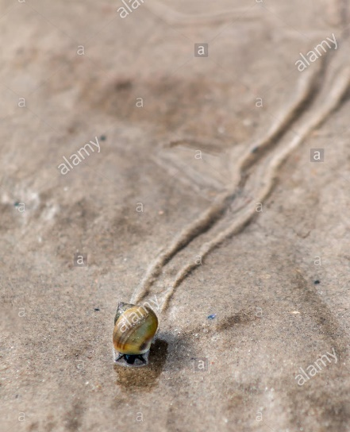 | Sound button matching. Write your phase 3 sounds on words and then see if you can match the sound to the word you can find. You will need to take your time and read carefully.  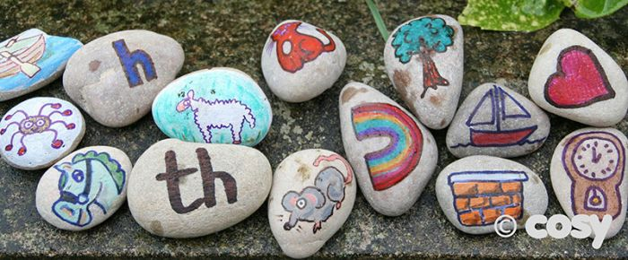 | Create your own story bag for a story you love. You will need to include your own version of the story, pictures of the characters, something they like to eat and a model of the setting.  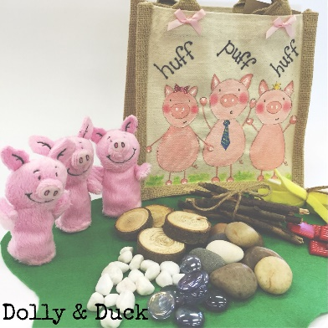 | Choose your own! What can you think of together?

Mathematics  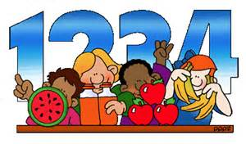 | Number dig and scavenge. Dig up buried numbers and then quickly scavenged the correct amount of that number. You are on the clock!  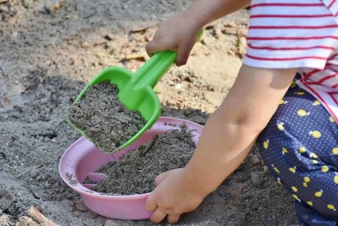 | Smelly feet doubling! Paint your feet in the garden (or somewhere suitable, it will be messy!) You get given and number and you will have to jump that many times. 3 = 3 jumps count all the footprints and that is your answer. See how you get on. | Using your skills of halving, can you half any number you see? Start off by counting out the number in one section of the mat and share it evenly. Nobody or thing should have more if it has been shared equally.  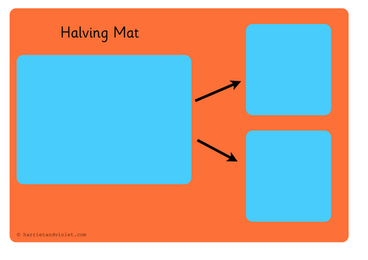 | Choose your own! What can you think of together?

Expressive arts and design | Paint yourself doing something Super! Could you by flying? Could you be super strong? Could you be super sneaky? | Create your very own Supertato! Make sure he is not dunked in jelly!  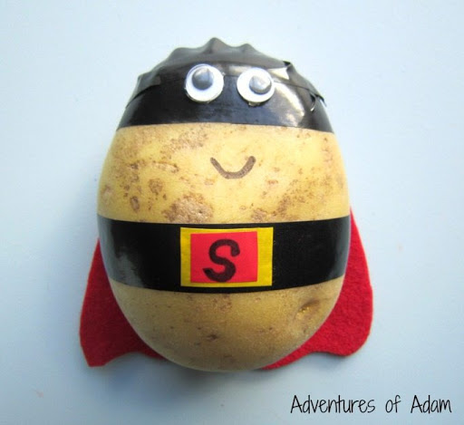 | Design and build your own superhero cape! | Choose your own! What can you think of together?

Understanding of the world | We live with so many superheroes, can you think of anyone who helps or has helped you? | Look for snails and slugs outside. Make a bug hotel indoors to explore slugs and snails-provide non-fiction books about slugs and snails.  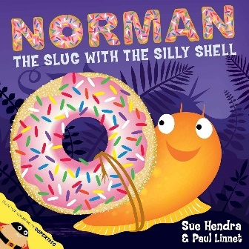 | Have a think about what would you like to be when you are older? Let me know why you would like to do that. It might be anywhere from a dancer to an astronaut, let me know!  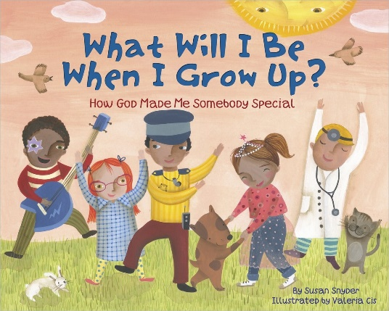 | Choose your own! What can you think of together?

