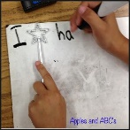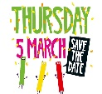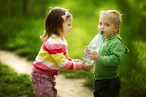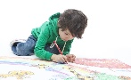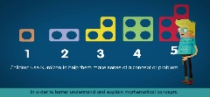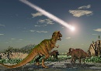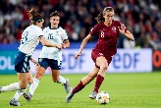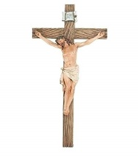

**Literacy**

As a class we will be writing sentences and have a focus on capital letters, finger spaces and full stops. Pendle class will be learning letter names and how they look e.g. A B C. We will be expanding on our knowledge of tricky words and implementing them into our writing. Children will be pushed to write unique sentences that they formulate and sound out independently.

**Expressive Art and Design**

We will be using pencils to sketch out and plan what we will be creating to better guide us when painting, drawing or collaging, Along with planning and drawing our unique creations with clear arms, legs etc. Pendle class we be learning how colour and shapes can be used to highlight key areas on our drawings.

**Understanding of the World**

Build up our own understanding of the world and specific things of interests such as volcanos. Investigate what certain animals eat looking at their diet, build and teeth and thinking critically about why an animal may have certain features. Use technology to research about animals that we find interesting and record that information.

**Mathematics**.

We will be using numicon to solidify our understanding of matching numerals to quantity. Children will be carrying out their own calculations and recording them in a way they understand and can discuss. We will be using key vocabulary such as doubling and halving and seeing how numbers change if we double or half them in various contexts.

**Communication and Language**

Children will be now implementing digraphs into their writing and now beginning to look at phase 5. We will be broadening our vocabulary with HFW and tricky words and also the new and unique vocabulary that comes with our topic. Children will be given independent challenges in guided reading to further their understanding of the books thy read.

**Physical Development**

We will be improving upon out gross motor skills with activities like trim trail challenges, running, catching, hopping and combining multiple skills together. We will also be discussing how we can live a healthy lifestyle.

**R.E**

Learning about sacrifice and the story of Easter.

Spring Term 2 Topic: Dinosaurs

Mr McGill Pendle Class 2020

This term we will be exploring the wonderful world of dinosaurs! Our author study will be on Ian Whybrow and Adrian Reynolds. Please can Learning Logs be handed in every Friday and reading books in bags daily.

**Personal, Social and Emotional Development**

Children will be learning about sacrifice and how we can show kindness and love to others we care for. Children will be encouraged to work independently and work at the key skill of perseverance when tackling a new / tricky task.