Topic – Dinosaurs
We will be delving into the wonderful world of dinosaurs this half term. To kick start this amazing topic we will be reading Harry and the Bucket full of dinosaurs. If your child has anything he/she wants to bring in linked to the topic they are very welcome to do so, it could be fossils, books or even a personal toy, I am sure it will get their imagination running!

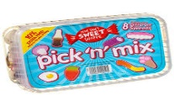
Spicy!!!
Medium
Mild

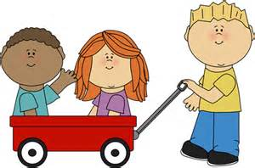  Communication and Language | Go on a sound hunt in the house, garden or just out and about. Put those amazing phonics skills to the test.  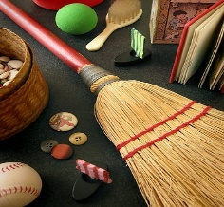 | Head Bands! Allow your children to design their own headband cards. You will then place the card on your head and guess what it is using the description provided by the other person. | . Tricky word hopscotch – in your garden or street write out our tricky words from phase 2/3/4! Jump from word to word and say the words loud and proud.  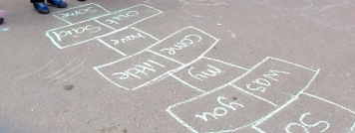 | Choose your own! What can you think of together?

Personal, Social and emotional Development.  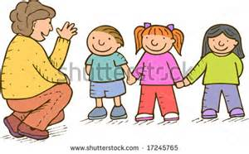 | Create your own Mini-Me and place him/her into a story. What are you great at? What do you like to do?  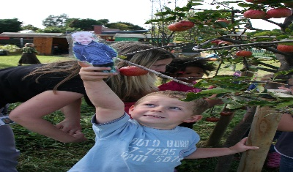 | Read a story together and identify how each character is feeling, Can you know discuss why they are feeling that way? Why are they sad/happy? | Work as a team and create your own enormous dinosaur. Work as a team to decorate and design it and name it together!  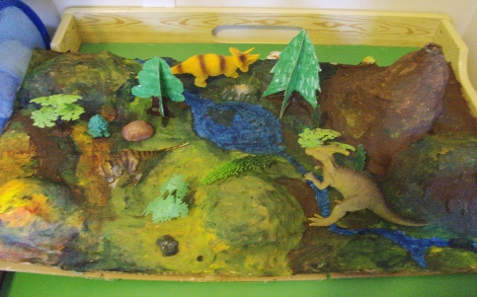 | Choose your own! What can you think of together?

Physical Development  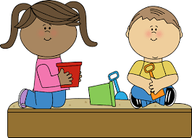 | Make your own dinosaur fossils using clay or playdoh and pressing shells, twigs pebbles.  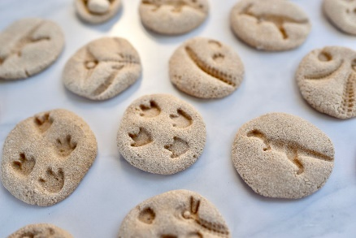 | TIMEBOMB! Race against the clock with throwing and catching counting as you go, when the timer stops the person holding the ball is out! You need to be quick.  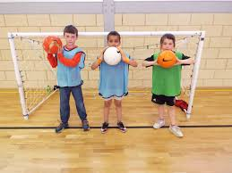 | To work on our agility/ dexterity twinkle toes are needed. Try skipping, playing football, or completing a climbing frame. | Choose your own! What can you think of together?

Literacy  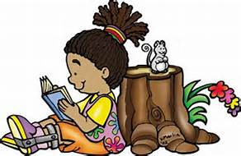 | Put tricky words into simple sentences, remembering finger spaces, full stops and capital letters. | For World Bok day 5th March write about the character you dressed up as, you are welcome to pick any other character too!  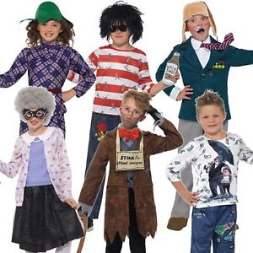 | Write your own story with a twist! Change key aspects of a story such as characters, settings or whatever else you can think of.  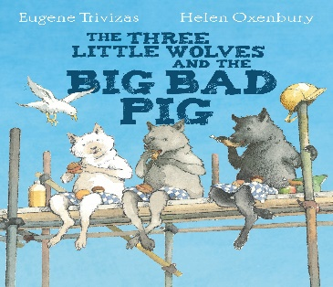 | Choose your own! What can you think of together?

Mathematics  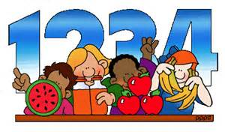 | Look at halving; together during meal times you can half food (and many other things) If someone has more, then it isn’t half!  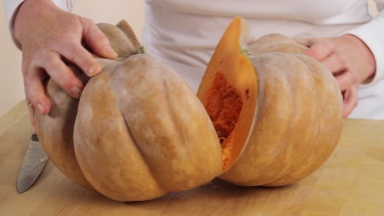 | Create your own ‘teen’ numbers with objects around the house. 14 = 10 spoons and 4 pillows. Get hunting! | Using a dice or simply your imagination carry out your own written calculations! Start off low and get bigger and remember if you are subtracting, pick the larger number first. | Choose your own! What can you think of together?

Expressive arts and design  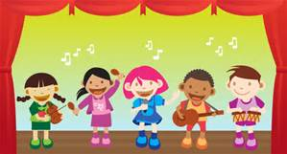 | Create a picture or collage of your very own dinosaur. She/he can be based on a real dinosaur or you can design your own! Experiment with colour and texture.  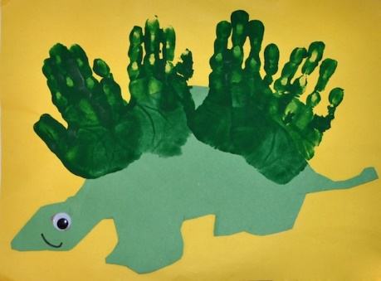 | Create a box model of a dinosaur using materials from your recycling box.  Can you create a dinosaur with different textures? Colours? | Using large boxes or smaller construction kits such as Lego. Have a go at making a vehicle to escape from the dinosaurs.  Take photos of your vehicle!  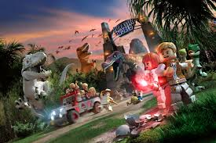 | Choose your own! What can you think of together?

Understanding of the world | For BSW (British Science Week) carry out an experiment of your choosing)  https://www.britishscienceweek.org/plan-your-activities/activity-packs/ | Use a computer to research your favourite dinosaur. What do they eat? Where did they live? How big were they? Include any brilliant questions you can think up!  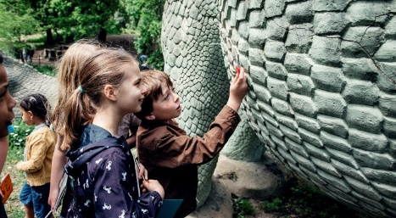 | Write your own fact file about dinosaurs, it can be as big and funky as you want! Fill it with all the facts you are interested about!  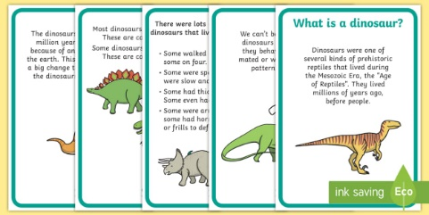 | Choose your own! What can you think of together?

