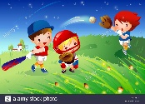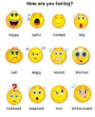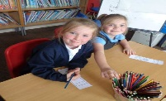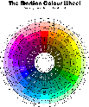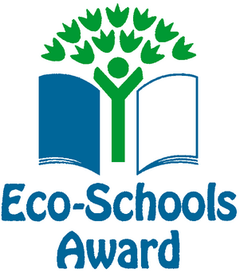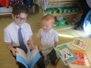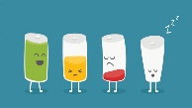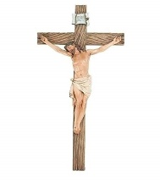

**Understanding of the World**

As the season changes, we will be exploring how this impacts on the environment around us. We will work with the ECO council to see how we can make small changes to help make our local community a better, cleaner and safer place. We will also be learning about a healthy balanced diet and how and why this is important for us to live a healthy life.

**Expressive Art and Design**

We will be making estimations and conducting experiments to see how we can change colour by mixing it with different shades or new colours entirely. We will produce a wide range of work using different materials using the children's ideas and a variety of resources.

**Mathematics**

Children will be working with capacity and exploring weight through different ways. Children will also be shown how to compare and sort items in unique ways. We will also be using critical thinking to explain and justify our assumptions. Children will also be recording their results with a range of resources and equipment.

**Communication and Language**

We will continue to build up our vocabulary and begin to move onto phase 3/4 books and consolidate phase 3 sounds. Children will be actively encouraged use prompts in the classroom like rainbow sounds independently. Children will be encouraged to broaden their writing by using more HFW/Tricky words in unique sentences they wish to write.

**Physical Development**

Children will have a focus on building up their range of gross motor skills with catching, running and moving in specific ways during games and P.E. The key outcome will be to see if they can master the movements required to show great dexterity and coordination.

**R.E**

Getting to know Jesus and learn about his miracles.

Spring Term 2 Topic: Percy Park Keeper (Great outdoors) Mr McGill Pendle Class 2019

I hope you all had a lovely Christmas and New Year together! I am sure 2020 is going to be even better than 2019 if that is possible. Pendle class is ready to reach bigger and better heights.

**Personal, Social and Emotional Development**

As a class we will be reflecting upon our emotions and trying to apply empathy to everyday situations. Children will reflect on the emotions we may feel and importantly why we feel this way. Once that is understood children can think about how to resolve any issues that happen or reflect upon their behaviour to think about actions and consequences.

**Literacy**

Children will be consolidating their phase 3 knowledge and beginning to delve into phase 4. In phase 4 you learn no new sounds but will come across longer words and new HFW and tricky words. Children will be completing phoneme frame sentences and a wide range of stories to truly enrich their writing with new vocabulary.