Topic - Percy the park keeper
Here is your pick and mix homework for the next 6 weeks! You are more than welcome to choose from the list below or be creative and do your own thing linked to the topic, it is about being fun open-ended learning, you can’t go wrong. Please bring your Learning Log in after 2 weeks for children to feedback and for us to see how they are getting on with the tasks.

Spicy!!!
Medium
Mild

Communication and Language | Place a tricky word or even one of the spellings in 1 of 3 cups. Give them a mix and figure out the right cup, then read the word! Have fun! Maybe you will place words under each cup to keep it quick. | Allow your child to select something from the house and use their senses and vocabulary to describe it to you. (Without saying the name of it!) See if you can guess what it is, then swap roles. Remember no peeking! | Make up your own rhyming cards, you can draw pictures and match up the images that rhyme or even write your own words. Remember to have fun and go bonkers, play it on your own, with a friend or as a family.  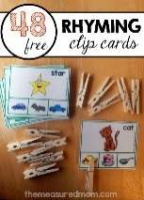 | Choose your own! What can you think of together?

Personal, Social and emotional Development. | Use a mirror and talk about the amazing person you see! Tell us how amazing you are. | Discuss how we can show kindness to an upset friend. You can write, act out or draw a picture of your idea.  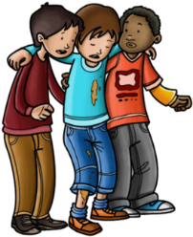 | Make a ‘Carebook’ in which you can show how you care and look after your pets by, loving, feeding, bathing and general care. You may have a cat or a horse it does not matter, they all need our love. If you don’t have a pet, show your love and caring nature to a family member. | Choose your own! What can you think of together?

Physical Development | Just like Percy does can you help in the garden, this may be digging up weeds, dead heading plants or sweeping up. Get out there and get active! | Make your own healthy food plate, showing a healthy balanced diet. Cakes may be delicious but are certainly not the only thing we can eat. | Make your own obstacle course with your family in the garden and give it a go. Test out your jumping, hopping and running skills.  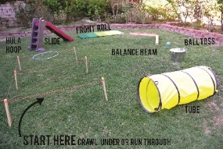 | Choose your own! What can you think of together?

Literacy | Have a go writing our tricky words, you can write them in the bath, on a window, with a paintbrush or in your book. You can even hide them after and go on a hunt for them. | Make your own character from a story you love, after you have found the right toy/object write about it.  What does it look like?  What does it like to do?  What does it like to eat?  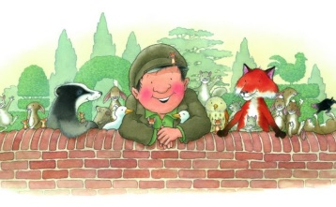 | Write a story for your favourite toy, he/she or it! It could be the hero or villain. If writing a story does not appeal, why not act it out? Have fun with it!  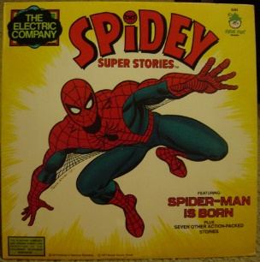 | Choose your own! What can you think of together?

Mathematics | To go with 1 more and 1 less, let’s make our own number line to 20. Use card, Paper, wood, or junk model one together. Get creative!  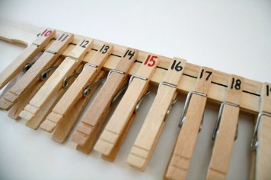 | Break out the scales at home and help prepare with the cooking or baking at home. Use those strong muscles for stirring, sharp ears for listening to instructions and keen eyes for paying attention to the scales.  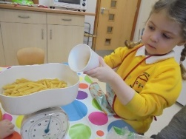 | Find out how many ways you can make a certain number. You could have 3 forks and 2 spoons to make 5 or you could have 4 teddies and 1 sock to make 5. Pick your number and go mad! | Choose your own! What can you think of together?

Expressive arts and design | Get outdoors and using the materials you collect and find create your own outdoor collage.  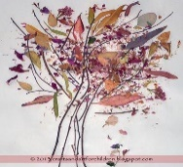 | Practice and preform one of the brilliant nursery rhymes, it can be a traditional nursery rhyme or something unique.  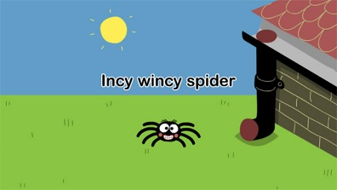 | Junk model your own Percy the Park keepers shed. Think about what you need to have in your shed.  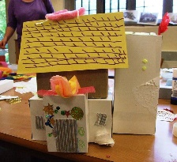 | Choose your own! What can you think of together?

Understanding of the world | Log into you Minimash account and save a piece of work you’ve done in your tray.  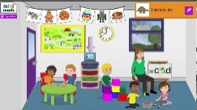 | Be a weather reporter over the weekend and discuss the changing weather. You can write it, draw it, take pictures or act it out on camera. | Choose one of the animals in Percy’s adventures and write a fact file about it.  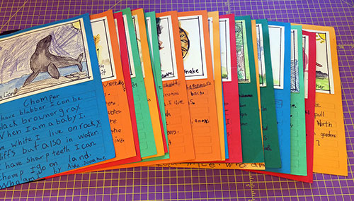 | Choose your own! What can you think of together?

