Image result for reading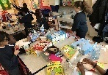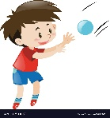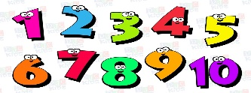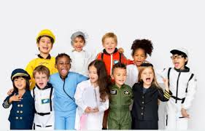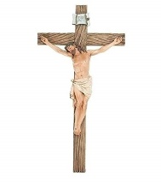

**Understanding of the World**

With our adventure into Tinga Tinga Tales we will get to explore the beautiful continent of Africa, such as the beautiful wildlife, art and culture. We will also be delving into the Nativity and the birth of Christ.

**Expressive Art and Deign**

Children will continue to use a variety of textures and materials to produce work that is meaningful. We aim to use a different art sytle heavily influenced by Tinga Tinga Tales and compare and contrast similarities and differences. This will lead to discussion about what we do and do not like and lead to an interesting dialogue between each other thinking critically about something.

**Mathematics**

Children will develop a better understanding with regards to shape and apply appropriate key vocabulary when necessary to identify a range of shapes. The key vocabulary we will be looking at will be sides, corners and edges which will help children to understand what a certain shape should look like by using words like because to describe them.

**Communication and Language**

Children will apply their phonetic knowledge in a wide range of situations such as through play and exploration, reading or writing. We will continue to explore rhyme and think about how we write and speak in the correct tense.

**Physical Development**

We will continue to progress with going to the toilet independently without being asked and then washing hands with soap. Children will continue to build upon their skills such as navigating space and having an awareness of the immediate space around themselves. We will continue to look at core skills such as kicking, catching and throwing too.

**R.E**

We will be learning about the birth of Jesus Christ and the meaning of Christmas.

Autumn Term 2 Topic: Tinga Tinga Tales (Safari)

Mr McGill Pendle Class 2019

The children have come back in brilliant spirits and are eager to explore and learn. Books are changed every Monday and Thursday during guided read so please ensure your bring your book bag in on those days.

**Personal, Social and Emotional Development**

We will discuss our key values with each other and apply them whenever possible such as kind hands. We will continue to think about our own emotions and how we can express them and continue to think about how someone else might be feeling and what we could do to help someone that is upset/ hurt.

**Literacy**

We will continue to become secure with phase 2 and expand our knowledge into phase 3. We aim to apply our phonetic knowledge in our writing and reading and demonstrate a good understanding of tricky words by writing them correctly during independent writing activities. Children will be encouraged to independently use a rainbow sounds to help with letter formation and an overall prompt to use during a reading or writing activity.