Image result for reading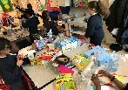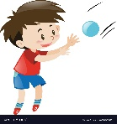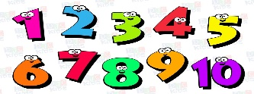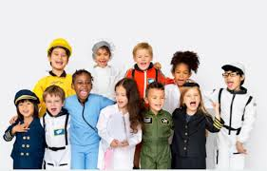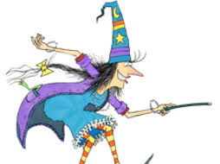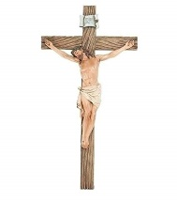

**Understanding of the World**

As a class we will discuss what we did over the summer holidays, comparing the similarities and differences with each other. We Children will be exploring purple mash with their own independent login, while using a computer or Ipad. We will be exploring different materials and the purposes we could use them for such as for junk modelling or construction.

**Expressive Art and Deign**

The class will use a wide arrange of materials in the art studio. Children will become familiar with the classroom songs, nursery rhymes and our hymns. Children will be taught how to use the range of equipment safely and correctly. Children will be encouraged to express themselves while dancing and singing throughout the classroom, e.g. using instruments or during role play.

**Mathematics**

Everyone will become more secure with numbers between 1-10. Children will begin to with different ways to count and work with resources such as height and weight. We will develop our understanding of patterns and how we can make them.

**Communication and Language**

We will be expanding our vocabulary while developing our understanding of phase 2. Children will role play with a story narrative in mind. We will show an interest in books throughout the school by reading and listening to stories.

**Physical Development**

We will build up our fine and cross motor skills by threading modelling and mark making. The children will develop their gross motor skills by navigating obstacles and throwing and catching. Children will build upon our understanding of the importance of washing our hands and ensuring we go to the toilet independently.

**R.E**

We will be learning about God’s family and how we can show kindness and consideration to each other.

Autumn Term 1 Topic: All about me

Mr McGill Pendle Class 2019

Welcome! This is the terms topic map, it will outline the exciting journey of what we will be trying to develop over this first term.

**Personal, Social and Emotional Development**

We will be focusing in settling into the classroom routine and begin to make new friends. We will discuss what we are passionate about to help support our learning. We will also learn the importance of sharing and taking turns with each other.

**Literacy**

Children will begin guided reading and start to discuss books in a group. We will be working towards becoming secure with phase 2 sounds. Children will be taught to give meaning to the marks they make by explain what they are writing/ drawing. We will be working towards reading phase 2 sounds, recognising some tricky words and applying this knowledge when reading CVC words and even simple sentences.