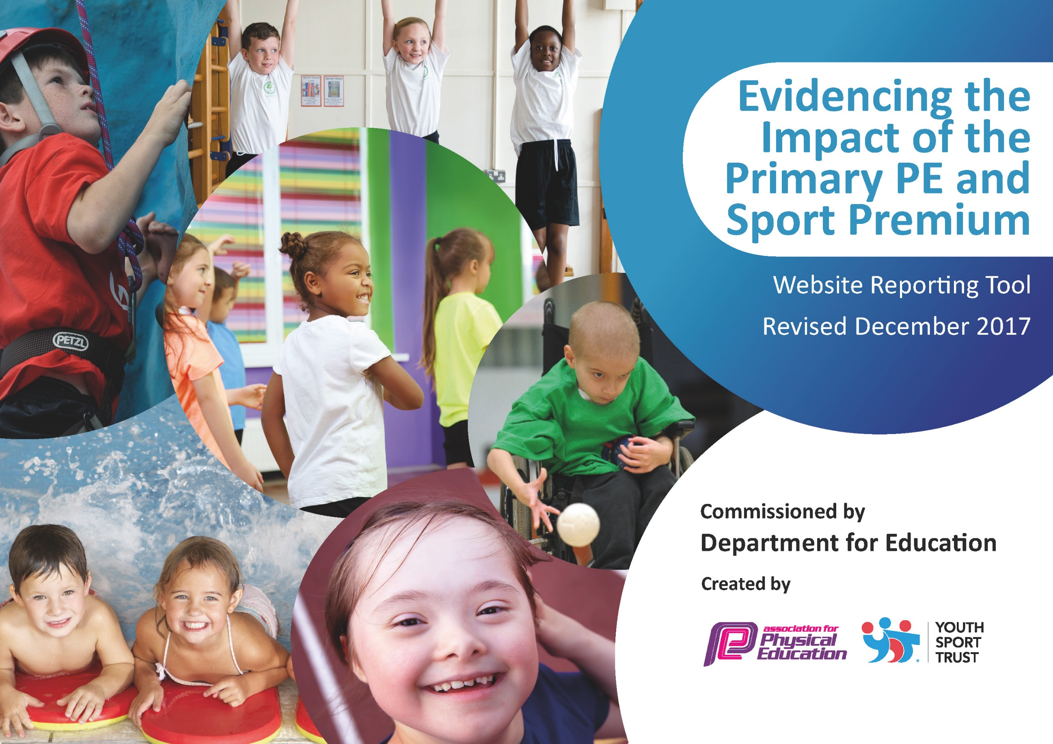

Schools must use the funding to make additional and sustainable improvements to the quality of PE and sport they offer. This means that you should use the Primary PE and Sport Premium to:

- develop or add to the PE and sport activities that your school already offers
- build capacity and capability within the school to ensure that improvements made now will benefit pupils joining the school in future years

Please visit gov.uk for the revised DfE guidance including the 5 key indicators across which schools should demonstrate an improvement. This document will help you to review your provision and to report your spend. DfE encourages schools to use this template as an effective way of meeting the reporting requirements of the Primary PE and Sport Premium.

We recommend you start by reflecting on the impact of current provision and reviewing the previous spend.
Under the Ofsted Schools Inspection Framework, inspectors will assess how effectively leaders use
the Primary PE and Sport Premium and measure its impact on outcomes for pupils, and how effectively governors hold them to account
for this.

Schools are required to publish details of how they spend this funding as well as on the impact it has on pupils’ PE
and sport participation and attainment.
We recommend regularly updating the table and
publishing it on your website as evidence
of your ongoing review into how you are using the money
to secure maximum, sustainable impact. To see an example of how to complete the table please click HERE.

Support for review and reflection - considering the 5 key indicators from DfE, what development needs are a priority for your setting and your students now and why? Use the space below to reflect on previous spend, identify current need and priorities for the future.

Key achievements to date: | Areas for further improvement and baseline evidence of need:
-Champions in competitive sport for Gymnastics in KS1. Year 1 boys came 1st and 2nd in a mixed year ½ competition.  -Silver Sports Mark medal for 2 years running.  -Many sports activities planned across each school year group.  -Putting the minibus to good use – getting children out to sporting competitions.  - An increase in child participation across school | Monitor ‘heat map’ and constantly improve provision and variety offered to children with a view to sustaining this for the future.  Run a mile needs to be developed on the playground. There are plans for a ‘Morning Mile’ club  Link PE Curriculum for other subjects

Meeting national curriculum requirements for swimming and water safety | Please complete all of the below*:
What percentage of your current Year 6 cohort swim competently, confidently and proficiently over a distance of at least 25 metres? | 100 %
What percentage of your current Year 6 cohort use a range of strokes effectively [for example, front crawl, backstroke and breaststroke]? | 100 %
What percentage of your current Year 6 cohort perform safe self-rescue in different water-based situations? | 100 %
Schools can choose to use the Primary PE and Sport Premium to provide additional provision for swimming but this must be for activity over and above the national curriculum requirements. Have you used it in this way? | Yes/No  Any children who needed additional swimming lessons joined the class lessons and as our children are in Year 2, we took our children for additional lessons to develop confidence and stamina.
*Schools may wish to provide this information in April, just before the publication deadline.
Action Plan and Budget Tracking
Capture your intended annual spend against the 5 key indicators. Clarify the success criteria and evidence of impact that you intend to measure to evaluate for students today and for the future.

Academic Year: April 2018 – April 2019 | Total fund allocated: £16610 (spent more as a result of having money left over from last year) Spending = 17,500.36 |  | Date Updated:20.4.19
Key indicator 1: The engagement of all pupils in regular physical activity – Chief Medical Officer guidelines recommend that primary school children undertake at least 30 minutes of physical activity a day in school |  |  |  |  | Percentage of total allocation:
 |  |  |  |  | 16.5%
School focus with clarity on intended impact on pupils: | Actions to achieve: | Funding allocated: |  | Evidence and impact: | Sustainability and suggested next steps:
PE Screen. Dance and sporting /club programmes for children to lead children in activity at break times and before school. Anomaly Screen.  Hiring a Sports Coach (Mr. Howarth) to develop further opportunities for children to partake in sport daily. Mr. Howarth to run two lunch time clubs, an afternoon club and two after school clubs. | Year 3/4 children as sport leaders for playtimes. Place a huge emphasis on this role. Children will be trained to use the Anomoly screen and lead wake up shake up sessions, dance and competitive games at break times each day.  Sports Coach to develop ‘Sports Young Leaders’ in school. As well as children participating in Sports – getting children to lead younger children for a greater impact. | £2500 per year for 3 years.  £399.38 |  | Children develop interests in sporting activities. More children involved in daily exercise. More children leading sporting activities at break times.  Children have developed further confidence in sport as well as leading others. Young Leaders lead games and activities every lunch time to increase participation. | Screen has been purchased and paid for over 3 years. Continue to develop new software to engage children.  Look into developing the netball court, adding new small tennis nets and a mile track for the children.  Mr Howarth to continue into the next financial year developing the confidence of further groups of children.
Key indicator 2: The profile of PE and sport being raised across the school as a tool for whole school improvement |  |  |  |  | Percentage of total allocation:
 |  |  |  |  | 12.3%
School focus with clarity on intended impact on pupils: | Actions to achieve: | Funding allocated: |  | Evidence and impact: | Sustainability and suggested next steps:
Sports leaders to give ‘sporting’, ‘participation’ awards in the weekly golden assembly. Raise the daily profile of sport in school.  Getting children involved in problem solving for Sports Day through Militarycation. A group of ex-service men who promote, outdoor learning, problem solving and teamwork activities with a military focus.  New Sports Equipment for children to use to develop their participation and raise the profile of sport in school.  Football Development Programme. Maths through Football. Linking in skills of football to mathematically understanding – through practical means.  Sports Activity Bouncy Castles to launch the Sports Week 2018 | Sports leaders to lead sports part of the assembly – badges and certificates required for awards  Militarycation came in to do a day with the children, with problem solving and teamwork ‘Outdoor’ activities with the children. After the day spent with the children, they then ran a bespoke sports day – incorporating the skills the children had learnt.  New football posts, netball nets, balls, footballs, netballs, bibs, tennis equipment. All needed to promote sport.  FA trained coaches, spent the day with each class doing maths through football. Developing mathematical skills whilst taking part in sport.  To raise the profile of SPORTS Week – engaging every class and every child. | £13.85  £552  £845.75  £300  £450 (paid for this financial year – but happened in the last financial year) |  | Increase the amount of parents coming to assembly.  Children learnt about teamwork and supporting others through problem solving. The lessons learnt can have an impact on the development of all children – looking at how to preserve and work together.  Through new equipment – it raises the profile of the education and participation in sport. Having the new equipment allows the children to participate fully.  Feedback from the children showed 100% enjoyed doing maths outside through sport.  Children enjoyed 45 minutes of sports bouncy castle activities. | Further certificates and badges. Focus group of children to continue to develop new ideas.  Activities learnt can be used by staff to develop further Outdoor Learning opportunities across school.  No big pieces of equipment are needed for next year now. The equipment is safe to use and will be looked after to last a long period of time.  Look into doing something over a term to support maths through PE. Target groups of children to support for next year.  Maths on the Move have been booked in for the Autumn term to work with Year 5/6 one morning a week.

Key indicator 3: Increased confidence, knowledge and skills of all staff in teaching PE and sport |  |  |  | Percentage of total allocation:
 |  |  |  | 2.3%
School focus with clarity on intended  impact on pupils: | Actions to achieve: | Funding  allocated: | Evidence and impact: | Sustainability and suggested  next steps:
In house development for staff to support their needs – led by the PE Coordinator and the Sports Coach. | Staff to develop confidence in a range of games activities – working with a sports coach for a half term. | £399.38 | Staff have developed confidence in teaching games.  This is to be developed further through the PNE Community and Education Trust to work weekly with children. | All planning CD’s to be purchased and used to support the Lancashire Curriculum. A new EYFS and KS2 Curriculum CD is due to come out from September – this will be looked into.  A much greater percentage is being spent on training staff with PNE next year.
Key indicator 4: Broader experience of a range of sports and activities offered to all pupils |  |  |  | Percentage of total allocation:
 |  |  |  | 13.4%
School focus with clarity on intended  impact on pupils: | Actions to achieve: | Funding  allocated: | Evidence and impact: | Sustainability and suggested  next steps:
Children to take part in a range of different sports that are not normally offered – through ‘Judo Education’. 6 weeks of Judo, Fencing and Archery. 12 weeks of Tennis.  Fencing – KS1  Judo – KS1&KS2  Tennis Coach – EYFS &KS1  Archery – KS2  Football Development Programme – KS1 and KS2.  KS1 and KS2 Use interactive screen at break times doing yoga and dancing. | Ensure all children across school have been able to access a range of different sports. Continue the partnership with Judo Education and Tom Luke Tennis. | Judo: £300  Fencing: £330  Judo: £330  Archery: £330  Tennis: £1050 | Feedback from children 100% of children enjoyed taking part in archery, as a new sport.  100% of children want to do even more Judo in school.  100% would recommend fencing to anyone who has not tried it.  Judo breakfast club to be re-introduced in September. | Continue to develop and invest in new activities and sport in school.  Tom Luke Tennis also ran an after school club over 2 school terms.
Key indicator 5: Increased participation in competitive sport |  |  |  | Percentage of total allocation:
 |  |  |  | 55.5%
School focus with clarity on intended  impact on pupils: | Actions to achieve: | Funding  allocated: | Evidence and impact: | Sustainability and suggested  next steps:
Children in school can access a wider variety of competitive sports. Impact on All children in KS2.  Purchase of a school minibus | Continue to develop strong links with cluster and Preston schools. Release PE leader to train children for further competitions. Enter further competitions with Dean Brandwood and Preston Schools.  Minibus purchased to enter more competitions as a school – proving to be beneficial long term both financially and with the ability to enter more tournaments. | £100  £9600 (potential add on costs for fuel/tax/insurance) | Preston Gymnastics KS1 Champions. Huge success after competing against many other children and larger schools. More children involved in competitive sport. All year groups took part/ or will take part in a competition this year.  Every year group have entered at least one competition due to have the means to get them there. | With a new minibus and getting more staff to drive the bus – it will be easier for the school to take part in more competitions.  With more people driving the bus for the next academic year, and less staffing issues children will enter even more competitions next year.  Mr Gilmour has started Minibus training May 2019 to complete for Oct 2019

