St Francis’ Catholic Primary school News

**An Invitation…**

The Mayor of Preston has asked our school choir to sing at St.George’s Church, Lune Street in Preston for a very special event on Sunday 12th May at 11.00am. Mr Warren will meet us there. Please put this date in your diaries for choir members!

**April Newsletter 2019**

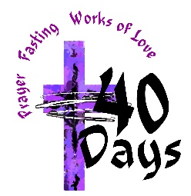Give it up!

Christine Dewhurst from CAFOD came to deliver an assembly all about families across the world who are in need of our help. Our children were sent home with little collection wallets in which to put any spare coins and send back into school at the end of Lent. As part of our almsgiving for Lent, we are having a non-uniform day for O.J’s Charity on Thursday 28th March. Please bring a £1 donation.

**Music Morning Concert**

You are all very welcome to attend our music morning concert on Friday 5th April at 9.30am in church.

We can no longer use our school hall for our concerts due to our impressive number of performers! Please bring along families and friends to watch our school Band, Choir , Glee Club, Parlick Class Glockenspiel players and other soloists.



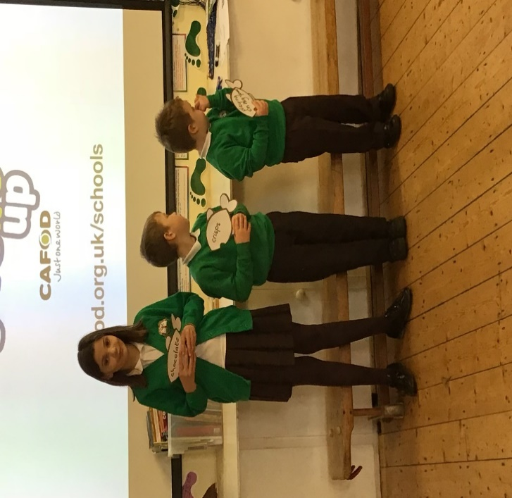

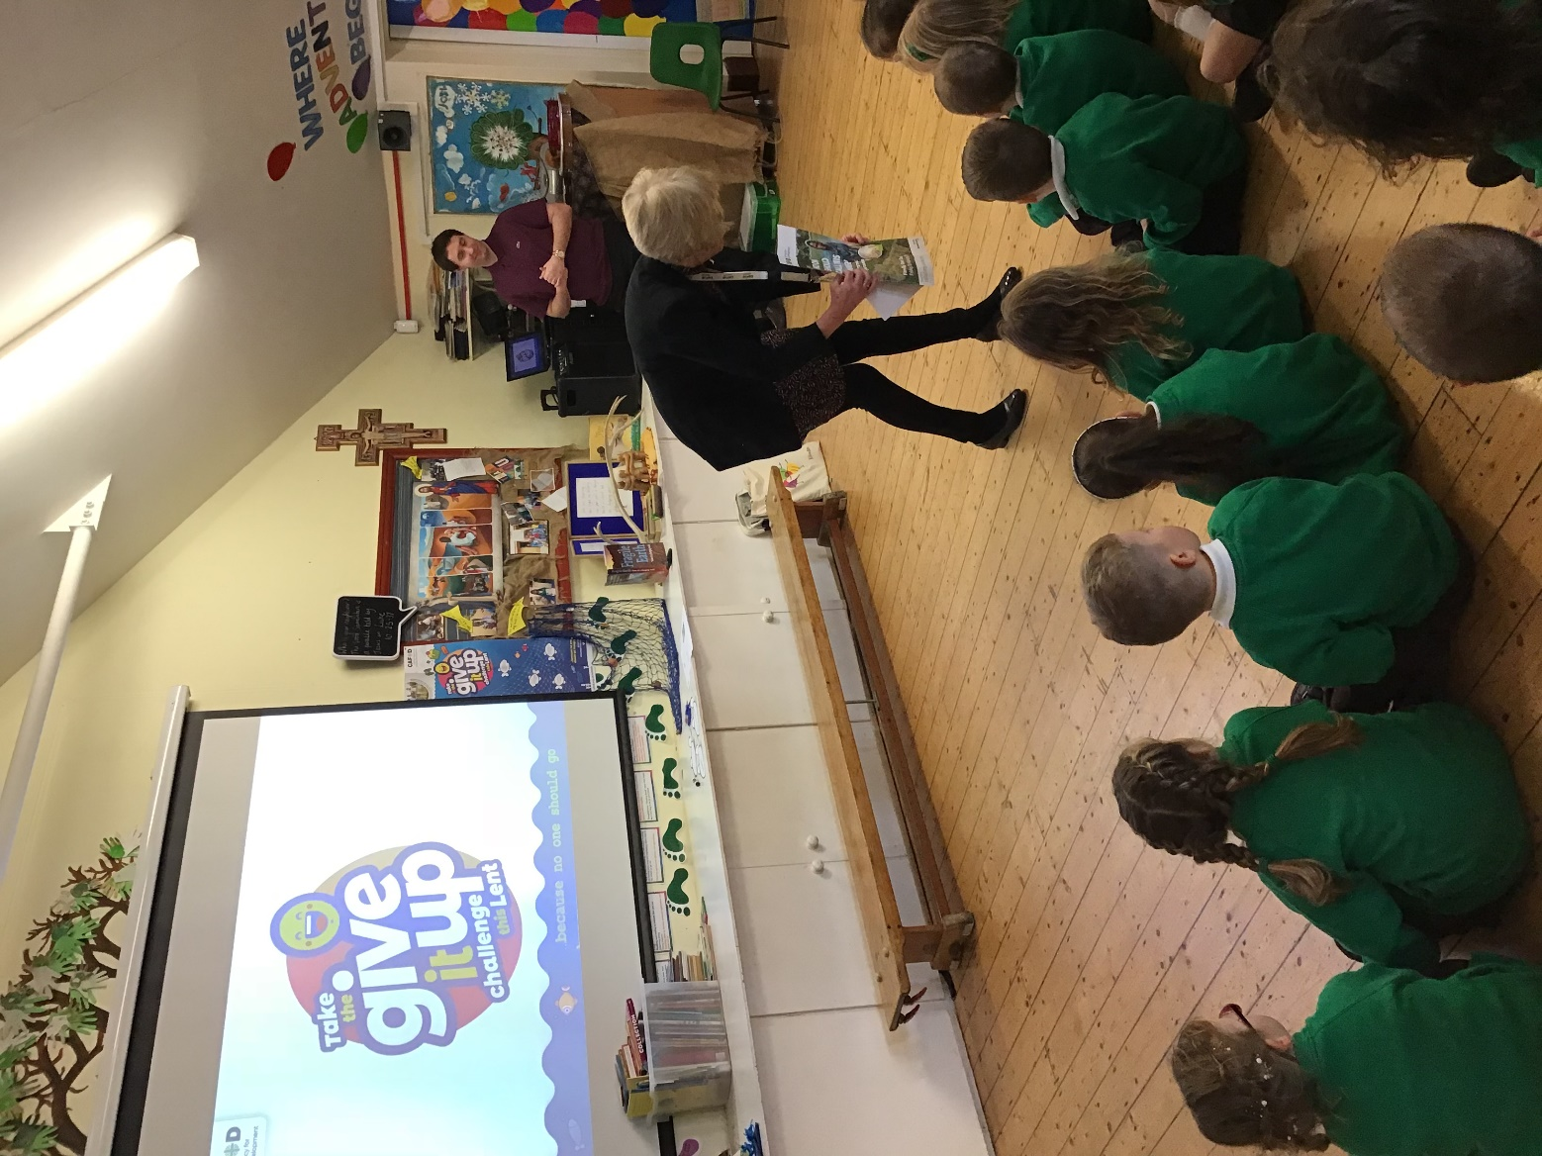

**Board game UFA Group visits Belmont Care Home**



**UFA GROUP VISIT TO ASCOT ART STUDIO**

**Thank you to Angela Wakefield for providing our children with such a rich experience!**

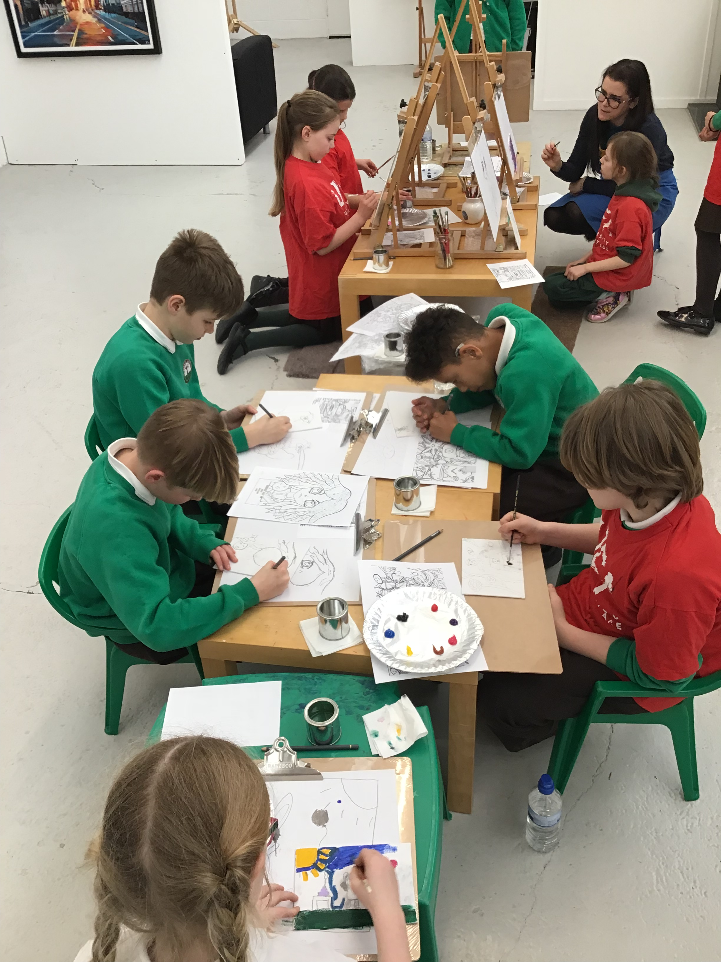

|  |  |
| --- | --- |
| 27th March | Year 5 at Cobble Hey |
| 28th March | Non-Uniform Day for OJ’s Charity (as part of our Lent almsgiving) |
| 29th March | PTFA Movie Night: 3.30pm in the school hall. |
| 4th April | Year 4 STEM Day at Longridge High |
| 5th April | 9.30am in Church-Music Morning Concert. Break up 1.30pm |
| 14th April | Palm Sunday Family Mass-SCHOOL BAND playing |
| 23rd April | Children return to school. |



