December 2018 Newsletter
Dates for your Diaries
Other News!
- We welcomed Preston College who performed, ‘The Elf Who Saved Christmas’ pantomime for the whole school last Thursday. The students and teachers do an excellent job and our children and staff thoroughly enjoyed the performance.
- CAFOD Club have raised enough money to support a refugee child this Christmas – well done to them all for their hard work!
- The School Choir joined other schools from our Lancaster Catholic cluster schools at an Advent service last week. The children did a wonderful job and represented the school beautifully.
- A reminder that after school activity clubs have finished for this term. Staff led clubs will resume the week of the 14th January 2019; Information about the clubs will be given out the first week back after half term. Teddy Tennis (run by Tom Luke) will resume the first day back on Monday 7th January 2019. A slip for the Tennis Club has gone home, if you would like your child to do the Tennis Club, please book in with the details provided.
- This Friday will be the last assembly – there is no assembly next week.
Thursday 13th December 2018 | 6.00pm: Key Stage 2 Carol Service in Church. All welcome.
Friday 14th December 2018 | 2.00pm: PTFA Christmas Party & Christmas Jumper Day (own clothes and Christmas jumper! Please bring a £1 to raise money for the appeal.)
Monday 17th December 2018 | 1.30 – 2.00 pm Carol singing at Bushell House Nursing Home.  End of term target reports sent home.
Tuesday 18th December 2018 | 9.15am: Mini –Carols around the Tree for Nursery and Pre-School families in the school hall.
Wednesday 19th December 2018 | 12:00pm Christmas Dinner Day!
Thursday 20th December 2018 | 2.00pm and 6.00pm: Infant Nativity in church. (Reception class, Year 1 and 2). All welcome.
Friday 21st December 2018 | Break up for Christmas holidays at 1.30pm. Have a lovely Christmas everyone!
Monday 7th January 2019 | Return to School for Spring Term. Happy new year!
A VERY SUCCESSFUL CHRISTMAS FAIR!
A big thank you to all those who supported the Christmas Fair on Sunday; it was a great success with plenty of money raised for the Parish, PTFA, CAFOD and for School. The band and the choir performed incredibly well and made us all very proud!
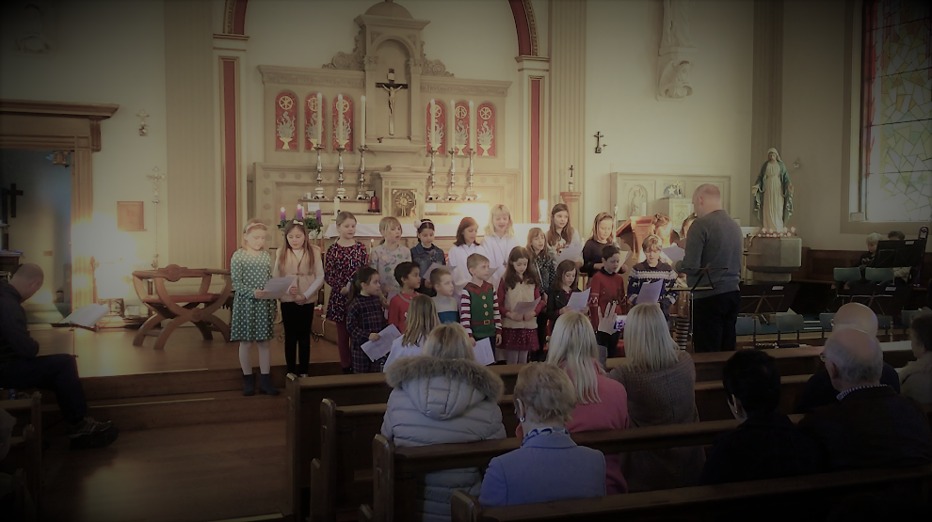
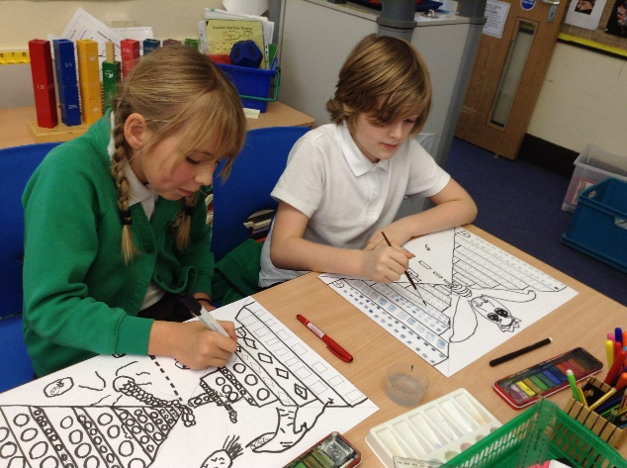
Here are a few photographs of the last few weeks across school! Please check out the app and class pages for further photographs
A VERY KIND DONATION!
We are pleased to introduce to you to our brand new iPads! Sixteen new iPads have been bought by the PTFA thanks to a parent donator. We are extremely grateful and excited to get using the new iPads in class; they have most definitely updated our IT resources. We have up-to date apps ready to use, with enough iPads enough for a whole class; this is something the school has been in need of. They will be used across the whole curriculum and across the whole school. A massive thank you again!
