November 2018 Newsletter
Amphitheatre
We are well on the way with designing our amphitheatre – watch this space for the development which will hopefully get underway soon.

Lottery Grant

We received great news this week - we have been successful in our application for a £10,000 grant from the National Lottery! The bid will help develop an outdoor classroom area that will hopefully be linked in with the current willow dome, planters and animal area of the school.

SPORTS CLUB AND SPORTS NEWS
It is great to see so many children joining in our new lunch time sports club. The children have been having a great time – combining problem solving skills with physical challenges.
A huge well done to the netball and football teams who braved the weather this week, taking part in their tournaments at Longridge High School. It was bitterly cold, but the children competed in great spirits, showing wonderful sportsmanship.
Also, our incredible gymnasts were in action last week. As always, the children represented themselves well, demonstrating their gymnast talent. The boys even managed to bring home 3rd place! Well done to all those involved.
NEWS FROM THE CLASSROOMS!
Learning Logs will be sent home each Friday giving you updates on what your children have been learning that week.
NURSERY and PRE-SCHOOL - The children have been outside in the Millennium, enjoying some rustic outside learning; enjoying marshmallows around the fire.
PENDLE – Pendle have been making incredible Christmas trees using 2D shapes; check out the website to see pictures.

PARLICK – Children have been putting the final paintwork details to their ‘London’s Burning’ homes, before they go up in flames next week!

FAIRSNAPE - Fairsnape are getting into their ‘Pied Piper’ topic, enjoying some ‘hot seating’ drama. The children have also created some inspirational art work, based on the artist, ‘Escher’; check out the class page for pictures.

BEACON - Beacon Class have create an incredible piece of patchwork art – themed around Harry Potter; get on the class page to see pictures.

Dates for your Diaries
You will receive text messages, school letters, messages in your child’s Learning Logs (specific to your child’s class), school APP notifications, information on our school website and reminders on the playground Anomoly screen. Please pop in to see Miss Taylor in the school office if you have any queries or questions or call school at any time.

30th November | Staff INSET day. Children at home.
5th December | 1:30 – 2:30 School Panto, ‘The Elf That Saved Christmas’ –by the students of Preston College.
9th December | 10:30 Family Mass and Christmas Fair in the school after Mass. The school band will be performing.
13th December | 6.00pm: Key Stage 2 Carol Service in church. All welcome.
14th December | 2.00pm: PTFA Christmas Party & Christmas Jumper day (bring a £1)
17th December | End of term target reports sent home.
18th December | 9.15am: Mini –Carols around the Tree from Nursery and Pre-School families in the school hall.
19th December | 12:00 Christmas Dinner Day!
20th December | 2.00pm and 6.00pm: Infant Nativity in church. (Reception class, Year 1 and 2). All welcome.
21st December | Break up for Christmas holidays at 1.30pm
7th January 2019 | Return to school for Spring Term.

MISS. DEAKIN NEWS!
I’m glad to tell you all that Miss. Deakin is recovering well at home. She is very much on her way to making a full recovery! She is in regular contact with school, as we keep her updated on all the events that are taking place. She misses all the children, wishes you all well and looks forward to returning to school.
Snacks
Children are free to bring in their own healthy snack, as well as fruit being available. Toast is 20p.
MONDAY—Fruit
TUESDAY—Fruit
WEDNESDAY—Toast
THURSDAY— Fruit
FRIDAY— Fairtrade
(Drinks are available for 40p. Fairtrade snacks available between 25p– 45p)

Raising money for charity
A huge thank you to all the parents/carers/grandparents who have helped the school raise money over the last month; your support is very much appreciated. We have raised enough money to support the rabbits and chickens throughout the winter months. We have also supported some great charities through your kind donations and cake sale. Again, thank you for supporting your children and the school in raising money for charity. The children really do see the value in supporting others.

Our School App
Have a look at our School APP that will sync with your mobile calendar. You will get notifications with messages to remind you of dates and it will take you directly to latest school information. Please be aware that we are using the app more than ever to keep you updated on upcoming dates. Just visit ‘ourschoolsapp’ on Google Play or App Store and type in our postcode: PR3 2FJ.

ARMISTICE 2018

Year 4 children did a fantastic job to commemorate the 100 year anniversary of the end of the World War I. I’m sure any of the parents in attendance will agree with what an incredible job the children did. Spending 10 hours at the Guild on the Sunday, after the endless hours of rehearsals each Friday – the children did themselves proud. A big thank you to all the parents for supporting the children and the school. Photographs of the event can be found on the school website and on the Longridge Cluster Armistice Facebook page.

Other News!
- The school video is up on the website – please check it out.
- Our school is now featured in this term’s edition of NATE magazine due to our creative teaching approach towards writing. Check out the magazine at the front of school!
- Excitingly, we are also featured in the latest CAFOD newsletter to all Catholic primary schools in the UK, having helped them develop a ‘CAFOD Club’ box of resources. The box of resources has been sent out to all Catholic schools to use. We welcome another visit from CAFOD Headquarters after Christmas to support the development of CAFOD Clubs across different schools in the UK.

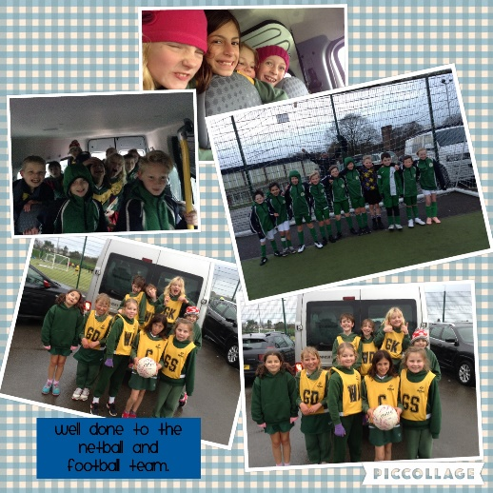
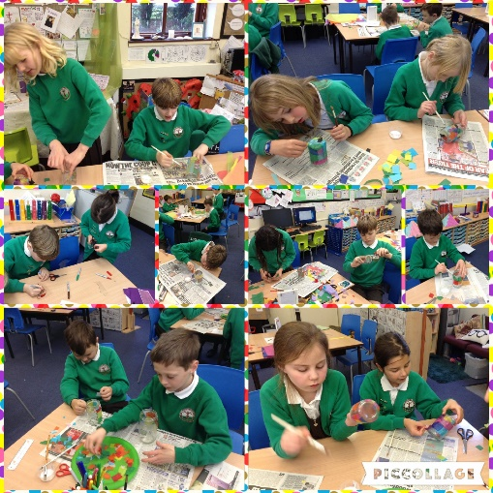
Here are a few photographs of some of the clubs and events happening at school at the moment.

