St Francis’ Catholic Primary School
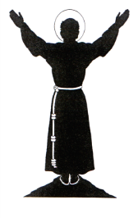 | The Hill  Horns Lane Goosnargh  PRESTON Lancashire  PR32FJ  www.stfranciscatholicprimaryschool.co.uk | 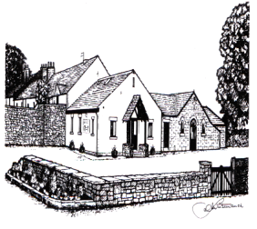
Miss S Deakin HEADTEACHER Tel 01772 865369 Fax 01772 863947

Save the Date
Glee Club, Band and Choir
Concert 4th February at Goosnargh Village Hall!

Come along and see the 2018 Goosnargh & Whittingham Festival Year launched with a swing! Our school band and choir are performing once again-but this time under new direction and with our Glee Club!
"Showtime" starting at 2.30pm, Sunday 4th February in the Village Hall, Goosnargh PR3 2BH
Adults £2 Children £1 (Free for Performers and Festival Queen Candidates)

Dear families,

We are very excited about performing alongside other schools at ‘Showtime.’ Our school choir, band and Glee club have been working incredibly hard in preparation for this and we look forward to showing the local community (again) just how talented our children are! Musicians will all need to be at the venue for 2.00pm so we can get ourselves prepared and the band set up. Please remember to bring instruments and music. Come in home clothes.

We are delighted that our younger children will be performing as part of Glee club and band. It will be a wonderful occasion to showcase our

This will be another great opportunity for our children to perform to a wider public.
Staff will be at the venue for 2.00pm, ready to greet you and your children. Thank you very much for your continued support.

S.Deakin

