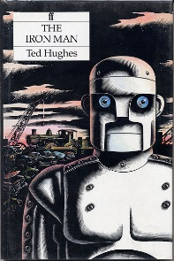Hhh.

**Literacy**

* **Novels as a theme-** Interpret ideas in order to visualise a character. Annotate sketches using words from texts. To read and analyse the story Iron Man by Ted Hughes. To explore plot structure, sentence structures and grammar used in text.
* **Recount – Diaries** Identify key points of a diary using who, what, where, when, how, why with evidence from text. Be able to respond in role to thoughts and feelings. To organise content for use in writing.

**Fairsnape Class**

**Autumn Term 2**

**Music**

Think ‘Stomp!’

We are going to construct our own set of instruments from junk. We will then use these to perform music and movement routines.

* Appraising
* Pitch
* Rhythm
* Musical notation
* Performance

**Topic: The Iron Man**

**Through our creative curriculum we will be looking at the following areas:**

The properties of different materials

Magnets

Creating a ‘metal’ band

Explore how pop up mechanisms work

Explore how things move

Draw in chalk

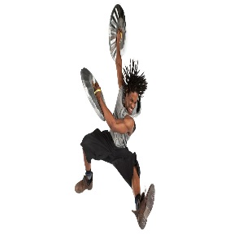

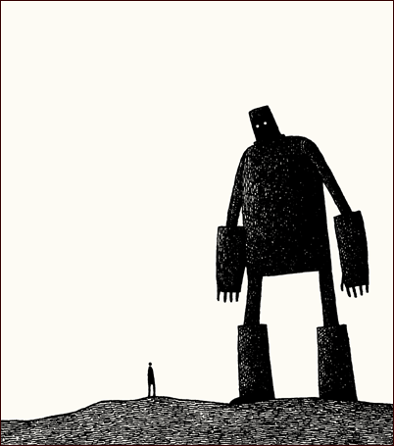

**Numeracy**

Solve problems, including missing number problems, using number facts, place value, and more complex addition and subtraction.

**Solve addition and subtraction two step problems in contexts, deciding which operations and methods to use and why.**

**P.E.**

Taking on the role of a ‘Super Hero’, the children will plan their own floor routines. They will list the types of travelling movements, jumps and turns they will use and work in small groups to create a piece together.

**Computing**

* Computer art
* debugging programmes
* Word processing skills
* 2Simple’s 2Code