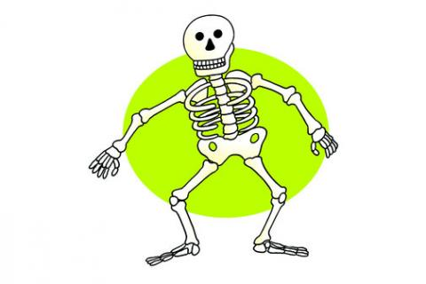Hhh.

**Fairsnape Class**

**Autumn Term 1**

**Topic – Healthy Humans**

**Through our creative curriculum we will be looking at the following areas:**

**Heathy food/Balanced diet**

**The eat well plate**

**Different diets of animals**

**Planning and preparing meals for a particular group of people**

**Computer Art and sketching**

**Maintaining a healthy lifestyle through healthy eating and exercise (Multi-skills circuits)**

**Literacy**

* **Poems on a theme-** Exploring and analysing poemsbefore planning and writing our own.
* **Persuasive letters –** Researching and analysing features of letters and in particular persuasive writing. Planning and writing a persuasive letter on an agreed theme**.**
* **Fables** **-**Analysing features of Aesop’s Fables in order to plan and write our own.

**Computing**

* Computer art
* debugging programmes
* Word processing skills
* 2Simple’s 2Code

**P.E.**

The children will develop their knowledge and understanding of how physical exercise and sport can have an impact on their health and fitness.

During multi-skills circuits, the children will measure the heart rate whilst resting and exercising. This data will be used in our maths lessons.

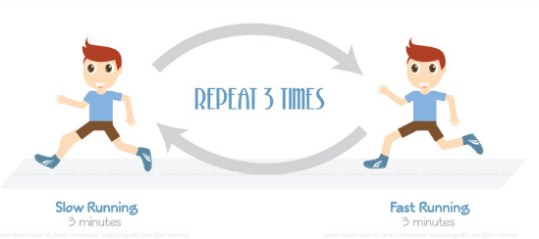

**Music**

* Appraising
* Pitch
* Rhythm
* Musical notation
* Performance

**Numeracy**

* Number and Place Value
* Counting in sequences / multiples
* Written Addition and subtraction
* Estimating
* Measuring using mm, cm and metres
* **Counting in sequences / multiples**
* **Written and mental multiplication**
* **Written and mental division**
* **Time**
* **3d Shapes**

**3d shapes**