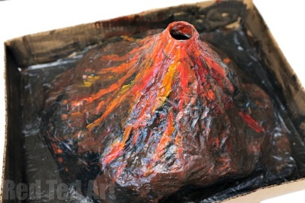
Fairsnape Homework Holiday Challenge!

Our new topic when we come back to school is called, ‘Rock and Roll’.

We will be studying rocks and volcanoes.

Your challenge is to make a volcano for the classroom that will fit on our shelves.

There are lots of videos on-line with examples.

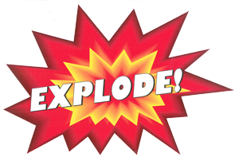
Please bring it for Friday 23rd February

as we will be filming them, as they…

You will need:
- A small plastic drinks bottle (without lid)
- Newspaper
Handy hint: You can make glue from water and flour.
- White glue (or flour and water)
- Water
- A large cardboard box
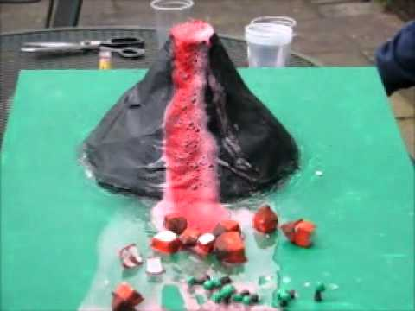
- Scissors (always supervise kids when they’re using scissors)
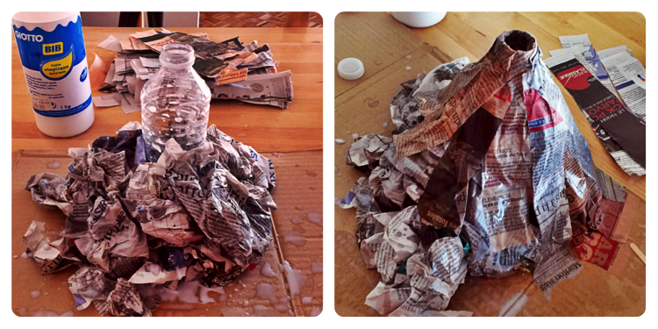
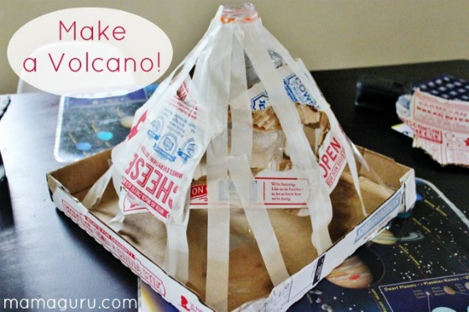
- Paint and brushes

