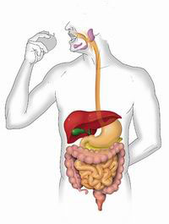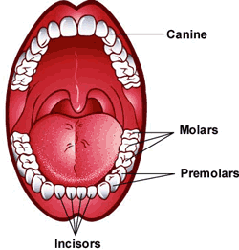

OTHER INFORMATION

Please continue to read with your child on a regular basis. This really does have an impact on their understanding and fluency.

Year 3 will swim on Monday afternoons.

PE for the class will take place on Wednesday afternoons. Please can children come to school on this day, dressed in their PE kits.

R.E

This term we will look at the Beatitudes. The Beatitudes are a set of teachings by Jesus and are intended to guide our behaviour.

October is the month of the Rosary and the feast of St. Francis. We will be looking at the lives of St Francis and Mother Teresa and how they have influenced others.

Our topic this half term is called ‘The Art of Food’. Within this subject we will be looking at digestion in humans and different animals. We will also be looking at our teeth, their uses and how we can keep them healthy. To do this, we will be undertaking a number of exciting investigations and explore how to do fair tests.

The children will have the opportunity to continue to develop their drawing skills by the drawing and painting of still life into 3D sculptures. Music will continue with Mr Severyn, with links to our topic.

Within P.E, pupils will continue to apply and develop a broader range of skills. All children will be having multi-skills PE lessons with Mr Bamber and the Year 3 children will also be having swimming lessons at Gorlands Pool, Longridge.

English

Charlie and the Chocolate Factory is our class novel this half term. We will be reading this together and making comparisons with the film. We will continue to work on our comprehension skills and develop our knowledge and understanding of SPAG (Spellings, punctuation and grammar).

Spellings will be sent home weekly and tested on Friday’s. We appreciate your support with this.

Creative Curriculum

Maths

We start our maths with place value recognising the value of each digit in three and four digit numbers. We need to be able to read, write, order and compare numbers to 1,000 (year 3) or 10,000 (year 4). We will continue to practise formal written methods for all four operations both in maths lessons and across our creative curriculum.

Years 3’s will need to know multiples of 4, 8, 50 and 100 this year. Year 4’s also need 6, 7, 9, 25 and 1000.

‘The Art of Food’ – Year 3&4 – Autumn Half Term 1